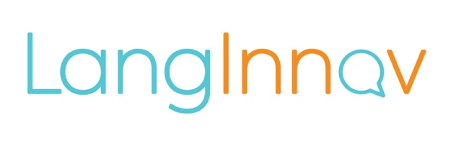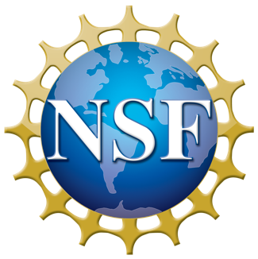
LangInnov Awarded $898,537 from the National Science Foundation
Small Business Innovation Research Program Provides Seed Funding for R&D

New York, NY, September 30, 2021 – LangInnov has been awarded a National Science Foundation (NSF) Small Business Innovation Research (SBIR) grant for $898,537
to conduct research and development (R&D) work on ground-breaking bilingual literacy technology that addresses the educational needs of children who speak a language other than English at home.
LangInnov provides innovative technology to improve educational outcomes for the growing emergent bilingual population in our school system. Our solution, the BLAST mobile app, automatically assesses bilingual speaking and literacy skills, and offers personalized game-like literacy activities. BLAST allows educators to make informed placement decisions and provide bilingual students with language development support in both English and their home language.
“NSF is proud to support the technology of the future by thinking beyond incremental developments and funding the most creative, impactful ideas across all markets and areas of science and engineering,” said Andrea Belz, Division Director of the Division of Industrial Innovation and Partnerships at NSF. “With the support of our research funds, any deep technology startup or small business can guide basic science into meaningful solutions that address tremendous needs.”

“We are very proud to be funded by the National Science Foundation and grateful for the opportunity to address the educational needs of emergent bilinguals, who represent 23% of school-age children in the U.S.,” said Dr. Rocío Raña, CEO of LangInnov. “The first version of the BLAST mobile app has been designed for the under-resourced bilingual Latinx community in our schools. These funds will allow us to continue developing BLAST to provide educators the data and tools needed to help Latinx children succeed.”

Small businesses with innovative science and technology solutions, and commercial potential are encouraged to apply to the NSF SBIR/STTR program, also known as America’s Seed Fund powered by NSF. Once a small business is awarded a Phase I SBIR/STTR grant (up to $256,000), it becomes eligible to apply for a Phase II (up to $1,000,000). To learn more about America’s Seed Fund powered by NSF, visit: https://seedfund.nsf.gov/

About the National Science Foundation's Small Business Programs: America’s Seed Fund powered by NSF awards $200 million annually to startups and small businesses, transforming scientific discovery into products and services with commercial and societal impact. Startups working across almost all areas of science and technology can receive up to $2 million in funding to support research and development (R&D), helping de-risk technology for commercial success. America’s Seed Fund is congressionally mandated through the Small Business Innovation Research (SBIR) program. The NSF is an independent federal agency with a budget of about $8.5 billion that supports fundamental research and education across all fields of science and engineering.

About LangInnov
LangInnov was incorporated in 2018 in New York City by two entrepreneurial women of color who are experts in bilingual assessment and educational technologies. Our solution, the BLAST mobile app, was developed with an award from the National Science Foundation with the goal of bringing equity in education to bilingual communities in the United States.
Learn more at https://langinnov.com | @wearelanginnov

