Michael Dillard releases book “Accidental Success: Accidental Millionaire Retirement” That Reveals Insights to Get to the Top

Author Michael Dillard is delighted to announce the launch of his new book, 'Accidental Success' available on Amazon and Barnes and Noble. Accidental Success by Michael sketches out a Reliable Plan to Achieve Goals and Become Successful in Life.

Accidental Success is a self-motivational book for someone stressed out with their life, career, or personal finances and needs the motivation to get up and get going. This book inspires, motivates, and teaches the readers how to build generational wealth step by step.

The book contains the inspiring real-life story of Michael Dillard and the secret formula that he used to go from unemployed on a Friday to traveling around the world as a Foreign Service Officer on a Monday.

Michael Dillard was born in Portsmouth, Virginia, and raised in Clarksville, Tennessee. Michael graduated from Northeast High School. From age 7, he was raised in a single-parent house when his parents divorced. The U.S. federal program called Upward Bound motivated him to develop a vision for his life. It provided tutoring and cultural exposure while in high school on the campus of Austin Peay State University.

In addition to being an author, Michael Dillard is an Executive Coach. He completed his ICF executive coach training from the Center for Executive Coaches. One can book or schedule a coaching session with Michael at www.madillard.com.

Michael has worked in countries like Afghanistan, the Democratic Republic of Congo, the Dominican Republic, South Africa, and Zambia as a Financial Controller.

Michael also served in the U.S Army for four years, where he served as a radio repairer. His duty stations included Ft. Carson, Colorado, Camp Casey, South Korea, and Ft. Stewart, Georgia.

Michael received his Bachelor’s Degree from Middle Tennessee State University, his MBA with a specialization in Financial Planning from Strayer University, and a Master’s Degree in Accounting from Liberty University.

Michael has put all the secret ingredients to success and happiness in the book, as he wants a maximum number of people to learn from his diverse experiences in life.

“I really enjoyed reading about Michael’s life and how he made it…. proving that despite setbacks, you can achieve success. This book is an inspiration to all, and I recommend it wholeheartedly,” says Mary H, a reviewer.

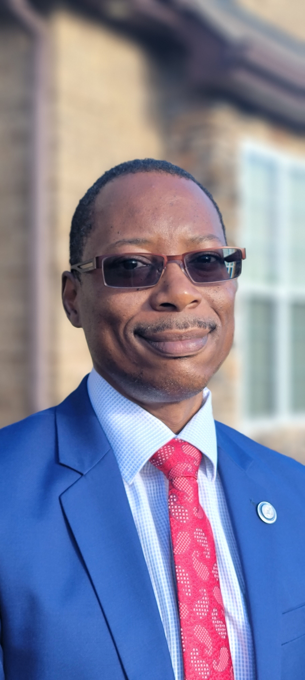

FOR MEDIA ONLY
To know more:
Author: Michael Dillard
From: Nashville, Tennessee USA
Phone: 615-810-1944 FOR MEDIA ONLY
Email: info@madillard.com
Website: www.madillard.com

