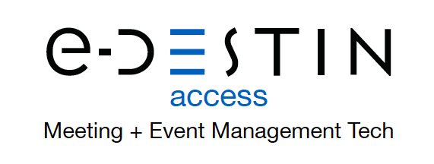

NFL ALUMNI TAP INTO POWER OF e-DESTIN
Online interface gives chapters maximum flexibility.

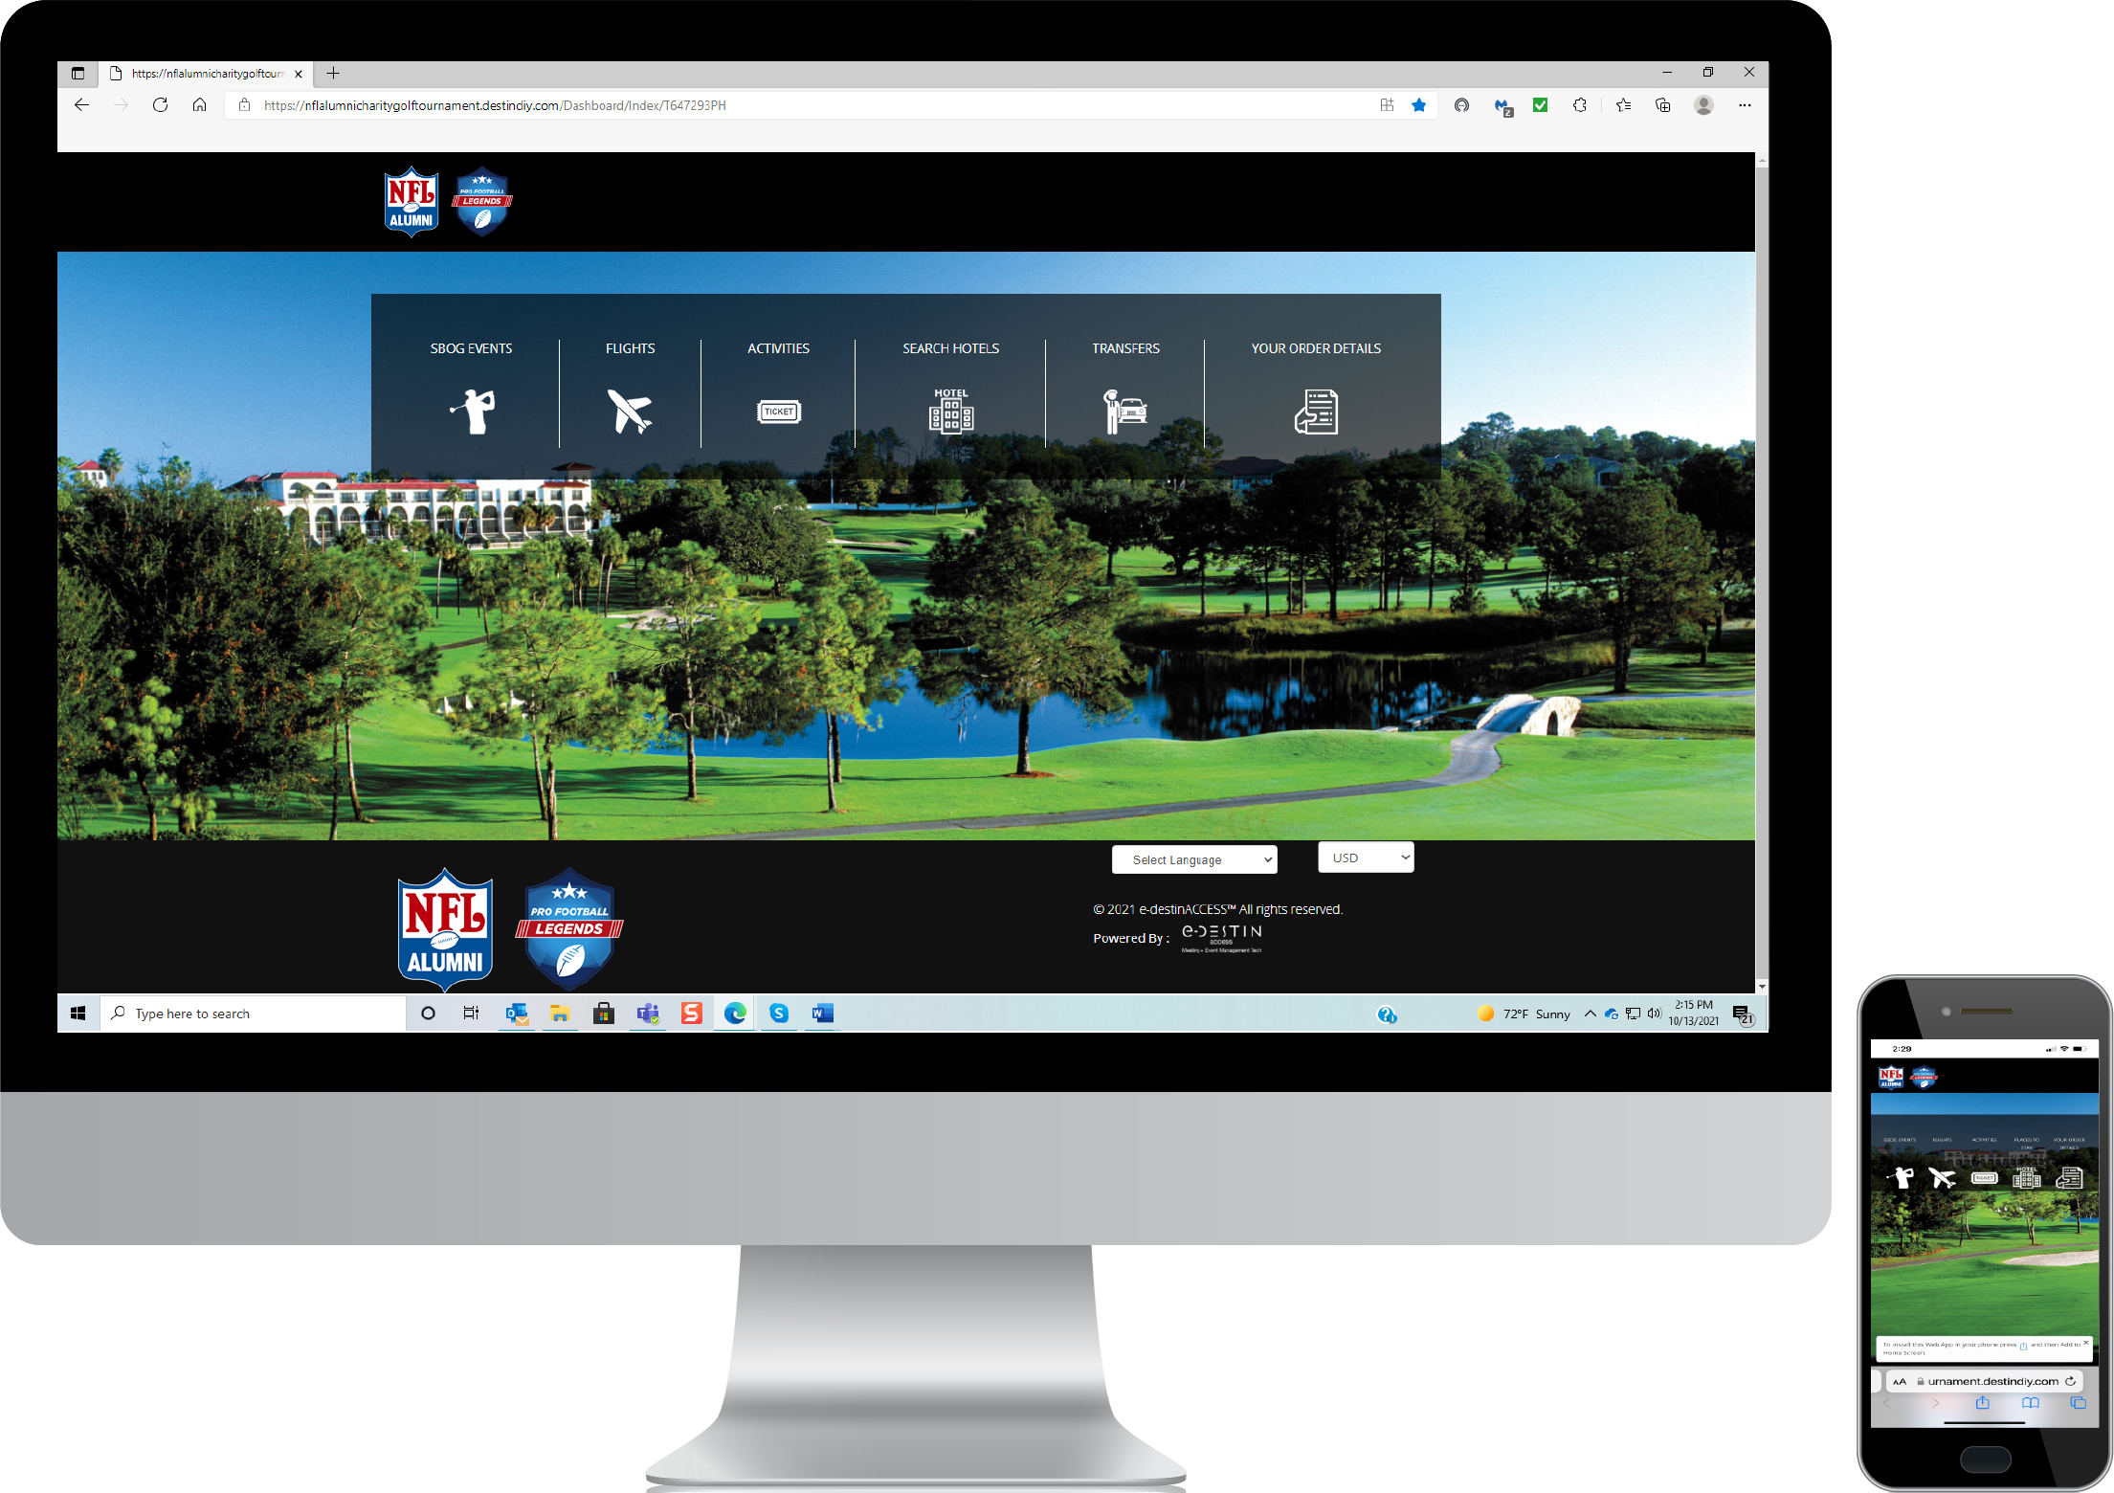

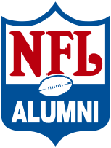
(TUCSON, AZ, October 14, 2021) Founded in 1967 by a small group of retired NFL players, the National Football League Alumni is the oldest, most well-known, and well-respected retired player organization in professional sports. Membership includes thousands of retired players, coaches, front office executives, spouses, cheerleaders, and avid fans across the country. It’s no wonder this prestigious group tapped the power of e-Destin® to support its largest event of the year—the 42nd annual “Super Bowl of Golf.”

“The DestinDIY® one-stop shopping features were particularly appealing to us,” said Krissy Garrett, Director of Chapter Relations for the NFL Alumni Association. “Our guests can book hotel, flights, ground transportation and even their practice round tee times on one platform.”

To the customer and event attendee, the front end is easy to use and very intuitive.

It’s the back end of DestinDIY® that especially appeals to meeting and event planners.

This one-of-a-kind, end-to-end solution for planners manages all aspects of meetings and events for organizations of any size. DestinDIY® helps planners improve their efficiency by up to 70%, saving time with a single-source digital tool designed to manage both group and individual bookings while also capturing revenue from shared commissions.

DestinDIY® has the flexibility to fully integrate multiple services—including HotelPlanner, FlyUs, Carey International, Tiqets and QuickBooks—to deliver a truly turnkey platform. Planners can create custom, dynamic event experiences with the ability to book group/individual rooms, air, exclusive Covid-19 at-home airport pickup and drop-off service, airport transfers and local activities.

According to Garrett, the DestinDIY® back end allows each NFL Alumni Chapter to manage their own event accounts, including apparel and signage orders, and accounting reports. This is especially valuable, she added, since the system aggregates all accounting in one place, which will simplify preparation for the year-end audit.

Training is underway for each of the NFL Alumni Association’s 43 chapters to easily brand and customize its own platform, as well as set up organizational hubs or individual events. NFL Alumni hold events ranging from golf tournaments to clay shoots, galas to board meetings, player, and cheerleader reunions—all of which are customizable on the e-Destin® platform. Researching and choosing local vendors enables regional NFL Alumni chapters to strengthen local economies and keep money with small vendors in each area.

Additionally, DestinDIY® provides a user-friendly planner dashboard that includes electronic proposal, contract generation, electronic signature, online registration, transportation scheduling, electronic departure notices and daily itinerary functions. In addition, financial forecasting, and cost reports, including program spreadsheets and final invoicing, are all available in real time.

Co-founded by proven destination management pros Wayne and Anita Beaubien,
e-DestinAccess is a meeting and event management technology provider that provides easy-to-use tools delivering end-to-end solutions that put planners in full power of their budget and ROI. e-Destin’s industry-leading products, developed in partnership with technology experts, are used to organize every facet of a group gathering, run insightful reports and access of-the-moment details any time, on any platform or device. All booked services are guaranteed, and e-Destin’s proprietary single-entry platform ensures mistake-free outcomes. Gains from significant time and cost savings allow planners to focus on the big picture while strengthening local economies.

For additional information, access the web site at www.e-destinaccess.com or call
1 (800) 605-5597.

# # #
Media Contact:
Wayne Beaubien
800.605.5597 ext. 101
wayne@e-destinaccess.com

