Stray Cat Finds Forever Home – and Becomes an Action Hero within Award-Winning Author's Fantasy Novel Titled Journey to Jumbalot

“The only thing bigger than his appetite was his heart.” That's how local award-winning author Ryan Wakefield described his best friend and the pet who changed his life. "I was just sitting on a patio chair one day and next thing I know, this large, loving cat jumped up into my lap. This unexpected visitor decided right then and there that he was staying with me, and I became a pet owner." He named his new friend Albert. "I was amazed at how large he was compared to other cats; he could easily push open my heavy sliding door when he wanted out and he even taught himself how to turn on the faucet to get a fresh drink of water." While amusing, Ryan says it was not so funny when Albert did that when he was at work...especially when the water bills arrived.

The two were fast friends for 13 years until Albert succumbed to poor health. That's when Ryan, an accomplished graphic artist, decided to make Albert the lead character in a new fantasy adventure novel to honor his memory.

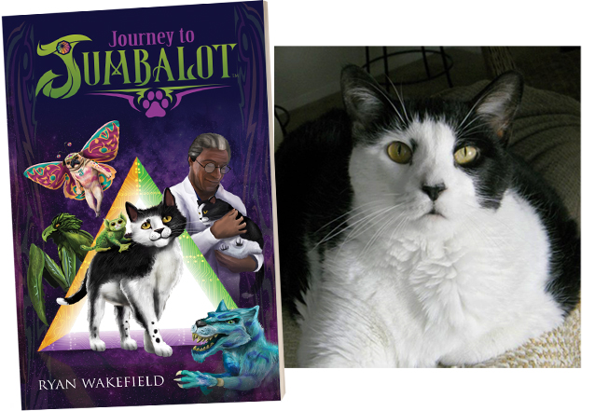

Ryan Wakefield always had a dream of writing a fantasy novel for young readers. Since he was young, he envisioned creating a fantasy world filled with colorful, hybrid animals. He loved the idea of blending two or three animals together to create a magnificent new species and dreamt about breathing life into a world filled with those creatures. That dream recently became a reality with the publication of his award-winning debut novel titled Journey to Jumbalot for young readers aged 11-14.

The book’s premise is about an engineer’s housecat, Alby, and his adventurous search for his missing friend named Professor Vincent Wizoom. Wizoom is a brilliant engineer and builds an unusual triangular doorway inside his laboratory. Following the completion of the doorway, Wizoom mysteriously vanishes. To Alby’s astonishment, the doorway opens independently and his compassion for his missing friend gives him the strength to venture through the door and finds himself transported to a strange, new world – Jumbalot. Jumbalot is not a typical fantasy world filled with dragons, elves, and goblins. No, Jumbalot is inhabited with hybrid animals called jumboos that include the following: menacing mantaravens, friendly froguars, courageous tigeroons, wise pandowls, and much more!

Ryan explained, “Young readers will find themselves cheering for an unassuming housecat to find the will to believe in himself and overcome overwhelming odds. The main protagonist, Alby, is initially doubtful of what he can do, but he discovers that the love for his friend gives him the strength to not only rescue him, but to stand up to a tyrant terrorizing the world of Jumbalot. During his journey, Alby learns about a belief system that most jumboos adhere to called Jumbaloo. The Jumbaloo Triangle focuses on three equal traits: compassion, bravery, and imagination. Alby learns to use all three during his adventure and I hope it teaches young readers the importance of self-confidence and overcoming insecurities.”

Journey to Jumbalot is the recent recipient of multiple awards including the following:

- Mom's Choice Award (Gold Recipient) for honoring excellence in family-friendly media, products, and services.
- Florida Writers Association’s Royal Palm Literary Awards (Gold Award) for published fantasy.

- Global Book Awards (Silver Medal) for children’s action and adventure category.

- Purple Dragonfly Book Awards (Honorable Mention) for new author: fiction category.

Ryan commented, “It’s a wonderful feeling to see my debut novel win awards and receive excellent reviews. More than anything, I love to hear young readers tell me how much they loved reading the book and the world of Jumbalot. I only wish I could pet Albert one last time and thank him for inspiring me to do this.”

View book trailers and an author interview: Ryan Wakefield - YouTube

Visit the following site to learn more about the novel: http://www.jumbalot.com

Journey to Jumbalot is available as ebook or paperback via Amazon: https://amzn.to/3rcg6aC

Ryan Wakefield
12821 Geneva Glade Drive
Riverview, FL 33578
ryjumbalot@gmail.com
727-412-2705

