PRESS RELEASE
For Immediate Release: Update October 6th 2021
Gallup Perfume Launches eCommerce Store

Perfume is Art. A Painting for The Olfactory Senses

Connecticut: Gallup Perfume announces the launch of their ecommerce store, customers
can buy a variety of handmade fine fragrances, handcrafted bath & body products, cosmetics, luxury
soap and perfume bars. Gallup Perfume, is an independent artisanal perfume house in Southeast
Connecticut, selling exclusively online. Only available in the US, Gallup Perfume prides itself on being a
small micro-batch perfumery, dedicating to producing unique high-quality fine fragrances you can’t find
anywhere else. All their perfumes undergo an aging process from a 6-week minimum, up to one year.
They use a wide variety of perfume ingredients from safe synthetics to the finest natural essential oils,
absolutes and tinctures in a multitude of blended varieties. From 100% safe synthetic blends to 100%
natural perfumery, along with every combination in between. We wanted to establish a variety of price
points so everyone can afford to partake in the wonderful world of indie perfume and find their own
unique signature scent, the painting they will fall in love with.

Gallup Perfume launched originally in May of this year with two scents and a backlog of scents
(Currently being aged) due to a year delay in opening, which was originally planned for Spring 2020.

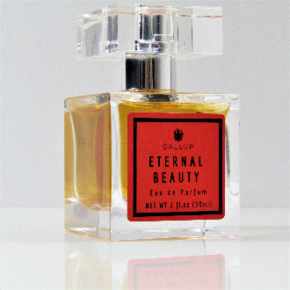
Released in May 2021
Eternal Beauty Eau de Parfum
Top Notes: Rosewood, Clementine, Black Pepper
Middle Notes: Egyptian Neroli, Jasmine, Sandalwood Mysore, Cinnamon
Base notes: Ambergris, Patchouli, Oakmoss, Pink Peppercorn, Vanilla Bean

Eternal Beauty is available on their website in 1oz bottle, packaged exquisitely in a reusable gift box with
magnetic closure & tied ribbon bow, priced respectfully at $165.00. Also Available in 10ml Travel
Automizer Spray, packaged in cute tall box with ribbon bow closure, priced at $65.00

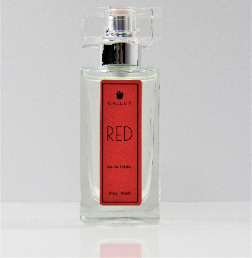
Released in May 2021
Red Eau de Toilette
Top Notes: Raspberry, Plum, Red Berries
Middle Notes: Gardenia, Rose, Jasmine
Base notes: Cedarwood, Russian Coriander, White Chocolate, Musk

Red is available on their website in 1.7oz bottle, packaged exquisitely in a reusable gift box with
magnetic closure & tied ribbon bow. priced respectfully at $135.00. Also Available in 10ml Travel
Spray, packaged in cute tall box with ribbon bow closure, priced at $55.00.

Released in September 2021
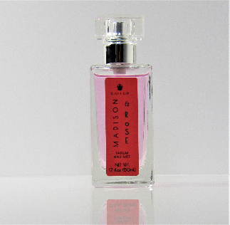
Madison & Rose Parfum Hair Mist
Top Notes: Ozone, Lemon
Middle Notes: Rose, Jasmine, Marine
Base notes: Sandalwood, Musk, Cedarwood, Cotton Candy

Madison & Rose is available on their website in 1.7oz size, packaged exquisitely in a reusable gift box
with magnetic closure & tied ribbon bow, priced respectfully at $85.00. Also Available in 10ml Travel
Automizer Spray, packaged in cute tall box with ribbon bow closure, priced at $40.00.

Eternal Beauty, Red and Madison & Rose by Gallup Perfume is available now on their website. To learn
more about their perfume, new release announcements you can follow them on facebook or instagram.
To purchase your favorite fragrance please visit www.gallupperfume.com

For further information, images or samples please contact:
Amyllia Gallup at Gallup Perfume
860-705-2218
info@gallupperfume.com
Visit www.gallupperfume.com for a full range of high-resolution image
Visit or follow us at:
Facebook https://www.facebook.com/GallupPerfumeShop/
Instagram: https://www.instagram.com/gallupperfume/

Note to Editors:
Gallup Perfume is an independent artisanal perfume house specializing in small micro-batch perfume,
currently sold, exclusively, in the United States. Customers may reach out to us for help in finding the
perfect unique perfume, to match their style or personality, for themselves or guide them in choosing
the best perfume gift for loved ones. We are also available for custom blended perfumes to suit individual
customer’s needs, along with an exclusive sale option.

