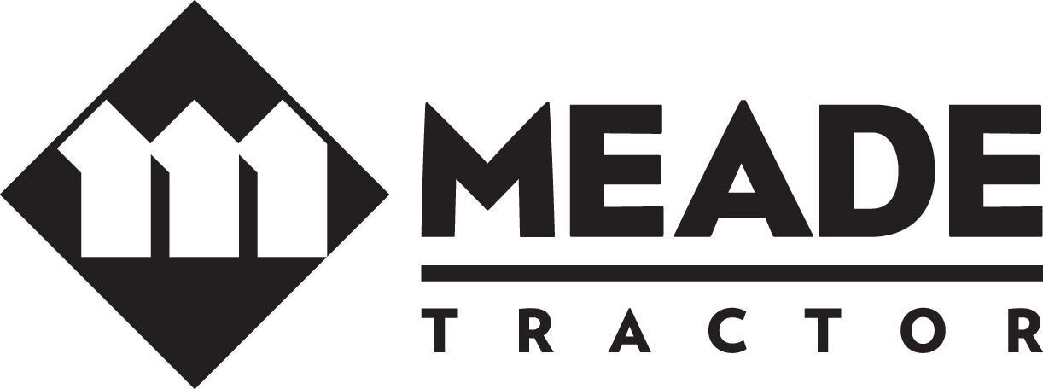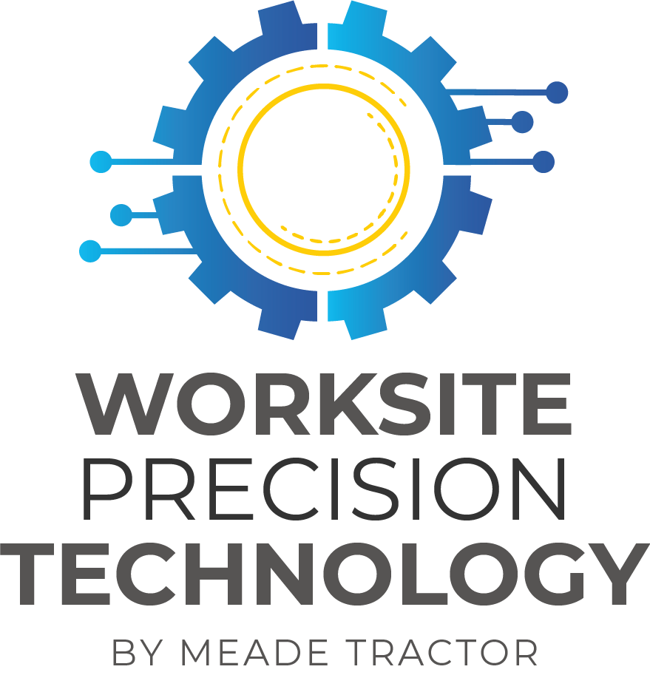
***PRESS RELEASE***
FOR IMMEDIATE RELEASE CONTACT: Matthew Bennett, General Manager Technology
NOVEMBER 17, 2021 matthew.bennett@meadetractor.com
502-253-3721

MEADE TRACTOR AND TOPCON JOIN FORCES TO BECOME A FULL-LINE TOPCON OEM DEALERSHIP AT ALL TENNESSEE AND KENTUCKY LOCATIONS

SULLIVAN COUNTY, TN – November 17, 2021 – ar
Meade Tractor is excited to add Topcon to its line of Worksite Precision Technology, which provides customized solutions to customers for maximum productivity, increased uptime, accuracy, and efficiency, including Topcon’s machine control and positioning technology.
Matthew Bennett, GM Technology said “This agreement will enable Meade Tractor to install Topcon grade control technology on additional manufacturer brands of earthworks equipment. We are pleased to expand service to our customers and are confident that increased access to affordable technology will increase their productivity. I believe this is a mutually beneficial arrangement for Meade Tractor, Topcon Positioning Group, and our customers.”

For more information about Meade Tractor, visit MeadeTractor.com

######

