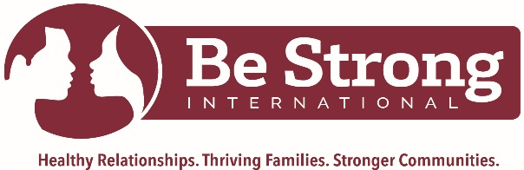

FOR IMMEDIATE RELEASE
CONTACT:
Monika Sanchez, monika@bestrongintl.org
Maria Mendez, maria@bestrongintl.org

Be Strong International to Host Their Annual Winter Charity Gala
in Support of Miami’s Individuals, Families and Communities.
The event will highlight the true reason for the season, at the spectacular waterfront
The Rusty Pelican in Key Biscayne, FL.

Miami, FL (November 17, 2021) – Be Strong International will host its Winter Charity Gala on Tuesday, November 30th at The Rusty Pelican, located at 3201 Rickenbacker Causeway, Key Biscayne, FL 33149. As part of their ongoing fundraising efforts, the Winter Charity Gala is the biggest event of the year, where Miami’s philanthropists meet to celebrate the tremendous impact their donations will have among the most vulnerable populations living in South Florida.

“We are excited to have our annual Winter charity event to help us continue all the services we bring to the community. We aim to become a national service provider that focuses intently on seeing individuals, families and communities become whole”, said Michelle Shirley, CEO of Be Strong International. “Teaching the importance of heart skills education is our main goal, and only with community support, can we continue to make this goal a reality”, Shirley added.

This year, it is our honor to announce that we will have Palmetto Bay's Mayor, Karyn Cunningham, as our host. We will also have Dr. Delvena Thomas from WEDR-99 JAMZ, among our marvelous speakers during the evening, along with other amenities.

During the event, anyone can make a philanthropic impact by making a financial gift of any amount to the organization. Proceeds from ticket sales and all donations will directly benefit high need and low-income families. Be Strong International will invest in the expansion of programs and services that serve at-promise communities through increased organizational capacity and reach.

Tickets are now available on Eventbrite, Be Strong International's Winter Charity Gala | Reason For The Season Tickets, Tue, Nov 30, 2021 at 6:00 PM | Eventbrite
For more information and updates, follow Be Strong International on social media @bestrongintl or through their website https://bestrongintl.org
###

`
About Be Strong International

Be Strong International is a leading non-profit that educates young people and parents through positive practices. Mrs. Althea McMillan, a retired Miami-Dade County Public Schools teacher, founded the organization in 1992. For more than a quarter-century, Be Strong International have provided youth and families in South Florida with tools to make better decisions about relationships, money, work, and family life. The organization uses evidence-based curricula to teach adolescents and parents about strategies for building healthy relationships. We deliver educational programming to students and parents online, and in-person throughout Miami-Dade and Broward County.

