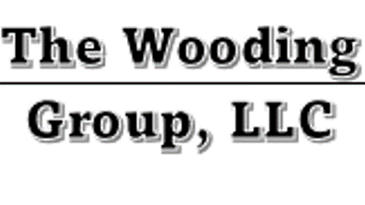
FOR IMMEDIATE RELEASE
November 19, 2021
Contact:
Randy T. Wooding, MSPM, PMP
rwoodingoffice@gmail.com
Local Business Owner Randy Wooding Named to NSBA Leadership Council
South Holland, IL – Randy Wooding, The Wooding Group, LLC, was recently named to the National Small Business Association (NSBA) Leadership Council. NSBA is the nation’s oldest small-business advocacy organization and operates on a staunchly nonpartisan basis. Wooding, a recognized leader in the small-business community, joins the NSBA Leadership Council alongside other small-business advocates from across the country as they work to promote the interests of small business to policymakers in Washington, D.C.
“As a small-business owner, I see daily the importance of being involved and active when it comes to laws and regulation,” stated Wooding. “Joining NSBA’s Leadership Council will enable me to take our collective small-business message to the people that need to hear it most: Congress.”
Randy Wooding is the Principal Consultant of The Wooding Group, LLC that specialize in technology project management, teaching business professionals and providing business consulting services for operational improvement and realizing ROI in technological capital investments.
Wooding joined the NSBA Leadership Council as part of his efforts to tackle the many critical issues facing small business, including tax reform, regulatory restraint, health care costs and how the Affordable Care Act will impact small business. The NSBA Leadership Council is focused on providing valuable networking between small-business advocates from across the country while ensuring small business a seat at the table as Congress and regulators take up key small-business proposals.
“I am proud to have Randy Wooding as part of our Leadership Council,” stated NSBA President and CEO Todd McCracken. “He came to us highly recommended, and I look forward our coordinated efforts for years to come.”
For more on the NSBA Leadership Council, please visit www.nsba.biz

###

