LEADING BY EXAMPLE: Dr. Tommy R. Nash, Virginia businessman, speaker, and author, immeasurable expertise has given way to a progressive, thriving COGA (Child of God Always) – Leadership Intelligence Creates Leadership Champions

Do nothing out of selfish ambition or vain conceit. Rather, in humility value others above yourselves. (Philippians 2:3 NIV)

A PROVEN LEADER

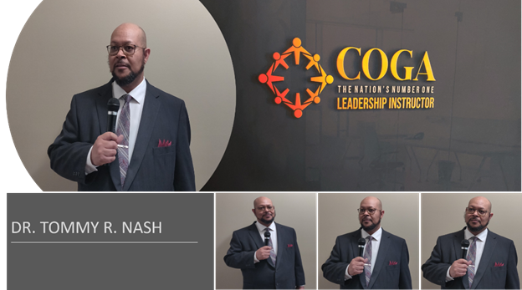
A TRUE INSPIRATION — A progressive, thriving business endeavor that is a little more than three years removed from its ceremonious inception, Dr. Tommy R. Nash’s COGA – Leadership Intelligence Creates Leadership Champions customarily offers a variety of services, most notably what it known as Kick It Up Keynotes, Insight Through Interviews, and Constructive Consultation.

To his distinctly unique credit, Dr. Tommy R. Nash’s business venture officially went into operations in 2018. Nevertheless, his remarkably brilliant expertise surrounding his feature endeavor dates back to the early 1980’s, to put it more precisely. I’ve been teaching and speaking about leadership for 40 years.

COGA – Leadership Intelligence Creates Leadership Champions offers credible presentations, including what is known as Into Your Purpose, Team Enablement, and Redefining Leadership, as mentioned on the company’s website at https://coga-leadershipchampions.com/.

A native of Duck Hill, Mississippi — a rural Montgomery County establishment that is comprised of 1,102 residents, according to the latest U. S. census — Dr. Nash emphasized, among other things, that his strategic mission through his featured endeavor is centered largely on ensuring that individuals and businesses fully grasp a thorough concept of the entire leadership complement.

You are here by purpose, not by circumstance! Always be the best version of oneself! I am a forward-thinking program, operations, business executive, and a 25-year U.S. Naval officer, who offers a wealth of industry, military, and organizational leadership experience, strong business understanding, and well-documented history of advancing the strategic direction of an organization. Many organizations experience a lack of organizational leadership; specifically, effective leadership, communication, and leadership ethics. I assist my clients through guidance, mentorship, and instruction. We work together to propel clients’ lives and careers to the next level with intention and ownership. I streamline operations by driving team cohesion, cultural diversity, inclusion delivering a top-tier workforce.

I am a professional speaker. Nothing compares to the power of action and as an organizational leadership speaker speak at various forums and settings. I thrive by creating innovative workshops and interactive keynotes to ensure that clients and organizations are ready for the next level of leadership. My brand, leadership champions and experts detail the fullness of my intentions. I assist my clients through guidance, mentorship, and instruction. We work together to increase leaders’ leadership effectiveness, enabling them to create paths from where they are to where they want to be.
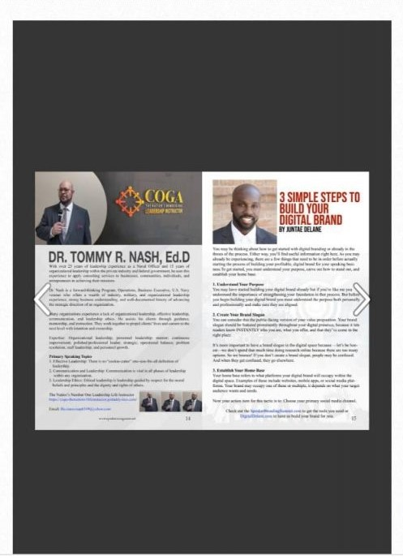

A longtime federal government employee, Dr. Nash earned a Bachelor of Science Degree from Southern Illinois University at Carbondale. Consequently, he acquired a Master of Business Administration from Strayer University, and Doctorates from Argosy University.

Dr. Nash’s competitive drive throughout life greatly propelled him for overseeing the day-to-day operations of COGA – Leadership Intelligence Creates Leadership Champions. Some things that drove him to start his business are: His vision to transform leaders and society. Contrary to popular belief, not everyone who becomes an entrepreneur is driven solely by a profit motive. He was and never has been driven by money. Some business owners have a strong desire to improve the lives of others and Dr. Nash continually believes that helping others is his purpose or calling, whether it be individuals, organizations, or communities.

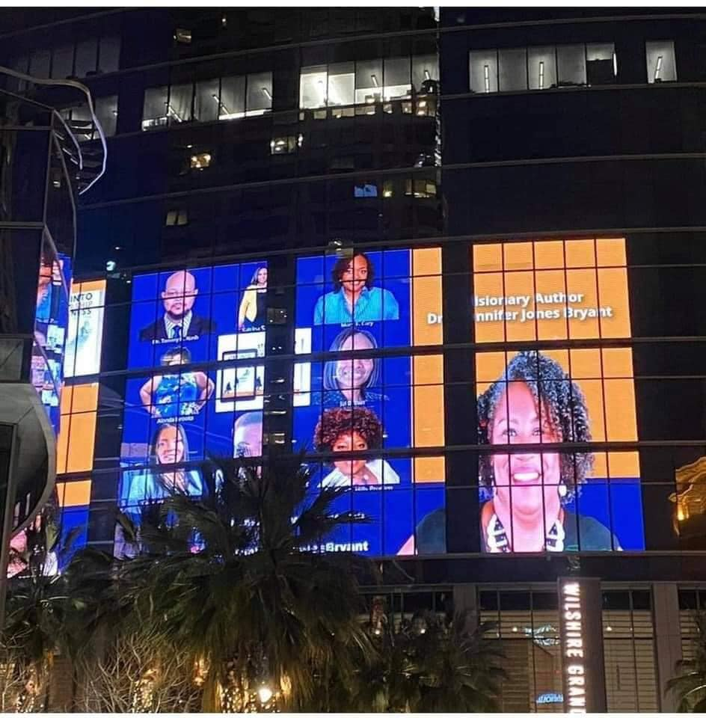Author Highlights: One of Dr. Nash’s latest authorship contributions are displayed in Dr. Jennifer Jones Bryant’s Step Into Leadership Greatness: Leadership Isn’t Just A Title, a book that made its official release in March 2021. In addition, he has authored The Leading Edges: Leading From The Front, Back, Sides, And Top To Bottom Leadership Intelligence Creates Leadership Champions.

Interestingly enough, Dr. Nash appropriately describes as a Sense of Achievement...Upon establishing his business, he began working toward achieving his goals. Flexibility…He enjoys working for himself and not others. Creation of Wealth…Another key and strategic factor that has given way to sustained success of COGA – Leadership Intelligence Creates Leadership Champions.

Dr. Nash further states that Being profitable is an inherent motive of an entrepreneur. He explains that most business owners want to earn profits. However, he reiterates that this was not the primary initiative for starting his business. Furthermore, few professions generate the wealth that a successful business can generate.”

As for the age the age groups to whom his business caters, Dr. Nash acknowledged that he would like to propose that he has no specific age group for whom he provides leadership assistance. He says this because leadership knows no age, race, or gender. Leadership abilities simply shine when given the right opportunity. Situations can sometimes present at just the right time and with the right project and at these moments people can demonstrate their innate abilities to lead.

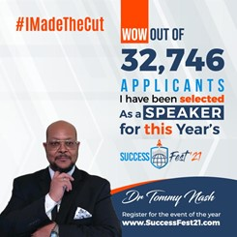
A MASSIVE GAME CHANGER — Leadership Intelligence Creates Leadership Champions offers credible presentations, including what is known as Into Your Purpose, Team Enablement, and Redefining Leadership, as mentioned on the company’s website at https://coga-leadershipchampions.com/.

A thriving, progressive business that is steadily generating a nationwide presence, Dr. Nash stressed that his personal mission through COGA – Leadership Intelligence Creates Leadership Champions is centered largely on working is to increase leadership effectiveness, enable business, organizations, communities, and individuals’ knowledge commitment, and maximize the transfer of successful leadership.

(COGA) Leadership Intelligence Creates Leadership Champions’ vision is to become the nation’s premier leader of professional speaking and leadership consulting, transforming humanity through inventive and innovative performances, enrichment, approaches, which are combined with corroboration procedures that are unified, customer-centric, and certifiable.

Dr. Nash further states that it is vital that he continues to inspire others, especially, leaders, aspiring leaders, organizations, communities, and others because many organizations experience a lack of organizational leadership; specifically, effective leadership, communication, and leadership ethics. There are many who inspired him to take part in this line of work: Les Brown, Dr. Will Moreland (His Personal Coach), Dr. Jennifer Jones-Bryant, and Shawn Fair are among the notable names.

Virginia businessman, Dr. Tommy R. Nash is savoring sustained entrepreneurial success as the face of COGA Life Instructor, gifted author.

A man’s gift makes room for him and brings him before great men. (Proverbs 18:16 NKJV)

For more information about Virginia Businessman/Author Dr. Tommy R. Nash of COGA – Leadership Intelligence Creates Leadership Champions, to inquire his services, to schedule him for a public appearance, book signing, or speaking engagement:

Phone: 540.498.2546
Facebook: https://www.facebook.com/dr.tommy.r.nash
LinkedIn: https://www.linkedin.com/in/dr-tommy-r-nash-coga-leadership-champions/
Website: https://coga-leadershipchampions.com/.
Email to: Businessman6349@yahoo.com.

