Cassie Sanchez

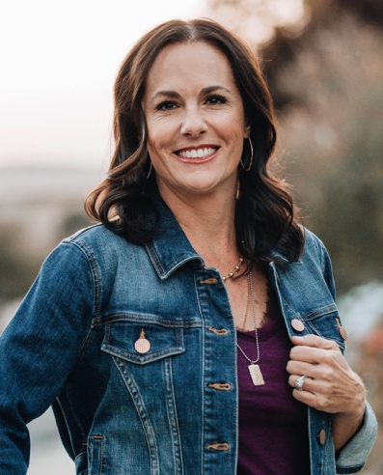
Bio

Cassie Sanchez grew up in Albuquerque, New Mexico, graduating from the University of New Mexico with a degree in marketing. Married to her husband, Louie, Cassie decided to leave the corporate world and become a stay-at-home mom, raising her two sons, Tyler and Chase.
Writing a novel had swirled in the back of Cassie’s mind since she was young, but she didn’t pursue it until the empty nest loomed in front of her and vacant bedrooms had her asking “now what.” She ferociously learned the craft of writing and more than a year of characters arguing in her head, she finished her debut novel, Chasing the Darkness.
Her passions in life are her faith and family, and now writing—creating worlds where magic awaits. Cassie enjoys golfing with her husband, coffee, and pestering her two adult children.

Connect with Cassie Sanchez

www.cassiesanchez.com

www.facebook.com/cassiesanchezauthor

www.instagram.com/cassiesanchezauthor

www.twitter.com/CSanchez_author

BOOKS

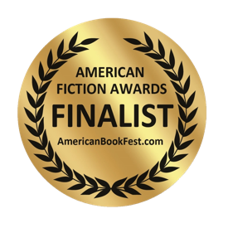
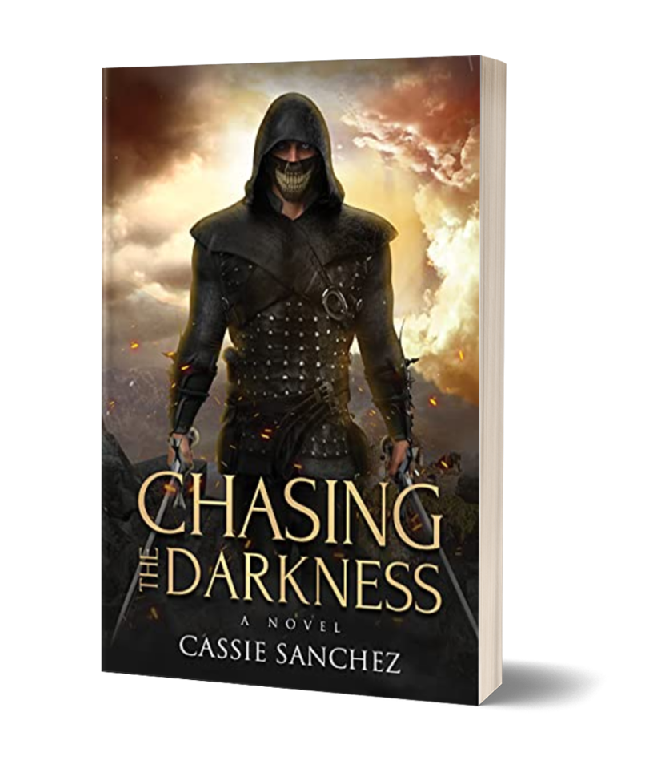
CHASING THE DARKNESS

Pain is inescapable. Suffering is a choice.

Azrael, the Angel of Death, knows pain. The deaths of his mother and sister, as well as his harsh experiences in the Watch Guard at age twelve, have brutally shaped him into the most feared assassin in all of Pandaren. Azrael’s role as a Hunter requires him to search for those with magic, called Spectrals, which he is happy to do. Hunting allows him to pursue his true goal—exacting revenge on the Fire Spectral who altered the course of his life.

Azrael’s obsession with revenge and power leads him to undergo an experimental procedure that gives him magic, but when this procedure has unexpected and dangerous side effects, he becomes a liability to the Hunters and the Watch Guard. Rescued by the people he has sworn to eliminate, Azrael finds himself questioning everything he once believed as years of secrets and lies are exposed. His very nature is challenged as he battles unfamiliar emotions and navigates relationships that contradict the heart of a killer.

Can the Angel of Death have a Conscience? Can Azrael?

Chasing the Darkness is an escape to a land of magic, sword fights, and love, with memorable characters who must face the darkness within and journey down a path of destruction or redemption.

AUTHOR: Cassie Sanchez
PUBLISHED: February 1, 2022
PAGE COUNT: 278
ISBN: 978-1631956096
PAPERBACK: $17.95

REVIEWS

“Sanchez’s series opener is a robust blend of fantasy and romance, seeded with twists for a consistently rewarding read…A well-balanced romance/fantasy that fans of both genres can enjoy.”
- Kirkus Reviews

“Chasing the Darkness is an imaginative fantasy adventure story with a vibrant cast and a storyline that is relentlessly entertaining. A fast-paced sword and sorcery adventure that was hard to put down. If you enjoy stories like The Witcher or Assassin’s Creed then you will find plenty to enjoy in this suspenseful fantasy novel that keeps things much more clean but loses none of the intrigue.”
- Literary Titan

“The twists and turns in Chasing the Darkness are simply delightful. Readers who like stories about sword-and-sorcery fantasy worlds where the hero is deeply flawed and transforms from evil to good; where love is a new possibility and redemption a driving purpose to life and justifying one’s actions; and where physical form, magic, and the desire for a life of love sometimes overwhelms purposes will find Chasing the Darkness compelling. Fantasy readers are in for a treat.”
- D. Donovan, Senior Reviewer, Midwest Book Review

“Chasing the Darkness is a beautiful read, as mysteries keep unfolding in each chapter. This book gets four out of four stars… I recommend it to lovers of medieval romance, action, and magic.”

- OnlineBookClub.org

“Chasing the Darkness is an action-packed epic fantasy novel written by Cassie Sanchez. Filled with action, intrigue, romance, and betrayal, Chasing the Darkness is a wild fantasy ride that keeps your eyes glued to the page. Author Cassie Sanchez weaves an intricate tale of power, revenge, and redemption that fans of epic fantasy will find thoroughly entertaining. The plot moves at a breakneck speed with twists and turns that keep you firmly engaged in the narrative. The characters have well-developed arcs and diverse personalities. I would recommend Chasing the Darkness to readers who love epic fantasy novels.”

- Pikasho Deka, Readers’ Favorite Book Reviews

“…readers find a significant and inspirational hero, transformed from a questionable, almost detestable one… Exciting and revelatory in its hopeful message that good triumphs over evil and that even the most deplorable character can change for the better, this book will engage readers of all ages.”

- Nicole Yurcaba, The US Review of Books

INTERVIEW TOPICS

- Inspiration for Chasing the Darkness
- My writing process
- Background
- Identity crisis and the empty nest
- What writing means to me

SAMPLE QUESTIONS

- What was your inspiration for Chasing the Darkness?
- How long did it take you to write the book?
- When did you learn you wanted to be a writer?
- How many books have your written?
- What resources did you use when learning the craft of writing?
- What does your family think of your writing?
- What do you think makes for a good story?
- What character is your favorite in Chasing the Darkness?
- What were some themes that were important for you in this book?
- What are you currently working on?

