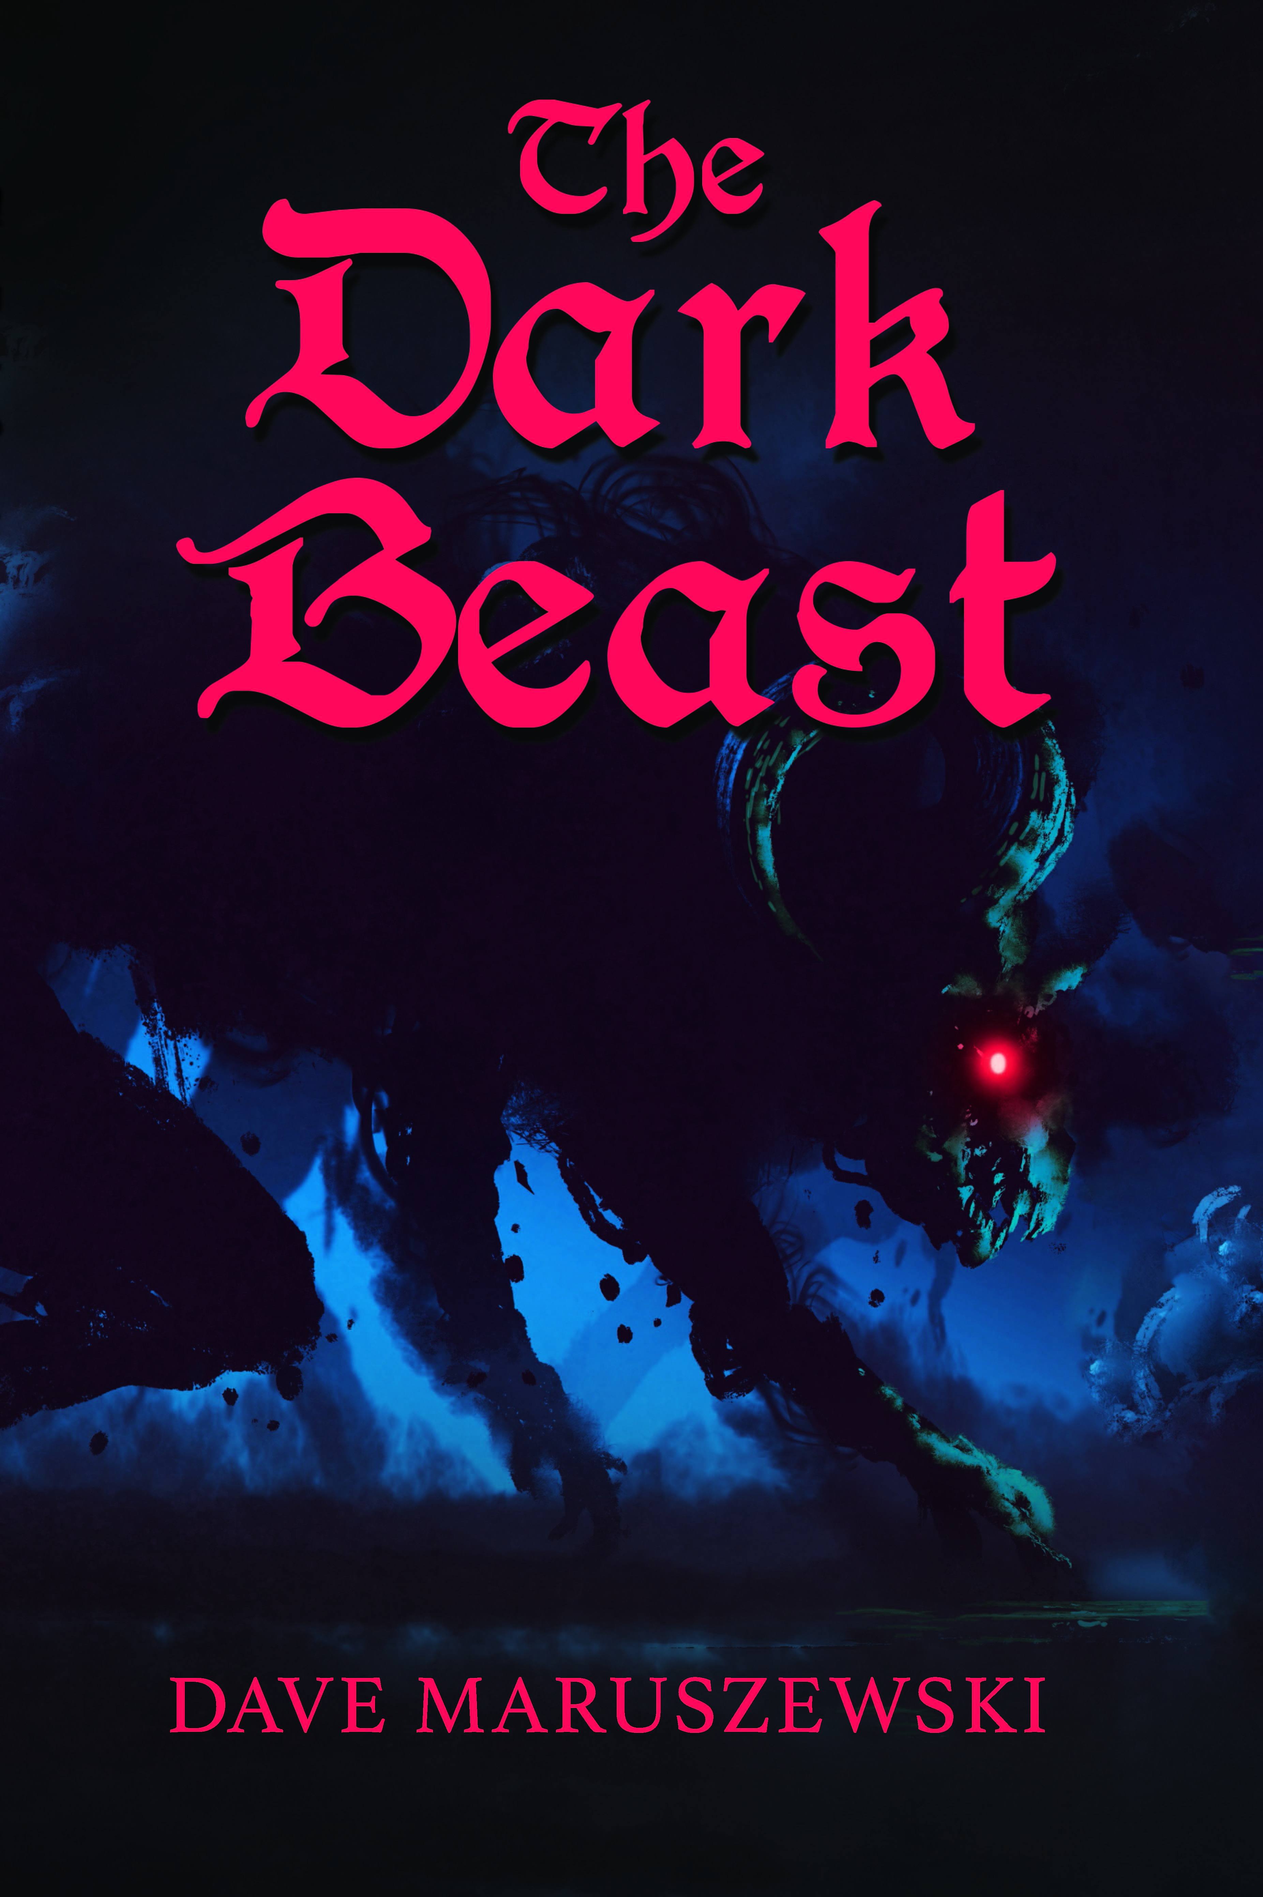
The Dark Beast
FOR IMMEDIATE RELEASE
Contact: Dave Maruszewski
digitaltumult@gmail.com
240-440-3446
www.ravenromdaandravai.com
www.digitaltumult.com
$9.99 Paperback/$3.99 E-Book
“With a fast-moving plot and exciting action scenes, Raven, Romda and Ravai: The Dark Beast will grab the attention of even the most restless young readers.” -The Book Review Directory
“The narrative is told in a readable, chronological manner, and the squires are appealing characters, as is their comical banter.” – BlueInk Review
Newcomer Dave Maruszewski will start a multi-book series for middle graders beginning with the exciting The Dark Beast. The Dark Beast is the first book of the Raven, Romda and Ravai series. This trio of newly knighted friends will embark on journeys of epic fantasy while dealing with everyday challenges that most youth face.
The book series will premiere on February 8, 2021 and focused on creating an enjoyable experience to those youth who normally don’t like to read. Shorter paragraphs, higher dialogue and focusing on interactions are some of the devices that are employed to encourage non-traditional readers.
As a person of a varied background, Dave employs aspects of all of his pursuits in this action-filled story. Dave Maruszewski is a former/current detonation physicist, teacher, painter, 3D modeler, animator, video game maker, software engineer, comic book dealer and engineering analyst.
This is available on Amazon as well as many other outlets through the Raven, Romda and Ravai website (ravenromdaandravai.com). Dave is available for interviews or guest writing. See contact information above.

