EnChroma Glasses That Help People with Color Blindness Now Offered at Best Buy

– Now Available on BestBuy.com, EnChroma Glasses Enable Those with Red-Green Color Vision Deficiency to See an Expanded Range of Clear, Vibrant Color –

Berkeley, CA & Minneapolis, MN – February 15, 2022 – EnChroma – creators of glasses for color blindness – and Best Buy Co. Inc. – today announced that EnChroma glasses are now available to millions of people who suffer from color blindness (Color Vision Deficiency) through BestBuy.com.

One in 12 men (8%) and one in 200 women (.5%) are color blind – 13 million in the US and 350 million worldwide. While people with normal color vision see over one million colors, the color blind only see an estimated 10% of hues and shades. To them, green and yellow, gray and pink, purple and blue, and red and brown look similar, and colors appear muted and dull. EnChroma glasses expand the range of colors the color blind can see and make colors more vibrant, clear and distinct to help them enjoy more of life’s colorful moments and overcome challenges at work, school and in everyday life.

“We are pleased that working with a world-renowned, trusted brand like Best Buy means color blind people will have more opportunities to buy, try and experience EnChroma glasses,” said Erik Ritchie, CEO of EnChroma. “This relationship will generate more awareness for the prevalence and effects of color blindness, and that there is something people can do – try EnChroma glasses.”
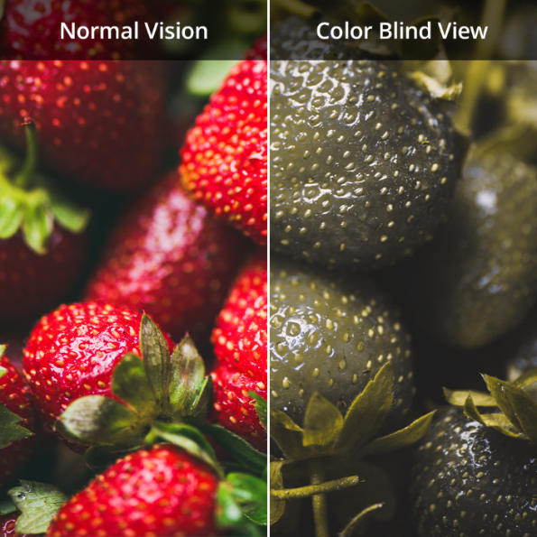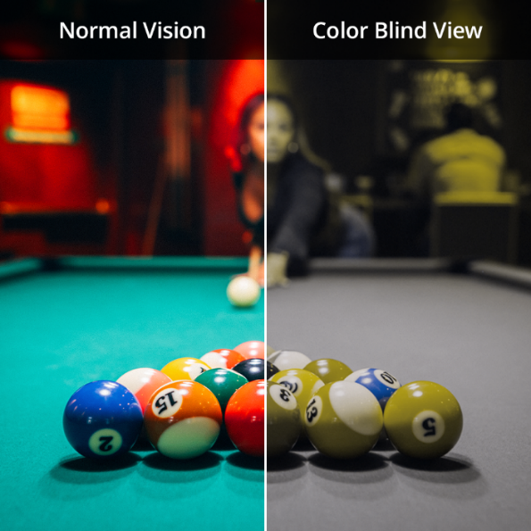
To view images depicting how people with color vision deficiency see colors, click here.

EnChroma glasses range in price from $229 to $389 and come in lenses for use indoors or outdoors and in child and adult-size frames. EnChroma glasses can benefit eight of 10 people with red-green color blindness. Results and acclimation times vary. The glasses can be tried risk-free and returned within 60 days for a refund.

Research on EnChroma glasses was supported by an SBIR grant from the National Institutes of Health (NIH). A recent study by the University of California, Davis, and France’s INSERM Stem Cell and Brain Research Institute, demonstrated the effectiveness of EnChroma’s lens technology. The glasses are offered by over 400 eyecare professionals worldwide and available at major museums, libraries, schools, universities and state and national parks for color blind guests and students to borrow.

About EnChroma
Based in Berkeley, Calif., EnChroma produces leading-edge eyewear for color blindness and low vision, and other solutions for color vision, sold online and through Authorized Retailers worldwide. Invented in 2010, EnChroma’s patented eyewear combines the latest in color perception, neuroscience and lens innovation to improve the lives of people with color vision deficiency around the world. EnChroma received an SBIR grant from the National Institutes of Health (NIH). It earned the 2016 Tibbetts Award from the U.S. Small Business Administration in recognition of the firm’s innovative impact on the human experience through technology, and the 2020 Innovation Award in Life Sciences from the Bay Area’s East Bay Economic Development Alliance. For more information call 510-497-0048 or visit enchroma.com.

Media Contacts:
EnChroma
Kent Streeb
Vice President, Communications & Partnerships
P: 530.908.9225
kent@enchroma.com

