GHV along with Tata Capital invests in Deeptek.ai, a Startup accelerated by GHV to Digitally transform Radiology Services globally

March 2022

The world has been disrupted in many ways in the last 3 years, with the onset of Covid-19. Lifestyles have drastically changed, and so have businesses. Several established business have suffered, while several new agile businesses have grown. While there are some industries that have suffered, healthcare is one industry that took center stage in last 3 years.

However, the opportunity this industry yielded was accompanied by tremendous pressure on the Healthcare system, infrastructure and personnel. There was a dire need to digitize, automate and streamline healthcare operations in this challenging time. This also presented an opportunity to Health-tech companies to disrupt the conventional processes and create value for the Hospitals, healthcare clinics, and patients, among the other key stakeholders in the industry.

One such company in Healthcare, Deeptek Inc (www.deeptek.ai), set on a journey less than 4 years ago, to understanding the processes and complexities involved in Radiology space, and is today pioneering the Radiology space by building disruptive AI solutions, which are helping the Hospitals and healthcare clinics in obtaining higher efficiency and accuracy in Radiology scans, along with enhanced reporting capabilities. Their Brand “Augmento” is a Cloud PACS solution for radiology imaging infused with Artificial Intelligence for medical image analysis and automating workflows. Their other products include Teleradiology solutions, and GENKI - X-Ray and CT Scans based AI-powered solution for Public Health Screening. It covers chest pathologies, including Tuberculosis and COVID19 like infections.

GHV, a global investment & innovation company headquartered in Singapore, works with disruptive companies such as Deeptek, and accelerate them to achieve the suitable product market fit, scalable business model, and build strong IP’s globally. GHV has been working with several Japanese Enterprises for their strategic collaborations in India, such as Maruti Suzuki, Marubeni, NEC, NTTData among many others. For Digital Transformation of Enterprises leveraging Indian Innovation, JETRO (Japan External Trade Organization, a government-related organization that works to promote mutual trade and investment between Japan and the rest of the world), has partnered with GHV, one of the pioneers working on the India-Japan Innovation collaboration.

Post joining GHV Accelerator in 2019, Deeptek achieved the key metrics that helped them raise capital within 8 months of acceleration. Investors such as NTTData, Nobori Ltd (Japan), and Pentathlon Ventures have backed Deeptek, along with GHV. Several global hospitals and healthcare clinics became their long term beneficiary of their product.

To help the startups achieve the growth metrics, GHV starts with evaluating the entrepreneurs “IKIGAI””, which helps mapping their passion, vocation, profession, and mission. Thereafter, GHV facilitates Strategic Collaborations, helps them build effective Go-to-market Strategies, and guides them on achieving the right product market fit, pricing, positioning, scalability models and much more. Earlier many Japanese Enterprises have collaborated with GHV for Innovation Investment advisory, Digital Transformation, India market entry, and setting up their incubators and accelerators. In 2021, GHV onboarded over 300 Japanese corporates in the network who intend to collaborate with Indian innovations.

This also helped Deeptek achieve its strategic vision, and also helped these Japanese enterprises with a collaboration that would not only have short and medium term bottom line impact through Digital Transformation, but also lead to long term value creation at bottom line level for the Enterprises (Hospitals and Healthcare Clinics), along with investment growth.

Traction & Achievements
- 150+ Hospital & Medical Imaging Centres as paying customers across India, Japan and APAC
- Research Overview: 14+ Publications, 25+ Research Presentations, 7 Patents, 6 White Papers
  - Participated in the 52nd Union World Conference on Lung Health- Virtual Event
  - Presented at COVID-19 Late Breaker Session on “An Automated Deep Learning Based Approach for a two for one screening of TB and COVID 19
  - Presented Poster on “Gauging the severity of Covid-19 using computer-aided tools in hospital settings from assessment of digital chest radiographic findings and patient’s clinical parameters”
- Team of 100+ Employees and Consultants
- 55,000+ Scans processed per month
- Total 10Mn+ Scans (Over 100K annotated monthly Big & Rich Data)
- TiE 50 Winner (TiECon 2020)
- Nominated as Best Radiology AI Company 2019

Based on this growth story, Tata Capital, the investment arm of India’s largest conglomerate of market cap $160bn (TATA group) has invested in Deeptek along with GHV, to further empower and scale the company. With this round, DeepTek has raised a total of over $10M in funding. Pune-based Pentathlon Ventures and Singapore & Gurgaon-based GHV also participated in this round along with TCHF II.

“Our investment in DeepTek addresses the high growth radiology AI industry with several unmet needs. DeepTek is among the few radiology AI companies with cutting-edge medical imaging offerings and successful track record of commercial adoption. We are excited to partner with DeepTek and enable a larger impact going ahead “ said Visalakshi Chandramouli – Managing Partner, TATA Capital Healthcare Fund

According to Vikram Upadhyaya, founder, GHV Group – According to Vikram Upadhyaya, founder, GHV Group – “Leveraging GHV’s Digital Transformation Platform through Industry Co-creation, several startups and Enterprises are reaping the benefits and achieving a win-win long term sustainable association and a strategic value creation, not only for their respective bottom lines, but also for the Industry as a whole. I have known Ajit for a long time now, and appreciate his commendable track record. While investing in early stage businesses, we have always placed a high emphasis on team, and Ajit not only brings great experience, but also a great process oriented approach of building great businesses.

Deeptek Founders’ Profile

Ajit Patil
- Master from IIT Kharagpur in Industrial Engineering and Operations Research
- Co-Founder, CEO of Vertex Software – a Japan market focused software services firm which scaled to around 700 employees – had strategic equity investment from Mitsui & Co. Ltd. – Japan and exited to NTTDATA

According to Ajit – “Radiology AI is a huge global opportunity, however the industry is in its nascent phase currently. DeepTek is among the very few companies that have established clear value promotion, enabling strong global adoption. This funding allows us to invest further in our global outreach and also in securing important regulatory approvals”

Amit Kharat
- DNB, PhD (MSK), FICR
- Consultant MSK Imaging, Professor of Radiology DPU-Pune, PhD Guide + Established and ran teleradiology practice Cyber Tele Radiology Pvt. Ltd. with local & international customers
- 70+ publications, Scientific papers at ISS Hawai 2015, ECR 2015, RSNA 2014, Dubai 2104 Awards.
- Fellowship ICRI 2016, Ashok Mukharjee Oration 2014, K M Rai Oration 2017

“DeepTek’s AI-enabled radiology solutions transform radiology operations, enabling productivity growth by 3x to 5x. Today through our offerings, we touch over 500,000 patients every year and are well poised to grow from here” – said Dr. Amit Kharat – Co-Founder, CEO of DeepTek.

Deeptek Team Visual

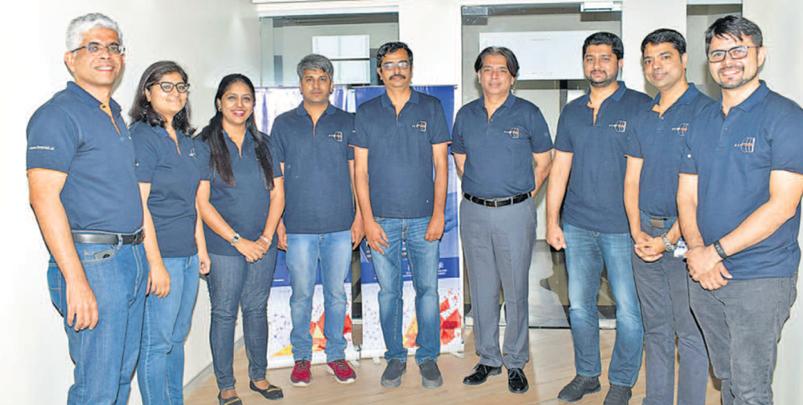

Deeptek Logo

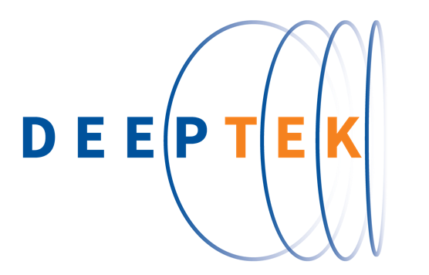

GHV Logo

