DSV Opens New One Million Square Foot, LEED Certified Facility near Dallas, Texas

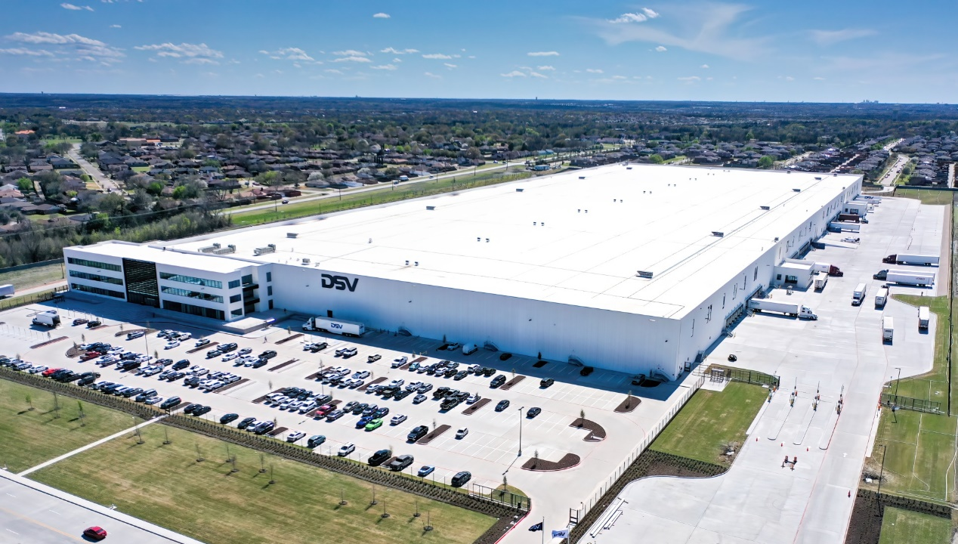

DSV’s new state-of-the-art, multi-client distribution center located in Lancaster, TX, just south of Dallas, offers one million square feet of warehouse and office space and supports over 90,000 pallet positions, 40-foot clear height, 130 dock doors and a 13,000 square foot temperature-controlled space.

The building and interiors are Leadership in Energy and Environmental Design (LEED) Certified.

The First of its Kind in the USA
This new Texas facility consolidates all activities within the company’s Solutions, Air & Sea, and Road operations into one location, which is a first in the United States. DSV is able to provide customers with a one source solution for warehousing, distribution, transportation, and value-added services across multiple industries, all under one roof.

Located in the Dallas-Fort Worth metroplex, the facility has access to DFW airport, major interstate highways and intermodal terminals. The logistics facility is a strategic hub for transport throughout the US and an excellent gateway for trade with Mexico.

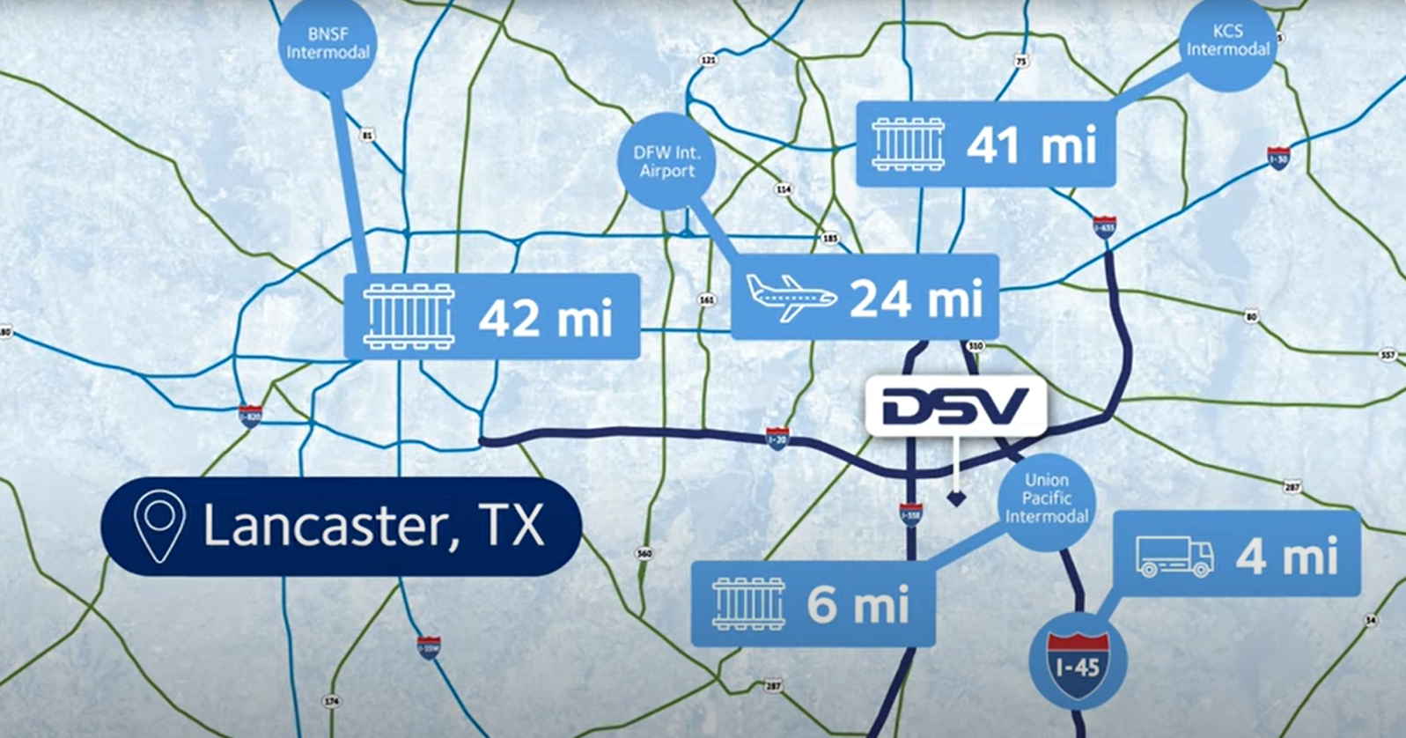

Key Features:
- One million square feet
- 90,000 pallet positions
- 40-foot clear height
- 130 dock doors
- 13,000 square feet of temperature-controlled space
- AIB, SQF, TSA certifications
- CTPAT certified
- LEED certified
- Perimeter fencing
- Video security system

About LEED Certification
LEED is a third-party green building certification program and the globally recognized standard for the design, construction, and operation of high-performance green buildings. Certification is based on standards for location and transportation, materials and resources, water, energy, and indoor environmental quality.

Press Contact
Rebecca Martin, Director of Marketing and Communication
Rebecca.martin@us.dsv.com

