The Alphabet Grand Prix Press Release

Andy Cox  (562) 986-0972  andy@wetduckpublishing.com  www.wetduckpublishing.com | FOR IMMEDIATE RELEASE

Who Will Win This Educational Pursuit?

[LONG BEACH, CA, April 25, 2022] First-time author Andy Cox and published illustrator Richard Kinsey team up for this children’s book that teaches the ABCs in an engaging way: through rhyme, alliteration, and detailed, colorful illustrations. Fatherhood and artistic expression drove Mr. Cox and Mr. Kinsey’s relationship, both of whom reside in Long Beach, CA. Their book is currently available through Wet Duck Publishing.

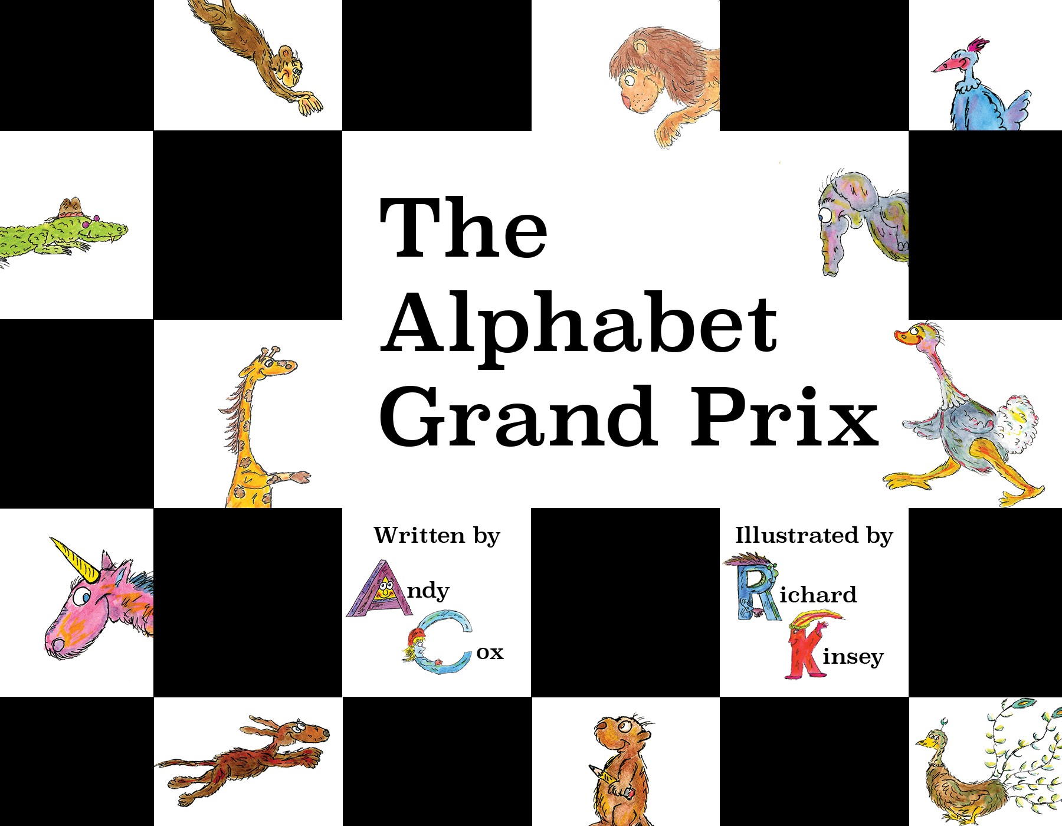
The Alphabet Grand Prix is heavy on alliteration and rhyme in its teaching of the ABC’s. Kinsey’s illustrations match the flow of the words and add alliterative animals to each personified letter that is behind the wheel. The concept of the book is designed to be read to young children who are beginning to grasp letters, but skilled readers still find joy in the details of this picture book.
“This cheerful book offers whimsical elements and includes unusual terms like jalopy and vehicle manufacturer names that car-racing fans will enjoy spotting. The friendly, quirky-looking creatures are appealing, and the text’s tight focus on alphabet concepts offers learning opportunities…A lively educational book that will particularly appeal to animal and car enthusiasts.” — Kirkus Reviews

The Alphabet Grand Prix is available for purchase on www.wetduckpublishing.com as of Monday, April 25, 2022.

Andy Cox is a first-time author, with aspirations to adapt several remaining ideas into published works. His style has long been appreciated in his local community, but he now sends his work to the world. Richard Kinsey is an awarded actor and artist, whose credits include Javert (Les Miserables on Broadway) and 6 published children’s books. Richard continues to work as an artist with ongoing projects in the United State and United Kingdom.

For more information, please visit www.wetduckpublishing.com.

