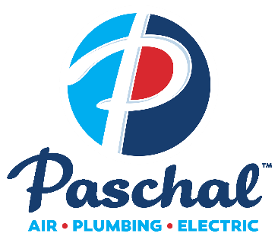
Contact: FOR IMMEDIATE RELEASE
Shanda Hunter
Communications Lead
Ph: 479.957-7866
shunter@gopaschal.com

Paschal Air, Plumbing & Electric expands to Hot Springs, Arkansas
Following Acquisition of GTS Inc. Heating and Cooling

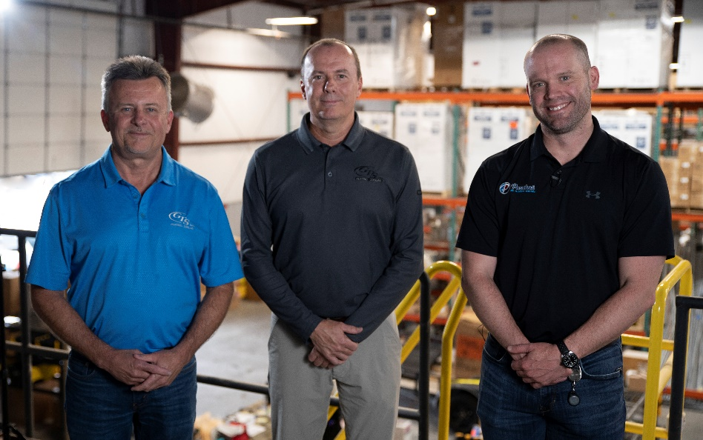
Pictured left to right, Mike Gibson and Joe Gibson of GTS and
Charley Boyce, Owner & CEO of Paschal Air, Pumbing & Electric.

Springdale, Arkansas – May 9, 2022 Paschal Air, Plumbing & Electric, Arkansas’ leading provider of home comfort services and replacements, is proud to announce we are growing to Hot Springs, Arkansas, following the acquisition of GTS Inc. Heating and Air.

GTS was founded in 1994 by Curtis Gibson and was most recently owned by Curtis’ two sons Mike Gibson and Joe Gibson. Paschal is proud to continue the tradition of quality, professional service GTS has been providing to Central Arkansas.

Paschal is a home services company based out of Northwest Arkansas. We have around 250 team members across six locations in Arkansas and Missouri, with a service fleet of more than 160 vehicles. Paschal has been blessed with significant growth over the last ten years, including recent acquisitions in Carthage, Missouri, Searcy, Arkansas and now Hot Springs.

”We have been looking to expand Paschal further into Arkansas for a while now, but wanted to find a company with the same customer-focused and employee-first reputation. We are excited to find those qualities at GTS and will continue to build on their already stellar reputation,” said Paschal owner and CEO Charley Boyce.

Paschal will combine our highly-trained, professional people with those of the same caliber from GTS to deliver world-class air, plumbing and electric services and installation.

ABOUT US

Paschal Air, Plumbing & Electric is dedicated to providing Professional People and Professional Service to the communities we’ve served for more than 50 years. With locations in Northwest Arkansas, Fort Smith River Valley, Central Arkansas & Southwest Missouri, we are committed to sustaining our 5-star reputation of providing trusted, unrivaled customer service and top-notch workmanship across the region.

