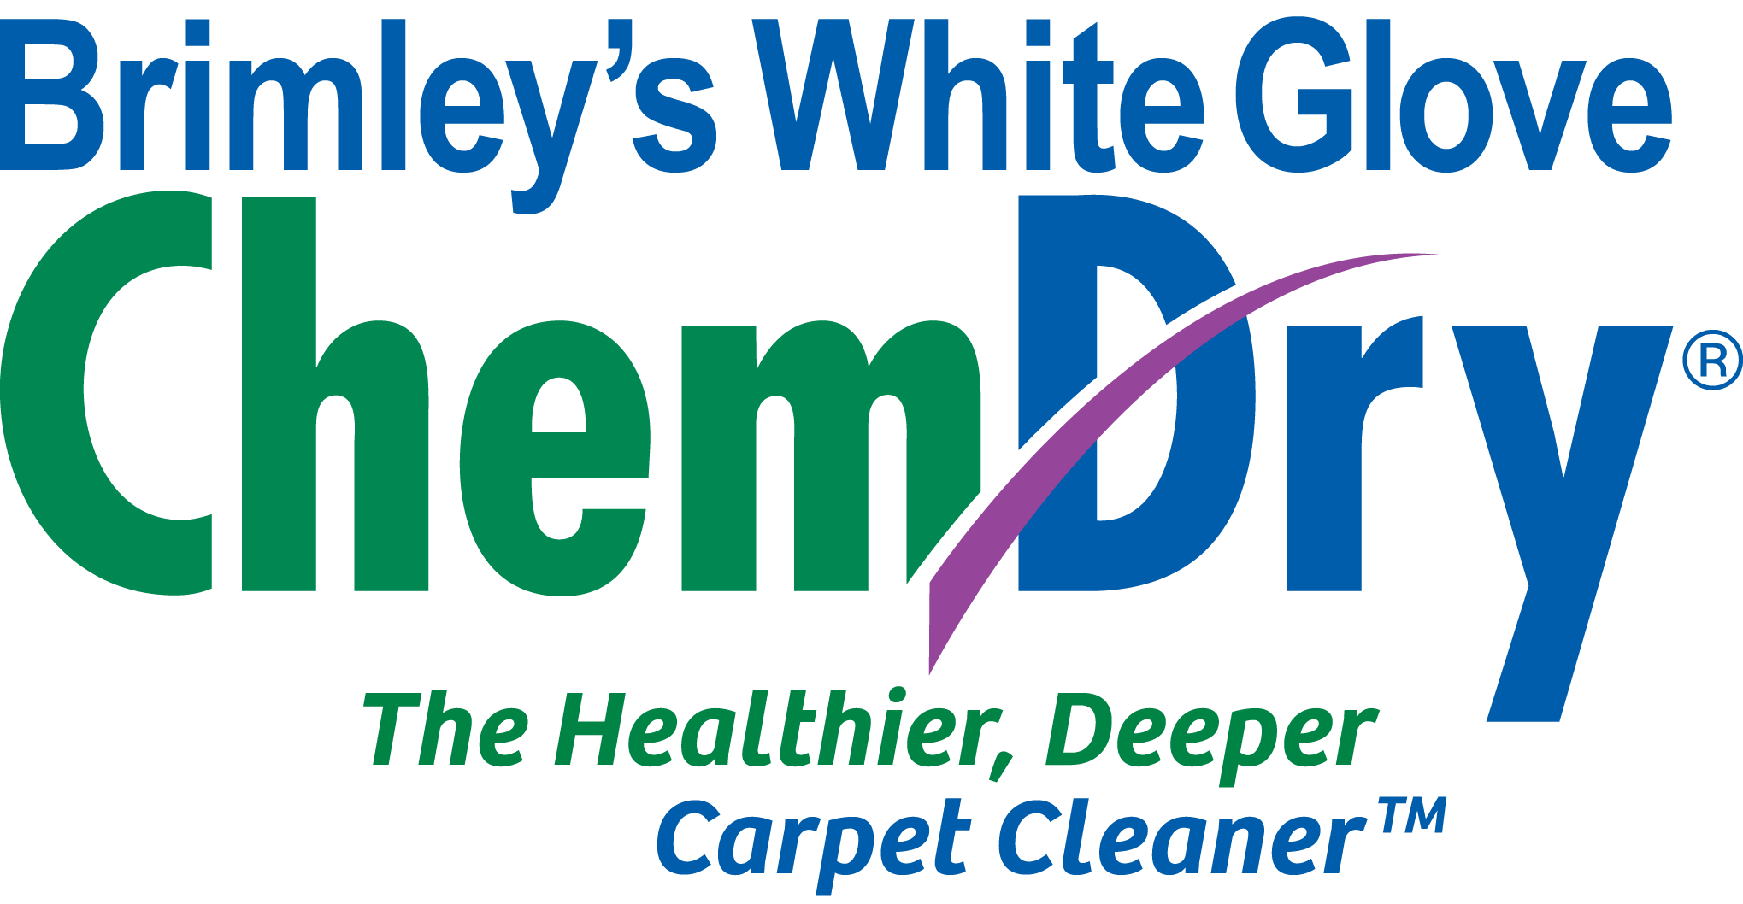
For Immediate Release Mike Court, Owner
5/9/2022 (480) 388-7708
mike@whiteglovecarpet.com

Mesa Carpet Cleaning Company Wins National Franchise of the Year Award

MESA, AZ 5/9/2022 - Brimley’s White Glove Chem-Dry has been named the National Franchise of the Year for 2022 at the most recent Chem-Dry national convention in Austin, TX.
- By winning the award, Brimley’s White Chem-Dry was recognized as one of the best of a national network of 1800 franchises, with Chem-Dry constituting the largest market share in the carpet cleaning industry.
- The award will allow Mike to participate in corporate-level meetings as a representative on the “Voice of Chem-Dry” board, which seeks franchise input on a number of different topics, ranging from national marketing campaigns to new equipment initiatives.
- Brimley’s will also be recognized as a national award winner on the Chem-Dry website among the list of other franchises under the “find your local franchise” listings.
- Brimley’s White Glove Chem-Dry has been in business in the valley since 1994. The company is family-owned, with Michael Court taking over the business in 2006 from his father, Steve Court, who went on to serve in the Arizona legislature.
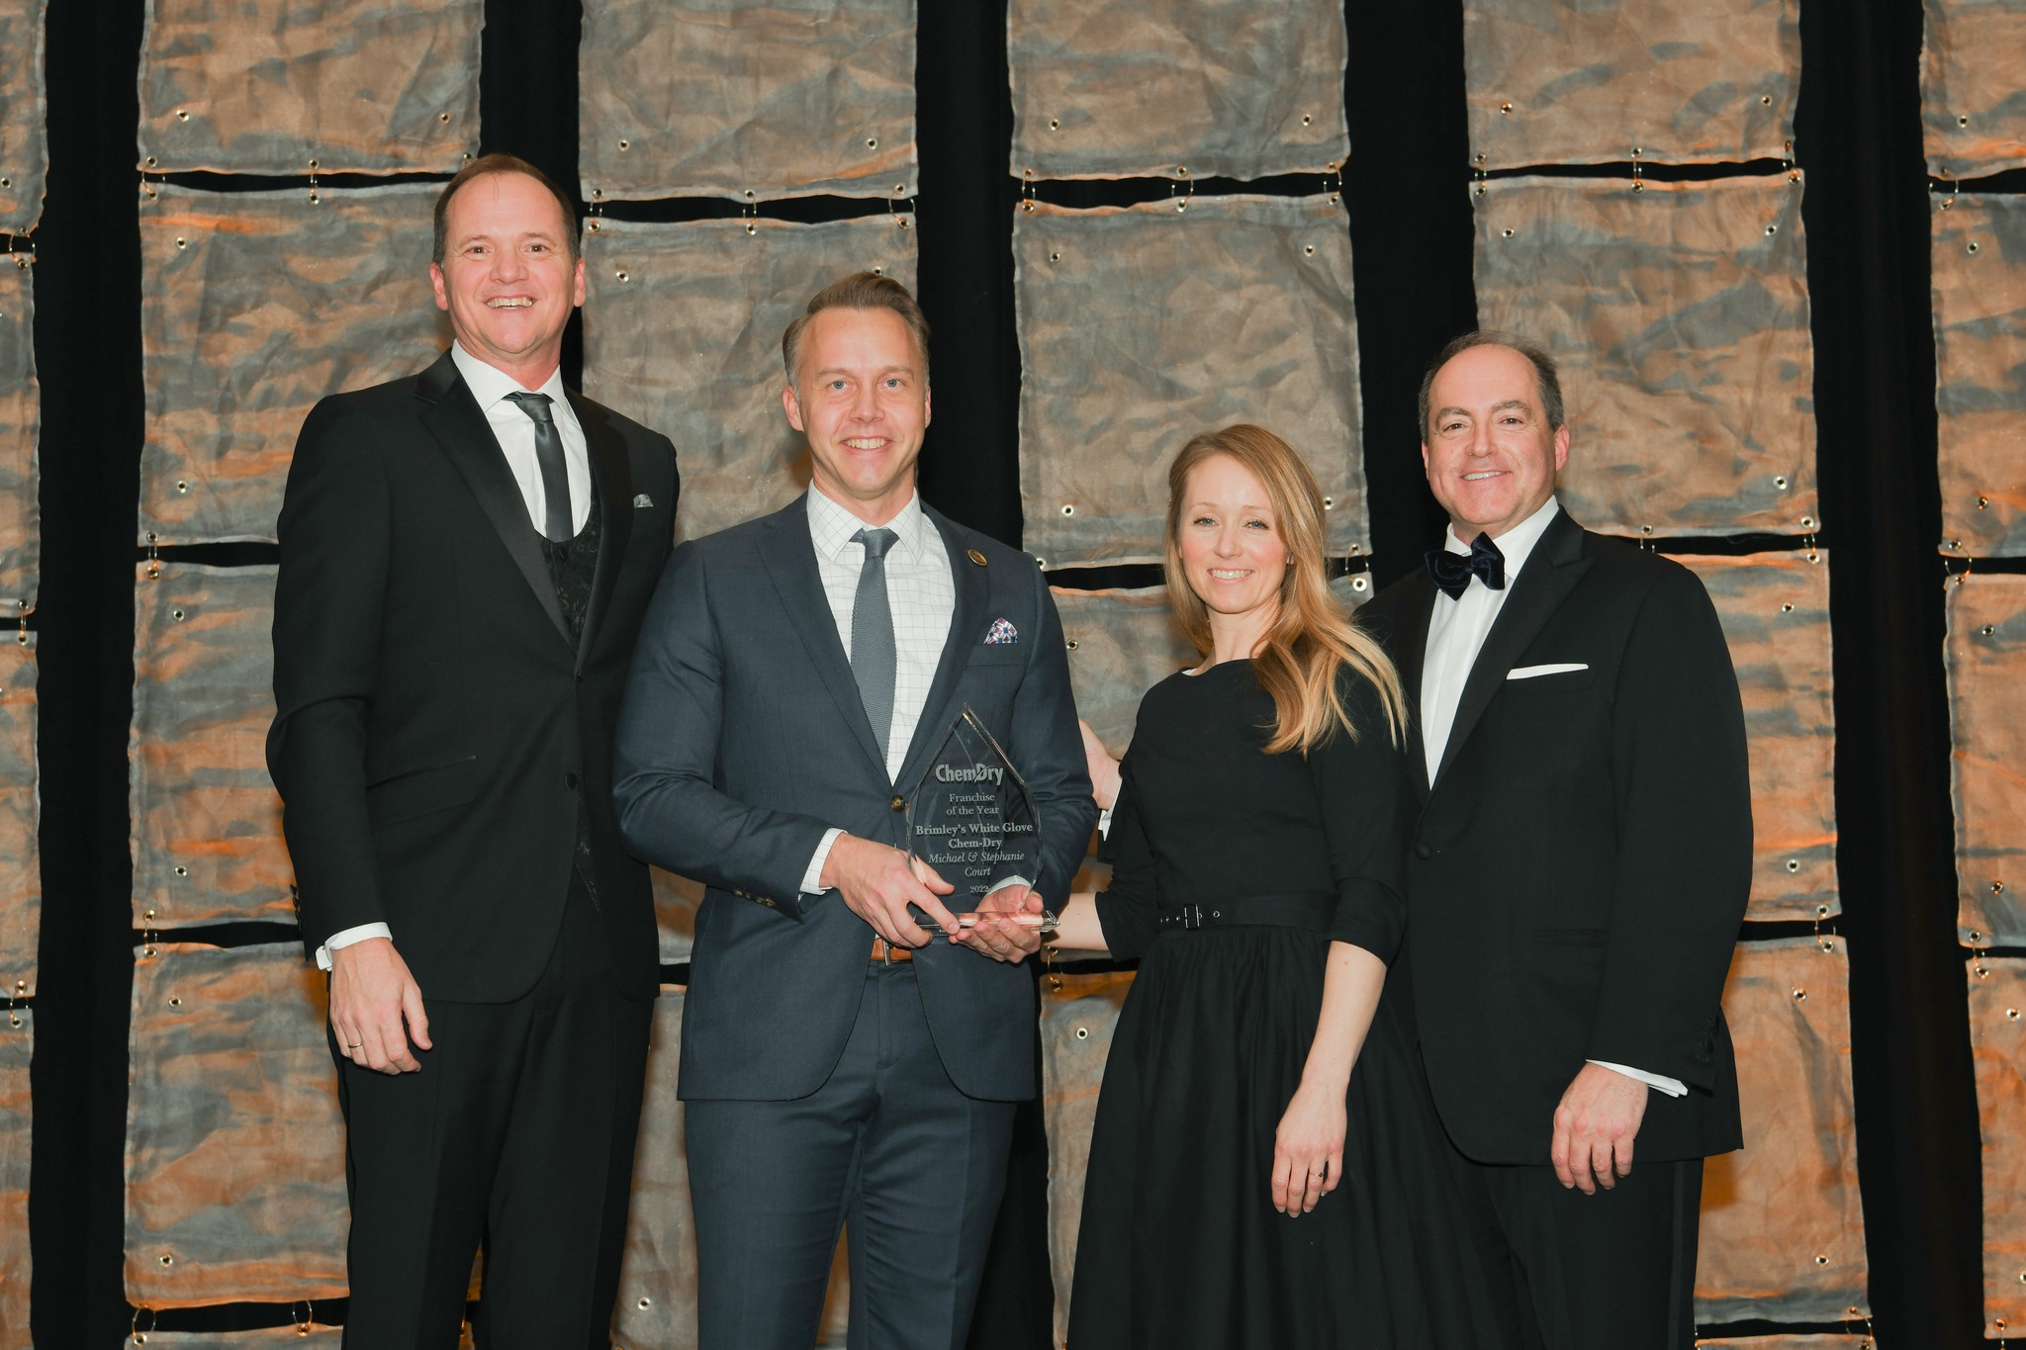
- Owners Mike and Stephanie Court live in Mesa with their four children. Mike is a native of Mesa and attended Westwood High School. He received a Marketing degree from Brigham Young University and recently completed an MBA from Arizona State University in 2018.
Pictured from left: Ed Quinlan (president of Chem-Dry), Michael Court, Stephanie Court, Dan Tarantin (President of Belfor Franchise Group)
“It feels so nice to be recognized after so many years of struggling as a small business owner. I was so happy to be able to present this award to my team as more proof that they are helping me build something remarkable.”
- Mike Court, Owner, Brimley’s White Glove Chem-Dry

“It’s been my pleasure to be associated with Mike and Stephanie during my time at Chem-Dry. The things that stand out most to me about Brimley’s is that their team always looks professional and that that they are so focused on customer service.”
- Ed Quinlan, President, Chem-Dry

The winner is nominated by fellow franchises and the finalists and winner are determined by the leadership team at the Chem-Dry corporate offices in Nashville, TN and Logan, UT.

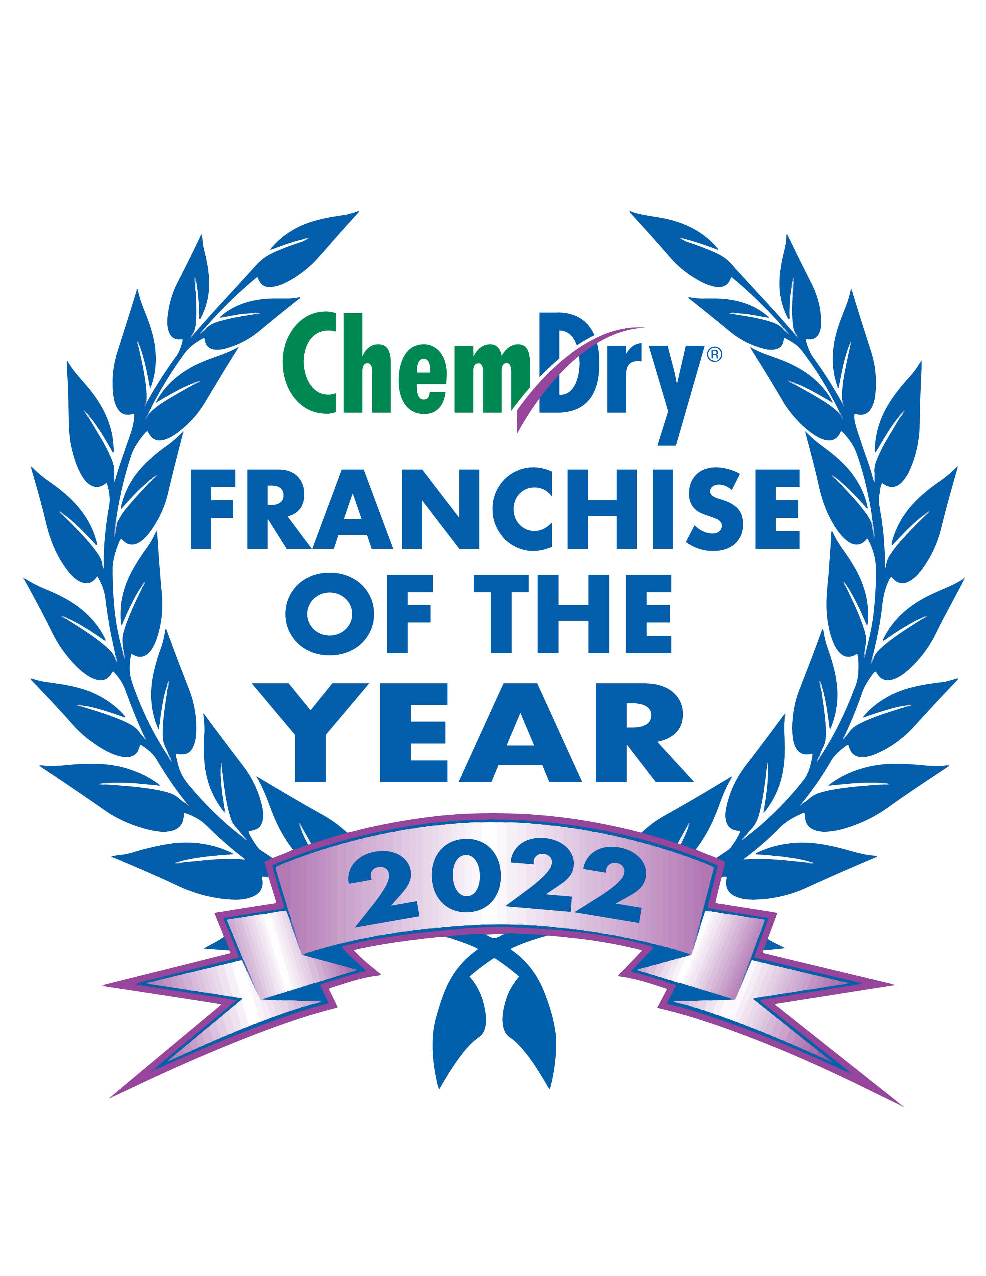
Brimley’s White Glove Chem-Dry provides carpet, upholstery, tile & grout, and area rug cleaning valley wide.
Contact info:
Brimley’s White Glove Chem-Dry
1722 N Banning
Suite 101
Mesa, AZ 85205
(480) 649-3663
https://www.whiteglovecarpet.com

