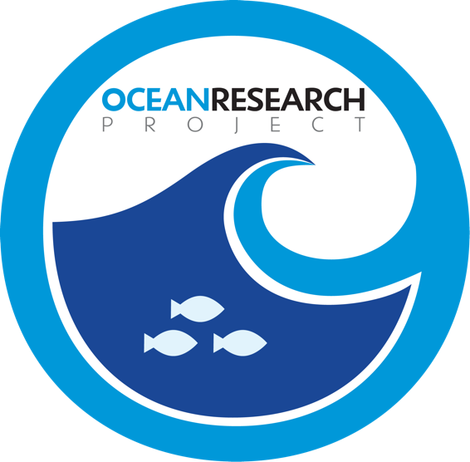

MEDIA ADVISORY:

Recognized Ocean Research Team to Unveil Multi-Objective Flagship, R/V Marie Tharp, for Ambitious Iceberg-Packed Expedition during Commissioning

(Annapolis, Maryland) – On May 14th at 2PM Nicole Trenholm, Principle Scientist of the Ocean Research Project and University of Maryland Ph.D. candidate, along with veteran captain Matthew Rutherford and crew, will host a commissioning of their organization’s flagship R/V Marie Tharp, custom-built to navigate uncharted polar territory in an extensive two-month mission in southern Greenland.

The data tested and collected during Marie Tharp’s maiden voyage will be used to enhance the accuracy of regional climate model estimates on glacial melt due to global warming – one of the key objectives of the expedition’s interdisciplinary research project, Go-Marie (Glacier-Oceans Mapping and Research Interdisciplinary Effort).

“We want to extend our mapping past 2022,” says Trenholm who will be joined by a rotation of ocean science experts on legs of the journey. “This is an urgent mapping endeavor as the arctic is warming at twice the rate of the global average leading to unprecedented land-ice melt.” Utilizing Marie Tharp, autonomous instrumentation, and remote-sensing observations, the Ocean Research Project will be able to map the seabed gaps and observe the water quality characteristics across the glaciated coastline.

Those attending the event are encouraged to enjoy discounted parking at Park Place Garage (3 Park Place) or the Calvert Street Parking Garage (19 St. Johns Street) and take the free shuttle to City Dock. Additional paid parking with free shuttles to the City Dock are available at Gotts Court Parking Garage, Whitmore Parking Garage, Knighton Parking Garage and West Garrett Parking Garage

DATE: Saturday, May 14, 2022

TIME: 2:00 PM

LOCATION: City Dock, Annapolis, MD

Notes for Media:

Trenholm will be available to the media after the event

Contact Information: Mike Desimon mike@sailjunky.com 240-498-1850

