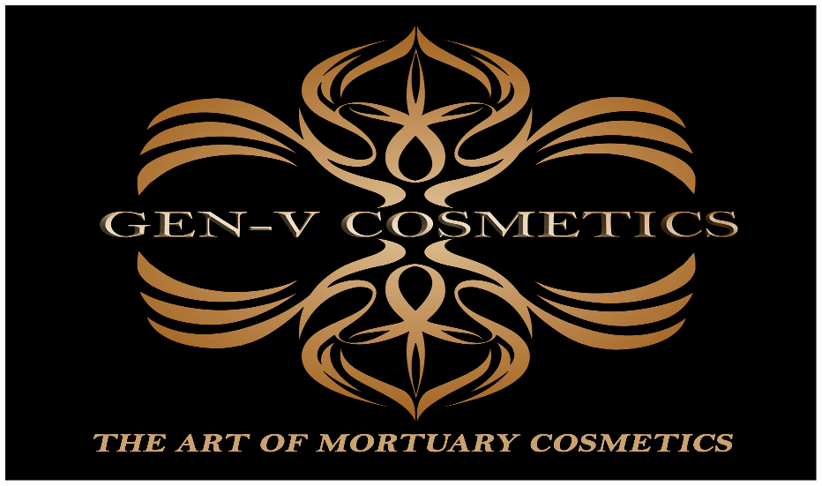

Bryan A. Isley FOR IMMEDIATE RELEASE: JULY 5, 2022
336-792-6637
info@genesis-v.com
www.genesis-v.com

GEN-V Mortuary Cosmetics launches new product line

Burlington, NC, July 2022 GEN-V has announced the launch of their new product line. The parent company has been in business for over 15 years. GEN-V focuses on the funeral services industry by introducing a portfolio of product launches backed with intellectual property. With this new launch, GEN-V aims to provide a more natural look for those who have passed away. We can successfully achieve this by merging old-line knowledge and experience, with new innovations. "GEN-V’s goal is to help embalmers, funeral directors, morticians and makeup artists job more consistent and stress free” said President of GEN-V, Bryan A. Isley. "We believe that our new product line achieves this."
To learn more:
www.genesis-v.com
Bryan Isley
256 West Trade Street
Burlington, NC 27217, USA
PH: 336-792-6637
EMAIL: info@genesis-v.com

