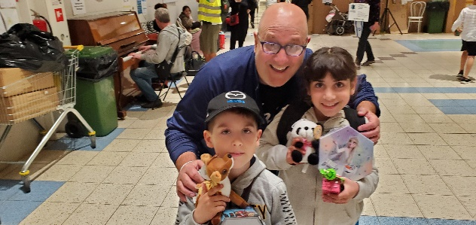

Help Save The Ukrainian Children Fundraiser
Hosted by Chef Roc
San Diego- After returning from a month-long stint on the Poland/Ukraine border, where he was cooking in the World Central Kitchen, Chef Roc is continuing his humanitarian efforts with a fundraiser on July 23, 2022. Chef Roc is hosting the fundraiser along with his partner David Biber at the Hidden Oaks Ranch and Studio, in Fallbrook, California, Andrew Futey, President of the Ukrainian Congress Committee of America, San Diego’s House of Ukraine, TRIO TV and Clark Datchler of Johnny Hates Jazz.

“On my last day in Poland, I was delivering art kits to the Ukrainian children at the refugee center Poland Welcomes, when I got surrounded by dozens of children looking to see what I brought for them. I gave a quick lesson on how to blow bubbles and start handing out the art kits. I wish I could explain the look in their eyes and feeling I got from the smiles on their faces.,” said Chef Roc.

The fundraiser on Saturday, July 23, 2022 will run from 1pm to 5pm. Tickets are limited to the 1st 200 people and are $75 each. There will be Chef prepared food along with wine, beer and soft drinks. There will be a Silent Auction and live entertainment. All donations will be going to PolandWelcomes.org in Radymno, Poland and to the Family Home Pokrova at the St. John Bosco Youth Educational Center in Lviv, Ukraine.
To Donate go to: https://gofund.me/6e24614f

Contact: Chef Roc * 619-933-3991
roc@chefroc.com
