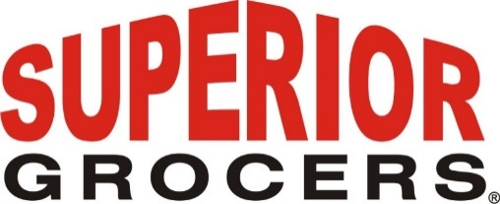

**Superior Grocers acquires Numero Uno**

**Santa Fe Springs, CA (July 18, 2020)**– Superior Grocers, a Southern California grocery retailer, announced today that it has acquired Numero Uno, an independent chain of 22 Hispanic retail grocery stores in Southern California.  Superior Grocers will now operate 69 grocery stores in Southern California.

Richard Wardwell, President of Superior Grocers, said, “We are excited to welcome the Numero Uno team and its customers to our company.  This acquisition will strengthen our presence in southern California and reflects our continued commitment to growing the company to better serve our customers.”

Doug Minor, President of Numero Uno, said, “We are looking forward to the opportunities for our team joining Superior and the ability to enhance our customers shopping experience.”

Kroll Corporate Finance (formerly Duff & Phelps Securities) acted as the financial advisor and Greenberg Traurig LLP as the legal advisor to Superior Grocers.  The Food Partners acted as the financial advisor and Duane Morris LLP as the legal advisor to Numero Uno.

Superior Grocers is one of the largest independently-owned chains of grocery stores in Southern California. Our philosophy is to offer the highest quality products with exceptional customer service. You can always count on excellent Quality, Variety, & Value when you shop at Superior Grocers. We are dedicated to building a community of loyal customers, vendors and staff where food shopping is fun and the spirit and love of family guide our action.

**@SUPERIORGROCERS**

Image result for facebook png Image result for instagram png

**Visit Our Website**

**Superiorgrocers.com**