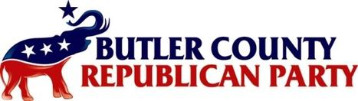
P.O. Box 841
Middletown, Ohio 45044
513.893.5292

To Whom It May Concern:

On January 11th, 2022, Matt King met with the screening committee of the Butler County Republican Party and received a “Highly Recommended” from that meeting.
On July 14th, the Butler County Republican Party had an endorsement meeting for State Representatives and from the Central and Executive members, in the newly formed house district 46, there was no endorsement of either candidate.

The Butler County Republican Party

