

**Superior Grocers Opens New Location in Santa Paula, CA**

**Santa Fe Springs, CA (September 14, 2022)**- Today, Superior Grocers opens their 70th store in Santa Paula, CA at 280 E Harvard Blvd. The store opened under the banner, The Market by Superior. A full-service Supermarket featuring the largest selection of Produce in Santa Paula, Grocery, Liquor, Fresh Quality Meat, a large assortment of baked goods, and an array of ready to eat Hot Foods.

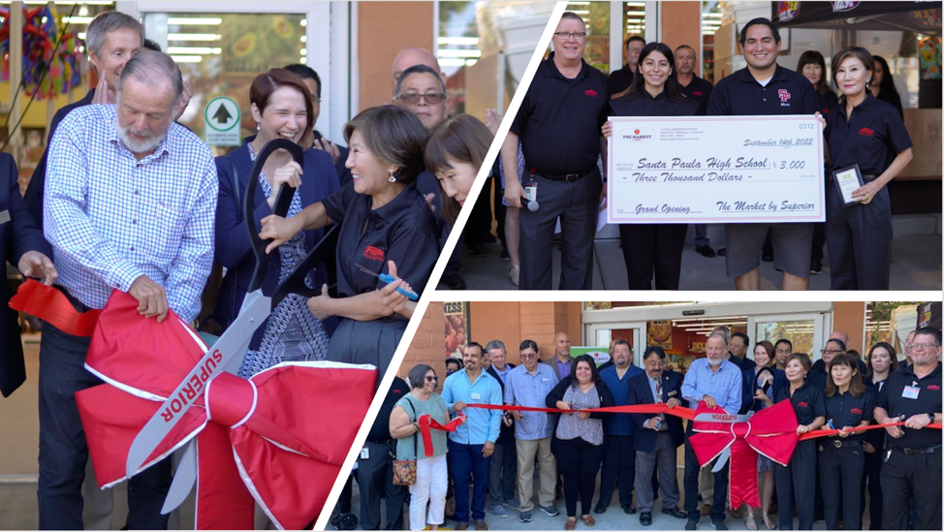

In celebration of the new store, Superior Grocers made donations to Santa Paula High School and Santa Paula Together.

“We are very excited to open The Market by Superior and to join the community of Santa Paula.” stated Richard Wardwell, President. “We are honored to serve the neighborhood with a great shopping experience as they have welcomed us with open arms.”

**About Superior Grocers**

Superior Grocers is one of the largest independently owned chain of grocery stores in Southern California. Superior began its operations in 1981 with one store and has experienced steady growth for over 41 years. It now operates 70 stores throughout Southern California. Aside from its wide assortment of grocery, produce, meat, bakery, frozen, deli, international foods & general merchandise products, Superior stores also offer a variety of freshly prepared products in the Bakery, Meat & Seafood, Service Deli and Hot Foods departments.

It prides itself in providing Quality, Variety, and Value to the communities that it serves. Superior Grocers is a strong community partner and continually supports programs that help bring a positive impact to its customers, including education, health awareness efforts and many local youth organizations and non-profit groups. For more information about Superior Grocers, please visit [www.superiorgrocers.com](http://www.superiorgrocers.com).

**@SUPERIORGROCERS**

Image result for facebook png Image result for instagram png

**Visit Our Website**

**Superiorgrocers.com**