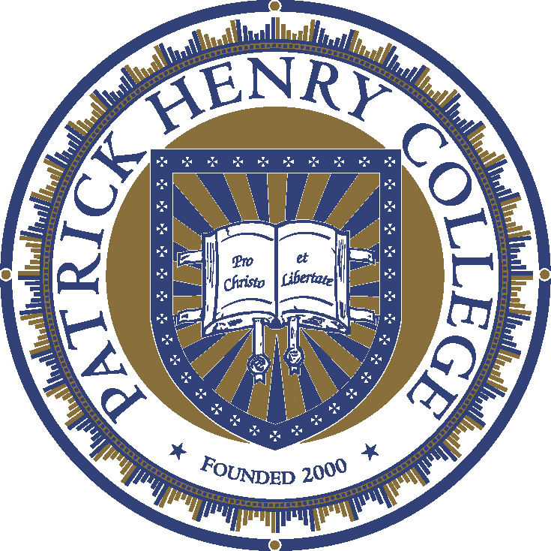

PATRICK HENRY COLLEGE EARNS “A” RATING FROM THE AMERICAN COUNCIL OF TRUSTEES AND ALUMNI (ACTA)
Purcellville, VA, September 26, 2022—From a survey of the academic core curricula of more than 1,100 colleges and universities, Patrick Henry College was recognized as one of only 24 institutions to receive an “A” rating and one of only seven colleges to earn a grade of 100%, in the American Council of Trustees and Alumni “What Will They Learn?”® annual report for the 2022-2023 school year.
“What Will They Learn?”® (WWTL) rates on an “A” through “F” scale based on how many of seven core subject institutions require students to study. Of the 1,100 in the report, PHC is one of just 24 institutions that requires at least six of the seven subjects to join the prestigious list of “A” schools and one of only seven schools to require all seven WWTL subjects—earning a grade of 100% and placing PHC in the top 1% in the nation. Additionally, PHC is the only Protestant/evangelical college in the nation that requires students to study all seven.
According to ACTA, “A well-designed general education curriculum equips students for conversations of perennial human concern and provides a foundation in essential aspects of our political, economic, and scientific systems.”
Because ACTA only reviews colleges and universities that are regionally accredited, the “A” rating from ACTA was only possible because of the recent vote by the Board of Trustees of the Southern Association of Colleges & Schools Commission on Colleges who voted unanimously to accept PHC’s application for membership. Patrick Henry College is now regionally accredited by the Southern Association of Colleges & Schools Commission on Colleges (SACSCOC).
By demonstrating compliance with the Principles of Accreditation, SACSCOC accreditation gives our students and their families confidence that PHC has adequate resources, programs, and services to promote student success. It also assures graduate programs and employers of PHC’s educational quality.
“The ‘A’ rating from ACTA’s What Will They Learn?® project is a distinct honor for Patrick Henry College and, along with regional accreditation from SACSCOC, confirms the effectiveness of our academic program. After just 22 years of existence, PHC has won more moot court national championships than any other college in America, had more graduates clerk for the US Supreme Court than any other evangelical Christian college in the nation, and continues an unparalleled track record of success in placing alumni in top graduate programs, law schools, and every level of government.” said Jack W. Haye, PHC’s president.
PHC offers a unique conservative Christian education that follows a classical liberal arts methodology. The fusion of three commitments sets Patrick Henry College apart from any other college in the world:
- High Academic Rigor
- Fidelity to the Spirit of the American Founding
- Unwavering Biblical Worldview.
Primary Contact: Stephen C. Allen, Assistant VP and Director of Communication
540.441.8722 | Email: scallen@phc.edu
Patrick Henry College | 10 Patrick Henry Circle | Purcellville, VA 20132 | phc.edu

