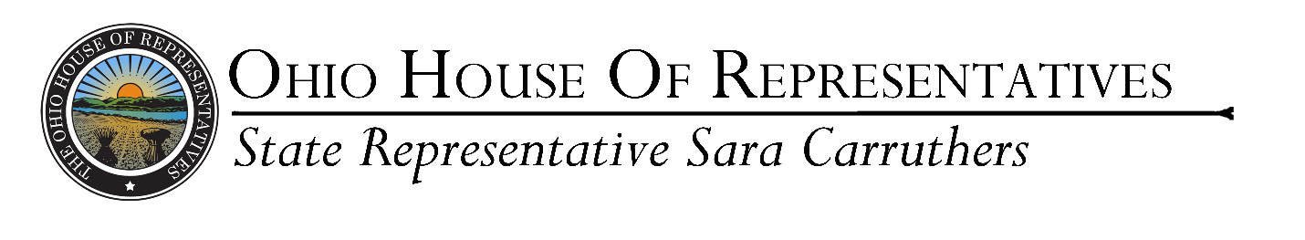
For Immediate Release:
Oct. 28, 2022

Carruthers Announces $8.7 Million in State Grants for Butler County

COLUMBUS – State Representative Sara Carruthers (R-Hamilton) announces Butler County has been awarded land reutilization funding from the state operating budget passed by the General Assembly last year.

“I really believe that these kinds of strong investments are going to make a difference for Ohio families,” Carruthers said. “With these grants, we can really work on uplifting our communities to bring viable businesses to our area, create jobs and make Butler County a better place to live.”

The Butler County Land Reutilization Corporation will receive a total of $8.7 million for 51 approved projects.

The announcement includes a total of $14.5 million for the land reutilization funding for 30 counties throughout the state. In addition to previous funds of $22.7 million set aside, the total grant amounts approved totals nearly $37.3 million in funding.

In 2021 the Ohio General Assembly allocated $150 million to help counties revitalize worn-down neighborhoods through the Demolition and Site Revitalization Program to improve property values and boost economic development. The program stems from House Bill 110, which Carruthers supported last year.

###

For more information, contact Rep. Carruthers’s office at (614)-644-6721 or rep51@ohiohouse.gov

