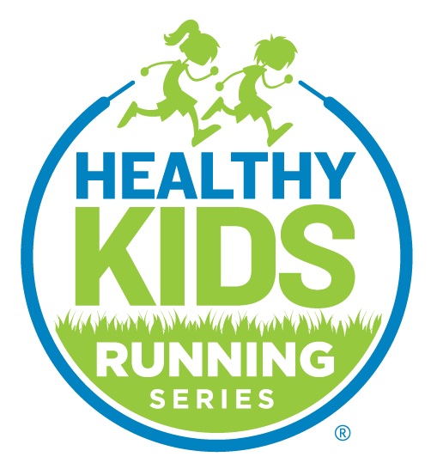
Contact Information:
Healthy Kids Running Series
484-352-2729
turkeytrot5k@HealthyKidsRunningSeries.org
MEDIA RELEASE
November 21st, 2022

ANNUAL GARNET VALLEY TURKEY TROT 5K WITH CASH AND PRIZES FOR BEST DRESSED, FIRST, SECOND, AND THIRD PLACE OVERALL WINNERS

Kick off the Thanksgiving holiday with families from the tri-state area at the Garnet Valley Turkey Trot 5K and 1 miler at Garnet Valley High School, 552 Smithbridge Road, Glen Mills, PA, 19342 on Thursday, November 24th at 9:00 AM. This race will take place rain/snow or shine.
For the 5K, $500 will be awarded to the top first place overall male and female finisher and $250 to the top second and third place overall male and female finisher. 5K Finisher medals will be awarded to first, second and third place winners within each male/female age group. Packet pick up dates are Tuesday, November 22nd 4:00 PM until 6:30 PM and Wednesday, November 23rd, 9:00 AM until 1:00 PM at 381 Brinton Lake Road, Thornton, PA 19373. Participating runners can also register online at: https://runsignup.com/Race/PA/GlenMills/GarnetValleyTurkeyTrot
All proceeds benefit Healthy Kids Running Series national youth running program whose mission is to provide an inclusive youth running experience inspiring kids to believe in themselves and lead an active healthy lifestyle. The HKRS Annual Turkey Trot also welcomes sponsors and volunteers, find out more here on how to get involved.
Healthy Kids Running Series, a national inclusive and fun youth running experience, inspiring boys and girls (ages 2-14) to believe in themselves and lead an active healthy lifestyle, is conducting a safe, five-week in-person spring running Series featuring once-a-week racing. To find a Series near you and register visit HealthyKidsRunningSeries.org.
Healthy Kids Running Series impacts more than 60,000 youth runners in 300+ communities across the United States. Healthy Kids Running Series engages communities and families by providing an inclusive youth running experience, inspiring kids to believe in themselves and lead an active healthy lifestyle. Learn more at www.HealthyKidsRunningSeries.org.

CONTACT:
Healthy Kids Running Series
484-352-2729
turkeytrot5k@HealthyKidsRunningSeries.org

