FOR IMMEDIATE RELEASE: December 5, 2022
Dustin Gledhill | president@BohemiansNYC.org | 917-378-3464

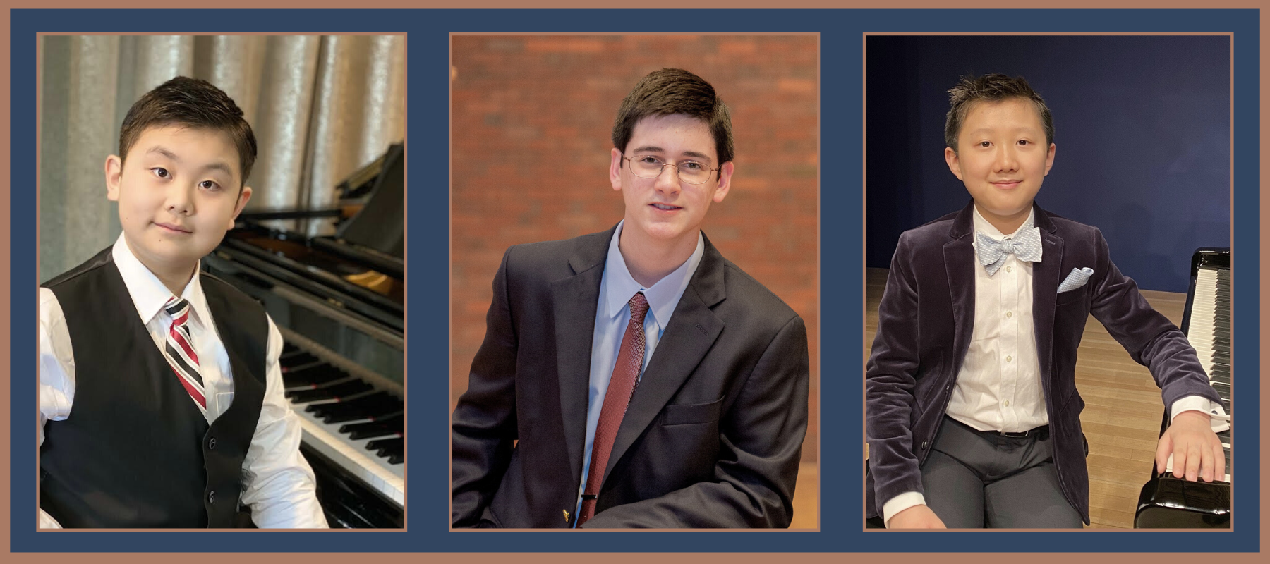

The Bohemians Announce Finalists of the Bohemians Young Artists Piano Competition
NYC - Today, The Bohemians: New York Musician’s Club announced three finalists of the Club’s first Bohemians Young Artists Piano Competition. These three young pianists will compete over a two-part final round on December 18th and 19th. The finalists were selected from a virtual preliminary round based on their expressive/musical ability, understanding of the composer's style/period, and the technical integrity of each piece. The 2022 Bohemians Young Artists Piano Competition finalists are:
- David Fu: age 14 from Scarsdale, New York
- Benjamin Wien: age 16 from Delmar, New York
- Timothy Yang: age 13 from Palos Verdes, California
“Our first Bohemians Young Artists Piano Competition aims to highlight the Club’s mission which is to further the cause of music and to support emerging artists and our members. We hope to engage young musicians and cultivate musical relationships with a new generation that will invigorate our Club’s 116-year history.”
- Dustin Gledhill, president of The Bohemians
Preliminary round judges were Kristian Chong from Australia, David Kadouch from France, Spencer Myer and Bryan Wallick from the USA. Our three finalists, each receiving a cash award, will compete in a live master class round on Sunday, December 18th with concert pianist and Indiana University faculty Spencer Myer, followed by a final recital round on Monday, December 19th. Each finalist is then ranked 1st, 2nd and 3rd based on their combined virtual round, master class, and recital performances. The 2022 winner will receive an additional $500 sponsored by Sabry Mohideen in honor of kidney.org, and will be announced during the post-concert reception at the December 19th recital. Tickets for one or both final rounds can be reserved at bohemiansnyc.org.
Part I: Master Class: Sunday, December 18, 2022, 1:30 PM: Public master class with Spencer Myer at the Kosciuszko Foundation 15 E 65th Street, New York, NY 10065
Part II: Final Recital: Monday, December 19, 2022, 7:00 PM: Final Recital Round at Scorca Hall, National Opera Center 330 7th Ave, New York, NY 10001
2022-2023 SEASON. The Bohemians’ 116th season kicked off in November with “Rachmaninoff Remembered,” a piano and voice performance continuing long-standing relationships with the Concert Artists Guild. The remainder of the season includes a new series titled “Bohemians Nouveaux,” an immersive musical experience including and venturing outside of Classical norms (February 6); “American Landscape” (Barber, Copland and Bernstein), a new collaboration with the Musical Arts Society of New Orleans (April 3); and finally “Juilliard 415,” a continued collaboration with the Juilliard Historical Performance division (May 8). For more information about the season and to purchase memberships and tickets, please visit www.bohemiansnyc.org.
Since its founding in 1907, the mission of The Bohemians: New York Musicians' Club has been to further the cause of music and camaraderie amongst its members. Now in its 116th season, The Bohemians honors tradition while inviting new collaborations, all in pursuit of supporting and elevating young artists for diverse audiences.
www.bohemiansnyc.org
###

