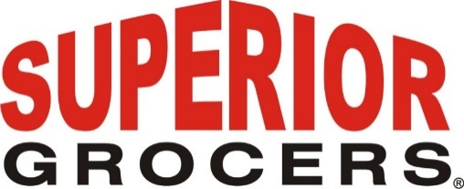

**Superior Grocers Is Now in the Central Valley-Opens New Location in Tulare, CA**

**Santa Fe Springs, CA (December 5, 2022)** - On Saturday December 3 2022, Superior Grocers opened its 71st store in Tulare, CA at 115 S. West St, the former Palace Foods Depot. The grocery retailer who primarily operates in Southern California has now expanded into the Central Valley. The new store features a large selection of Produce, Grocery, Beer & Wine, and Fresh Quality Meat. Plans for the addition of a full service Kitchen, Bakery, and Tortilleria are under way.

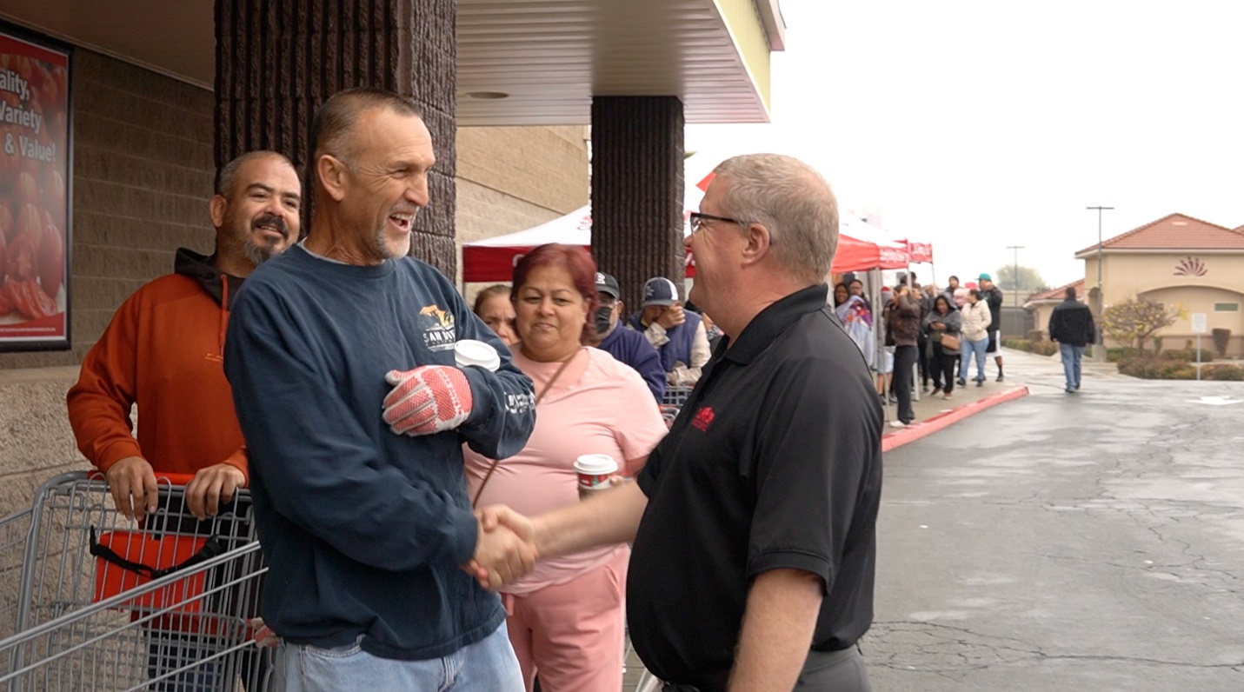

Richard Wardwell, President of Superior Grocers, greets a customer waiting in line to enter the new store.

The grand opening was a momentous event with City and County Officials in attendance along with customers eagerly awaiting along Tulare Ave. for the store to open. The parking lot was bustling with shoppers sampling products and listening to music from KCHI 1010AM El Gallito. Before the ribbon cutting ceremony, a $3,000 check was presented to Grandma’s House, a Tulare afterschool non-profit tutoring program that provides free tutoring for at-risk students. Another $3,000 check was presented to Tulare City Schools in support of early childhood education and arts education.

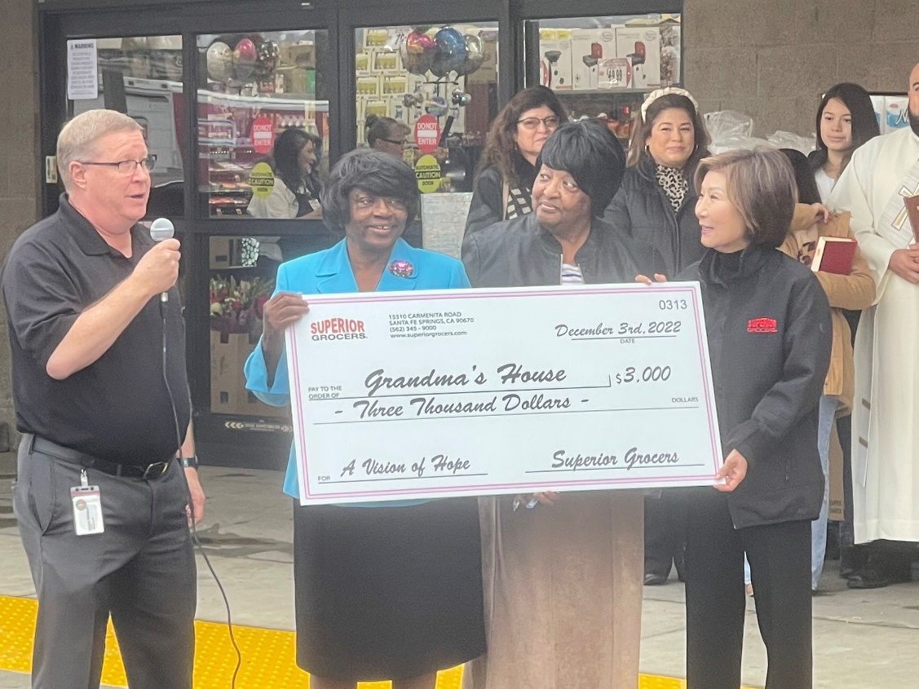

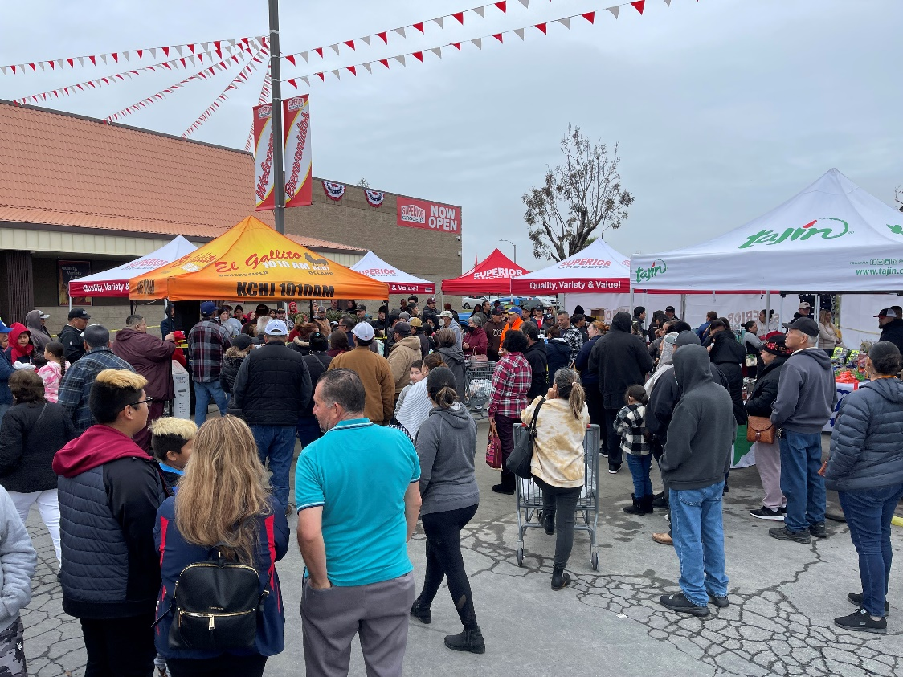

Once the doors opened, customers were seen walking down the brand new aisles, exploring the store and shopping for their favorite groceries. “We are very excited to open and join the community of Tulare.” stated Richard Wardwell, President. “We are honored to serve the Central Valley with Quality, Variety and Value as they have welcomed us with open arms.”

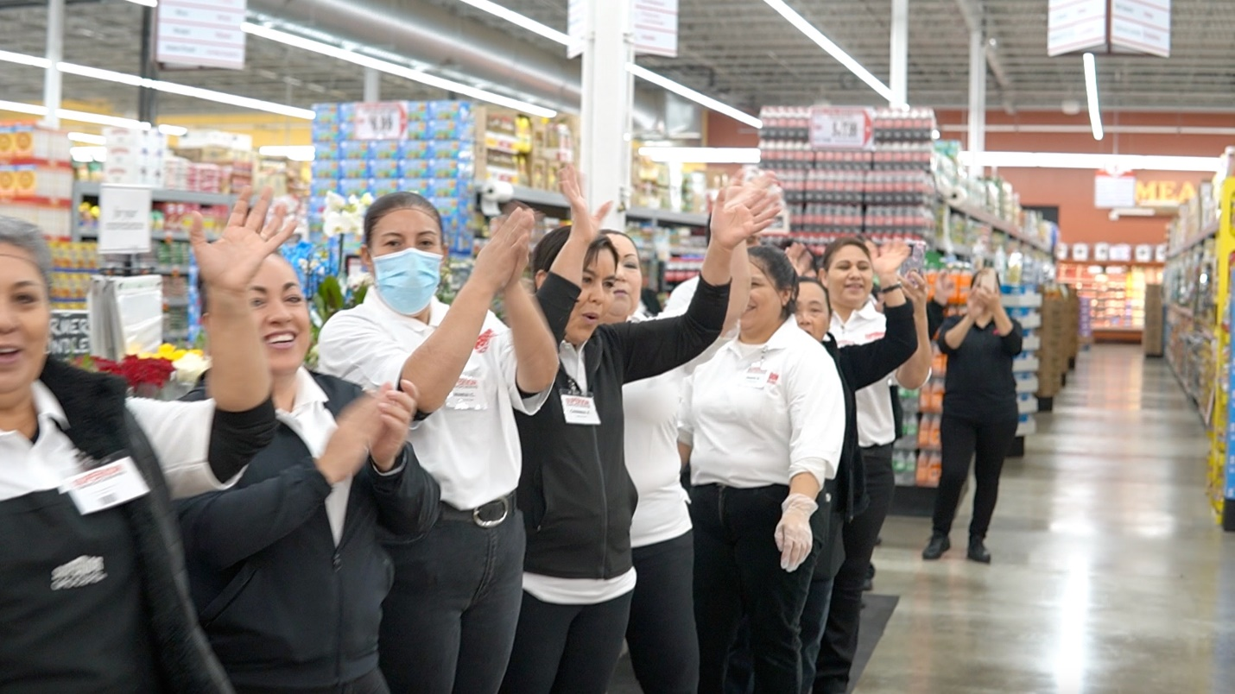

**About Superior Grocers**

Superior Grocers is one of the largest independently owned chain of grocery stores in Southern California. Superior began its operations in 1981 with one store and has experienced steady growth for over 41 years. It now operates 71 stores throughout Southern California and Central Valley. Aside from its wide assortment of grocery, produce, meat, bakery, frozen, deli, international foods & general merchandise products, Superior stores also offer a variety of freshly prepared products in the Bakery, Meat & Seafood, Service Deli and Hot Foods departments.

It prides itself in providing Superior Quality, Superior Variety and Superior Value to the communities that it serves. Superior Grocers is a strong community partner and continually supports programs that help bring a positive impact to its customers, including education, health awareness efforts and many local youth organizations and non-profit groups. For more information about Superior Grocers, please visit [www.superiorgrocers.com](http://www.superiorgrocers.com).

**@SUPERIORGROCERS**

Image result for facebook png Image result for instagram png

**Visit Our Website**

**Superiorgrocers.com**