GOSKATE is launching “Local Skatepark Support Program”

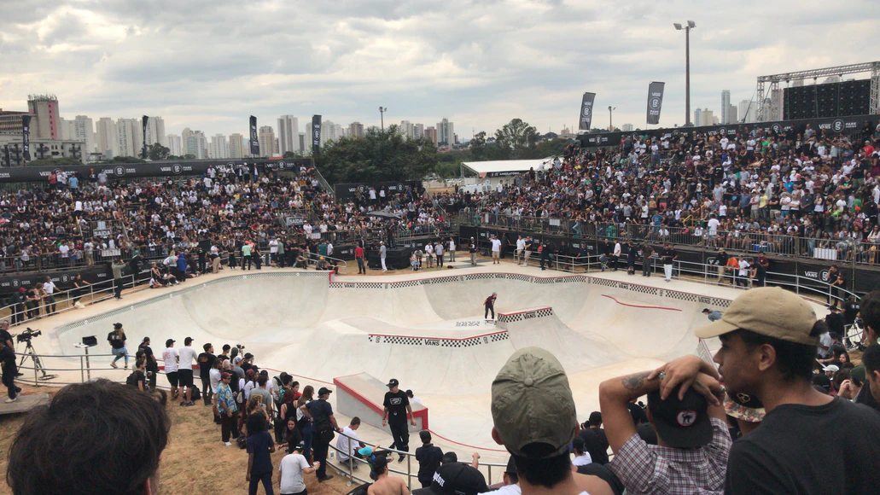

As lifelong skaters with a passion for teaching, GOSKATE was founded to help new skaters foster their love for skateboarding. Over the years, we’ve taught thousands of young kids and adults how to skateboard. We’ve done our best to inform, entertain and continue to teach them as they go on to become valuable members of the skate community.

For many skaters, a local skatepark is a second home. It’s where we make lifelong friends, develop interpersonal and social skills, discover new passions for art, videography, photography, and of course, develop our skateboarding skills.
Every local skatepark has its own family of skaters who make up the very fabric of the local skate community. So while a skatepark is literally where many future skaters will skate for the first time, taking their first push into a larger world, the skatepark will always play a central role in their lives from beginner to intermediate skaters, to sponsored and even pro skaters.
The GOSKATE Local Skatepark Support Program offers services designed to get more skateboarders into your skatepark. Simply put, we let more people know about your skatepark and offer services once they are there to want to come back for more.
We do so as the largest network of trained professional skateboarding instructors, with decades of skate heritage and thousands of students. Whether you’re a decades old skateboard park, an indoor skate park or a new skatepark, we’ve got the tools you need to make every day at the skatepark feel like Go Skateboarding Day.

GOSKATE Local Skatepark Support Program Service Offers:

List Your Skatepark on our GOSKATE Skatepark Directory

When GOSKATE started reaching out to skateboarders to become skate instructors, we quickly discovered how the skatepark was going to be vital to their success. In return, these instructors gave us their insight into what makes a skatepark great. Fast forward to today, we’ve compiled the most complete list of skateparks in the world. We’ve also highlighted through our blog some of the best skateparks in California, Texas, and Florida. If your skatepark is not listed already, we’ll list it for you and describe in detail everything your skatepark has to offer. You can send us edits to post as well.

Feature Your Skate Contests and Events on our Competitions Directory
Have a big skate contest coming up that you’d love as many people as possible to be informed on? We’d love to share your annual contest on our competitions directory page, so thousands of people can learn first hand where the best skating is going down in their area. It’s also a great place to connect with other potential brands for product and fundraising.

Provide Skateboarding Lessons by a GOSKATE Instructor

Let us do what we do best and come out to your local skatepark and teach a group skate lesson. GOSKATE instructors can help bring more to your event by hiring our instructors to give lessons during your opening. We can’t think of a better way to get new skaters into your skatepark and have them stick around as they progress as skaters. In fact, we’ve witnessed it happen first hand with hundreds, even thousands of our students.
- Do you have a local skatepark launch or grand opening?
- Have a big ceremony or event coming up?
- Hosting a skate workshop?
- Hosting an all girls skate night?
We’ve learned first hand that when a beginner skater starts off with an expert instructor teaching them the fundamentals of skateboarding, they are ten times more likely to stick with it. It’s also a great way to install a love of the local skatepark in a beginner skater no matter their skill level. We’ve seen many skateparks go on to hire GOSKATE instructors to have regular skateboard classes, where the local community of parents and kids can get together and support your local skatepark.
Contact us today at support_skatepark@goskate.com to find out how GOSKATE can help grow your local skatepark community!

