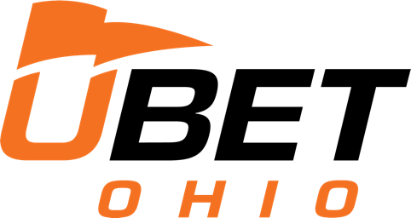
UBetOhio
4560 Heatherdowns Blvd. Suite 100
Toledo, OH 43614
beththegame@ubetohio.com

FOR IMMEDIATE RELEASE

UBetOhio Kiosks Are Live in Businesses Across the State – Increased Interest Remains Strong Post-Launch

TOLEDO, OH – January 26, 2023 – UBetOhio, an approved Ohio Type C Sports Gaming proprietor and emerging leader among self-service sports betting kiosk operators in Ohio, is seeing increased interests from Ohio businesses after the successful January 1 launch.
Since January 1, UBetOhio has been working hard to keep up with the dynamic changes and requirements for sports betting companies while ensuring a responsible and engaging sports betting experience. Their hardwork is paying off with post-launch orders for more and new kiosks from Ohio businesses who want to include sport betting in their establishments.
“Not all kiosk companies are created equal,” says Andrew Westmeyer, CEO of UBetOhio. “I know there have been reports of kiosks being out of service in bars and restaurants throughout the state but since January 1 – all of the UBetOhio kiosks have been live and taking bets. We have a network of partners who signed on early to reserve their kiosks and we have worked to make sure their customers are enjoying the best sports betting experience possible.”
According to UBetOhio, the pre-launch preparation of development, delivery and training required tremendous collaboration between UbetOhio, The Ohio Lottery and their supplier IGT. “We are proud to have delivered an excellent launch experience for our partners and customers and we remain committed to ensuring a successful and exciting addition to our Ohio sports experience,” said Westmeyer.
“When we knew sports betting was being legalized, we knew we wanted to be part of it,” said George Simon, CEO of Toledo’s Bar 145. “If you are watching any kind of TV in Ohio these days, you know there are many companies offering sports betting in Ohio. We did our due diligence in picking a partner to move forward with and we have been thrilled to have the UbetOhio kiosks in our establishment,” said Simon. “Not are only are they a great company, offering a great betting experience to my patrons – they are an Ohio-company and I am excited to help support the local economy.”
UBetOhio is an Ohio-based company with unmatched experience in the gaming and F&B industries. “As an Ohio company, we are committed to making this a success for our state,” said Westmeyer. “We are working hard to keep jobs and money here and see this as a wonderful opportunity for the state. Ensuring the legal requirements and the responsible sports betting practices are in place to make this a long-term success and a value to the state.”
UBetOhio was among the first companies to receive the Type C Proprietor License in Ohio by the Ohio Casino Commission. UBetOhio is an Ohio based group of investors working to bring a full-service betting experience to Ohio sports fans.
“Ohio has the best sports fans in the country, and it is no surprise that those fans are jumping into sports betting,” said Westmeyer.
The NFL divisional champtionsips continue this weekend as Ohio wraps up its first month of legalized sports betting.

About UBetOhio
UBetOhio is a Toledo, Ohio based Ohio Type C Proprietor licensed by the Ohio Casino Commission and regulated by the Ohio Lottery. UBetOhio intends to offer the premier full-service sports betting retail kiosk based solutions to over 1000 approved Ohio bars, grocery’s and restaurants throughout the state. UBetOhio will provide top of the line sports betting equipment and services, and our team is dedicated to creating the ultimate game day experience to Ohio sports fans.

For further information:
UBetOhio: betthegame@ubetohio.com

Media Opportunities:
Interested in learning more about Ohio legalized sports betting, the January 1, 2023 launch, betting proprieters and partners please contact: betthegame@ubetohio.com to discuss enhanced media opportunities.

