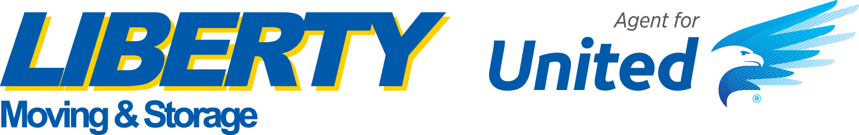**News Release**

For further information:

Carmine Vetrano  
Marketing Manager  
631-234-3000 ext. 236  
cvetrano@libertymoving.com

**LIBERTY MOVING & STORAGE WINS TOP COD BOOKER AWARD   
FOR THIRD STRAIGHT YEAR**

**ST. LOUIS – Feb. 28, 2022 –** Liberty Moving & Storage proudly announce that they were named the number one COD booker in the United States for the third straight year by United Van Lines.

United Van Lines is part of the most extensive van line in the country, UniGroup, and each year they present their award for the mover with the highest volume of local and interstate moves in the nation. Liberty Moving & Storage is incredibly proud and honored to be named this year's recipient.

"This achievement is a testament to our team's hard work and dedication. We've been providing quality residential moving services, and this honor reflects our commitment to excellence," said President and CEO Anthony Federico. "Our team works tirelessly to ensure every move is safe, efficient, and stress-free."

"We've built a reputation for providing superior customer service, and we take pride in offering an array of services tailored to our client's needs. From packing and loading to transportation and delivery, we are the experts in the moving industry," he added.

Liberty received this prestigious award in February from United in St. Louis, MO. This honor was part of the company's annual Learning Conference awards ceremony. United recognized the agencies that are the top bookers in their household goods business segments. Liberty outperformed the rest of United's 600 agents to be named the number one COD booker in the U.S. for residential-household goods.

Liberty Moving & Storage has been an agent for United Van Lines for over two decades. During this time, Liberty has won the Sales Achievement award multiple times, including 2021 and 2022.

For more information, please go to [www.libertymoving.com](http://www.libertymoving.com) or call 631-234-3000.

**About the Liberty Moving & Storage**

Founded in 1939, Liberty Moving & Storage is a family-owned and operated full-service residential/commercial moving, storage, and logistics company headquartered in Commack, NY. The company has four locations in the Tri-State area and employs over 250 people.

###



*Liberty Moving & Storage President Anthony Federico (second from left) accepting the Top COD Booker award for the third straight year.*