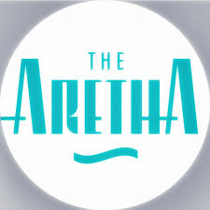

FOR IMMEDIATE RELEASE

MEDIA CONTACT:

Bankable Marketing Strategies
Erica Banks
313.412.0580

The Aretha Franklin Amphitheatre Partners with Detroit at Work, SER Metro and
Detroit Stage Employees Union to Host Hiring Fair for the 2023 Season

March 14, 2023, Detroit, MI – The Aretha Franklin Amphitheatre is excited to partner with Detroit at Work, SER Metro and Detroit Stage Employees Union to host the 2023 season hiring fair, Friday, March 24, 2023, from 12p – 3p at SER Metro 9301 Michigan Ave, Detroit, MI 48210. Managers will be on-site accepting applications and conducting interviews for over 300 positions.

Several jobs are available this season including:

- Bartenders
- Barbacks
- Box Office Staff
- Concessions:
- Production
- Stagehands
- Ushers
- Waiters/Waitresses

Attendees should bring a current resume and driver’s license or state ID. For more information, email employment@thearetha.com or visit thearetha.com.

“Every summer, we bring the world’s best artists to The Aretha. The team members we hire are no different; we recruit the best. Committed to unforgettable guest experiences, our talented team makes that happen,” said Shahida Mausi, President of The Right Productions, Inc., Manager of the Aretha Franklin Amphitheatre. “The Aretha is a gem in the city on the banks of the beautiful Detroit River and we want outgoing, enthusiastic, and energetic people to join our team. Working together we all enhance the concertgoers experience,” said Mausi.

###

Located at 2600 Atwater, the Aretha is a live entertainment concert venue uniquely positioned on the international waterway with Canada as its backdrop. The Aretha is a City of Detroit Recreation Department facility, managed and operated by The Right Productions, Inc. since 2004.

