FOR IMMEDIATE RELEASE

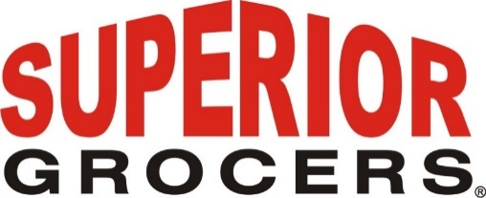

**Superior Grocers Announces Tom Finn as Senior Vice President of Marketing and Merchandising**

**Santa Fe Springs, CA (March 31, 2023)**- Superior Grocers, a leading independent grocery chain, appoints Tom Finn as Senior Vice President of Marketing and Merchandising. This change in leadership will help guide the company's continued growth and success.

Tom Finn joins Superior Grocers as Senior Vice President of Marketing and Merchandising. With over 35 years of experience in the retail grocery industry, Tom has dedicated the majority of his career to merchandising, marketing, and enhancing the customer experience. Prior to joining Superior Grocers, he served as Vice President, Center Store at Northgate Markets and Director of Grocery at Stater Bros. Markets, as well as holding several positions with Food 4 Less and Ralphs (Kroger banners).  
  
"We are excited to have Tom Finn join our team and lead our marketing and merchandising efforts," said President and CEO, Richard Wardwell. "His expertise and experience will be invaluable as we continue to expand our offerings and enhance the customer experience.”

**About Superior Grocers**

Superior Grocers is one of the largest independently owned chain of grocery stores in Southern California. Superior began its operations in 1981 with one store and has experienced steady growth for over 41 years. In 2022, Superior acquired Southern California grocery chain, Numero Uno. It now operates 70 stores throughout Southern California and Central Valley under three banners- Superior Grocers, The Market by Superior, and Numero Uno. Aside from its wide assortment of grocery, produce, meat, bakery, frozen, deli, international foods & general merchandise products, Superior stores also offer a variety of freshly prepared products in the Bakery, Meat & Seafood, Service Deli and Hot Foods departments.

It prides itself in providing Superior Quality, Superior Variety and Superior Value to the communities that it serves. Superior Grocers is a strong community partner and continually supports programs that help bring a positive impact to its customers, including education, health awareness efforts and many local youth organizations and non-profit groups. For more information about Superior Grocers, please visit [www.superiorgrocers.com](http://www.superiorgrocers.com).

For more information, please contact Dale Nakata at dnakata@superiorgrocers.com

**@SUPERIORGROCERS**

Image result for facebook png Image result for instagram png

**Visit Our Website**

**Superiorgrocers.com**