FOR IMMEDIATE RELEASE

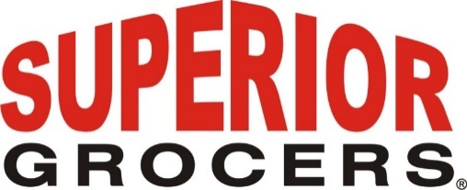

**Superior Grocers Promotes Miguel Alarcon to Senior Vice President of Operations**

**Santa Fe Springs, CA (March 31, 2023)**- Superior Grocers promotes Miguel Alarcon to Senior Vice President of Operations. Alarcon will continue to oversee the efficient operations of Superior Grocers and The Market by Superior’s 49 locations, which together employ over 5,000 associates.

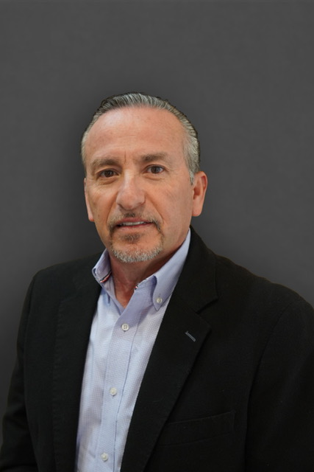

With over 40 years of experience in the retail industry, Miguel has worked his way up from a courtesy clerk to a store director before joining Superior Grocers in 2016. He previously served as the Regional Director of Operations at El Super and the Vice President of Operations at KV Mart.  
  
“We are pleased to promote Miguel Alarcon to Senior Vice President of Operations," said President and CEO, Richard Wardwell. “His leadership and commitment to excellence have been instrumental in our success and we look forward to his continued contributions."

**About Superior Grocers**

Superior Grocers is one of the largest independently owned chain of grocery stores in Southern California. Superior began its operations in 1981 with one store and has experienced steady growth for over 41 years. In 2022, Superior acquired Southern California grocery chain, Numero Uno. It now operates 70 stores throughout Southern California and Central Valley under three banners- Superior Grocers, The Market by Superior, and Numero Uno. Aside from its wide assortment of grocery, produce, meat, bakery, frozen, deli, international foods & general merchandise products, Superior stores also offer a variety of freshly prepared products in the Bakery, Meat & Seafood, Service Deli and Hot Foods departments.

It prides itself in providing Superior Quality, Superior Variety and Superior Value to the communities that it serves. Superior Grocers is a strong community partner and continually supports programs that help bring a positive impact to its customers, including education, health awareness efforts and many local youth organizations and non-profit groups. For more information about Superior Grocers, please visit [www.superiorgrocers.com](http://www.superiorgrocers.com).

For more information, please contact Dale Nakata at dnakata@superiorgrocers.com

**@SUPERIORGROCERS**

Image result for facebook png Image result for instagram png

**Visit Our Website**

**Superiorgrocers.com**