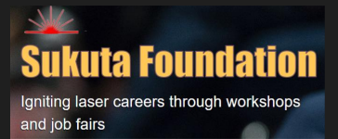
FREE Coast to Coast Lasers and Photonics Career Virtual Fair
The Sukuta Foundation brings together lasers and photonics job candidates and recruiters from leading laser companies in Silicon Valley and beyond biannually at its FREE Coast to Coast Lasers and Photonics Career Virtual Fair. The next career fair will take place on Thursday the 27th of April.
Participants will hear from employers who will share what their company is all about, careers currently available, and what they look for in potential candidates. Participating companies included Sciton, Coherent, MKS Photonics Solutions Division (Newport Corp, Spectra-Physics, Ophir, etc.), Canon Stanford Linear Accelerator (SLAC). They have jobs for all majors, not just lasers and photonics.
Participants will
- Learn more about the laser and photonics industry and what open positions are currently available, from engineering, manufacturing, research, accounting to marketing!
- Connect & Network with likeminded individuals.
- No geographical constraints
Interested career seekers can register at this link https://freelasercareerexpo.rsvpify.com
Interested companies contact advancementofficer@sukutafoundation.org

