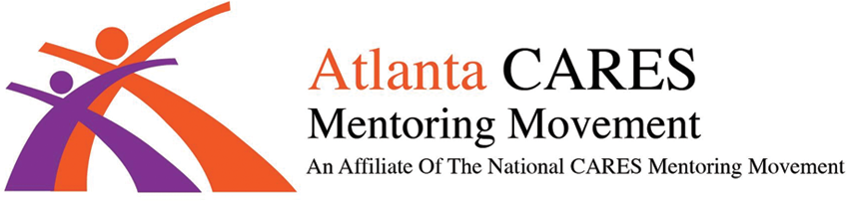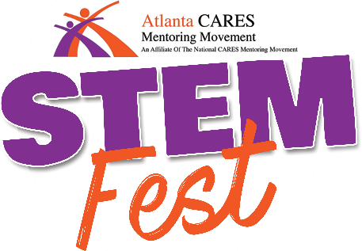
w w w . a t l a n t a c c a r e s m e n t o r s . o r g

FOR IMMEDIATE RELEASE
Contact: Brenda Coleman Phone: 770-316-3487 (Office)
Email: atlantacaresmentors@gmail.com

Atlanta CARES to Host STEMfest 2023 Youth Conference at Georgia Tech
Educating Youth on Careers in the STEM Fields and Encouraging Minority Participation

Currently underrepresented minorities—African Americans, Hispanics, and Native Americans— represent less than 10% of college graduates working in science and engineering occupations.

APRL, 2023 - ATLANTA, GA - Atlanta CARES is excited to continue its TEN YEAR STEM CAMPAIGN and to celebrate the campaign, the NINTH ANNUAL STEMFEST YOUTH CONFERENCE will be held at the Georgia Tech Exhibition Hall on Saturday, May 6, 2023, from 9:00am – 3:00pm. Atlanta CARES, a 501c3 organization, is an affiliate of the National CARES Mentoring Movement founded by former editor in chief of Essence Magazine, Susan Taylor. The purpose of the STEM Campaign is to provide awareness to youth and the overall community about the bright futures arising from STEM (Science, Technology, Engineering and Math) careers. Playing host to approximately 250 local middle and high school students, STEMfest will feature a “STEMulating” opening science demonstration, innovative and engaging hands-on student workshops, and informative parent workshops.

According to the U.S. Department of Labor, the demand for professionals in the STEM fields is projected to dramatically outpace the supply over the coming decades with over two million anticipated STEM job openings and a serious shortage of qualified college graduates to fill them. A free event, the primary goal of STEMfest 2023 is to provide information and create excitement about the numerous careers in STEM with the hopes of alleviating this shortage in the near future. The workshops will be facilitated by STEM professionals including educators, entrepreneurs, inventors, authors, and artists. Many of the STEM professionals will volunteer to serve as mentors for youth pursuing STEM careers.

STEMfest partners include the National Society of Black Engineers, the A.D. King Foundation, the APEX Museum, STEM Compass, Georgia Science and Robotics Academy Inc., LLC, Technologists of Color, STEM Atlanta Women, Biologue Laboratorium, Latest Creations Filmmaking Inc, BCR TechEd, and College For Free.

For more information on STEMfest 2023, please contact Brenda Coleman, Executive Director of Atlanta CARES, at 770-316-3487 or atlantacaresmentors@gmail.com.

