**News Release**  
Contact: Melinda Merillat  
Public Relations & Corporate Communications  
[corpcom@cbshouston.edu](mailto:corpcom@cbshouston.edu)

832.252.0745



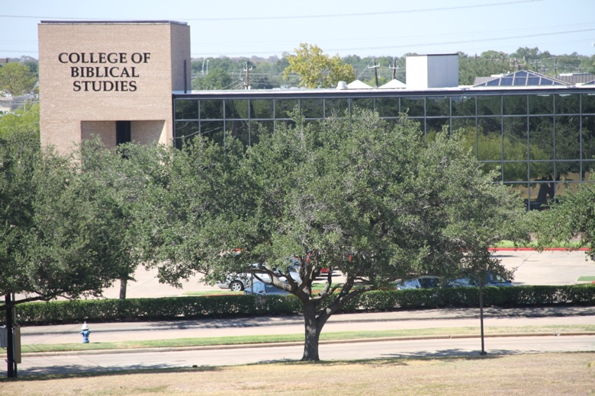

**FOR IMMEDIATE RELEASE**

**May 4, 2023**

**The College of Biblical Studies Announces Head Coaches for Men’s and Ladies’ Basketball Teams**

Houston - The College of Biblical Studies’ Athletic Department announces the appointment of Danny Evans as the Men’s Basketball Head Coach and Patricia Luckey as the Women’s Head Coach for their inaugural season in fall 2023.

Coach Patricia Luckey joins CBS as the head coach of the Lady Ambassadors and comes to CBS with more than 15 years of coaching experience. Coach Luckey played professional basketball with Priolo Sicily (Italian League) and Phoenix Mercury (WNBA). She has also played semi-professional basketball with San Antonio Breeze and Houston Jaguars 1999-2001. Coach Luckey grew up in San Marcos, Texas, where she won state championship and the 1992 MVP. Other highlights include 1993 Texas Association of Basketball Coaches Player of the Year, High School All- American, all district honors for volleyball, and a basketball scholarship to the University of Houston. Coach Luckey also played in the 1993 Kodak All-American game and was inducted into the University of Houston’s Hall of Fame, alongside her uncle, Riley Odoms who also attended the University of Houston and went on to play in the NFL with the Denver Broncos.

Coach Luckey believes all young people deserve the opportunity to develop their unique individualized talents and strengthen weak areas in order to passionately pursue greatness.

Coach Danny Evans joins CBS as the head coach of the men’s team, the Ambassadors, with over 25 years of coaching experience including 18 years coaching high school basketball where his teams won two large school TAPPS State Championships, three State Finalist appearances, two Bi-District Championships, and eight District Championships. His teams had a 236-71 record in eight seasons. Coach Evans spent 10 seasons as an assistant at Second Baptist High School. He is a 1984 graduate of The University of Texas.

Coach Evans believes athletics, coupled with CBS’s Christian values, offers student athletes potential for positive formation of life skills in other areas such as family, community, and work.

CBS Ambassadors and Lady Ambassadors first season take the court fall 2023. For more information visit https://www.cbs-athletics.com.

**About the College of Biblical Studies**

The [College of Biblical Studies](http://www.cbshouston.edu/) is located in Houston, Indianapolis, and Fort Wayne. Leveraging its academic rigor and biblical worldview training, CBS offers an accredited college education on-campus and online, with several programs offered in the Spanish language. Students receive transformational education and training for service to families, ministries, businesses, and communities around the world. CBS has provided biblically based education to more than 37,000 students since 1976 and is ranked as one of the lowest tuitions in Texas.