WRENÉ NOVA RE-RELEASES "SHAME": AN EXPERIMENTAL TAKE ON ELECTRONIC DANCE MUSIC WITH AN ULTRAMODERN MESSAGE
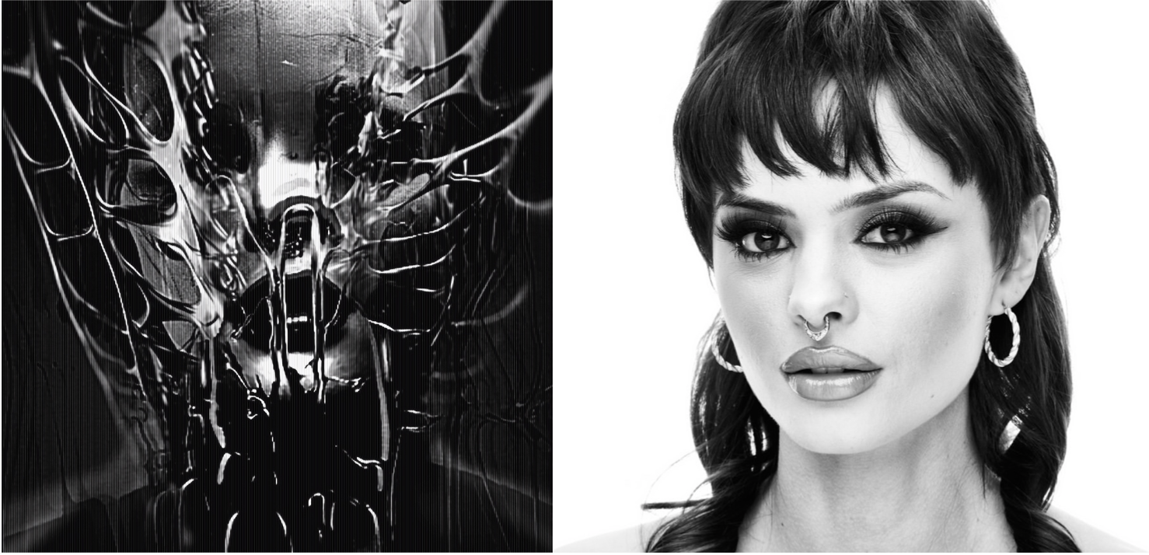

[Toronto, June 1st 2023] - Wrené, the boundary-pushing artist, is thrilled to announce the re-release of her electrifying track "SHAME." With its unconventional sound design and contemplative lyrics, "SHAME" challenges the norms of popular music and offers a fresh perspective on electronic dance music. The re-release is set for June 1st, captivating listeners with its atmospheric ambiance and catchy yet edgy allure.

Wrené's signature style is beautifully showcased in "SHAME," which stands as a testament to her artistic vision and commitment to authentic expression. The track's ultramodern sound design offers a different sound within the EDM genre- one that is dark and abrasive, paired with vulnerability in expression. The music is stylistically large, immersing listeners in a sonic experience that is both captivating and unique.

In discussing her motivation behind "SHAME," Wrené Nova explains her desire to defy the constraints and conformity that pervade many popular styles of music. She emphasises that true artistic expression should not cater to narratives that simply appease the fear of social rejection. Instead, she believes that music should reflect the intricate spirits and minds of individuals, embracing the complexity of human experience.

With "SHAME," Wrené Nova offers a refreshing take on love and self-perception, challenging traditional narratives for young women. The track fearlessly explores regret and delves into darker aspects of self-reflection, all within a catchy and repetitive tune. By questioning the portrayal of women's emotions in popular love songs, Wrené aims to encourage a deeper and more nuanced expression of personal experiences, even within genres typically considered "simple" or "popular."

"SHAME" is a bold statement that demands attention. Beginning with a driving kick drum, and ethereal vocals, to transition into a loud and abrasive whirlwind- SHAME invites listeners on a wild journey- and to perhaps reflect on their own self.

About Wrené Nova:
Wrené Nova is a multifaceted artist with an unorthodox approach to music. With her fearless exploration of unconventional soundscapes and thought-provoking lyrics, she is emerging as a powerful voice in the Toronto music scene. Wrené's commitment to authentic expression and her dedication to experimentation contribute to her unique sound to be discovered. With her re-release of "SHAME," Wrené Nova continues to push boundaries and redefine the limits of artistic expression.

