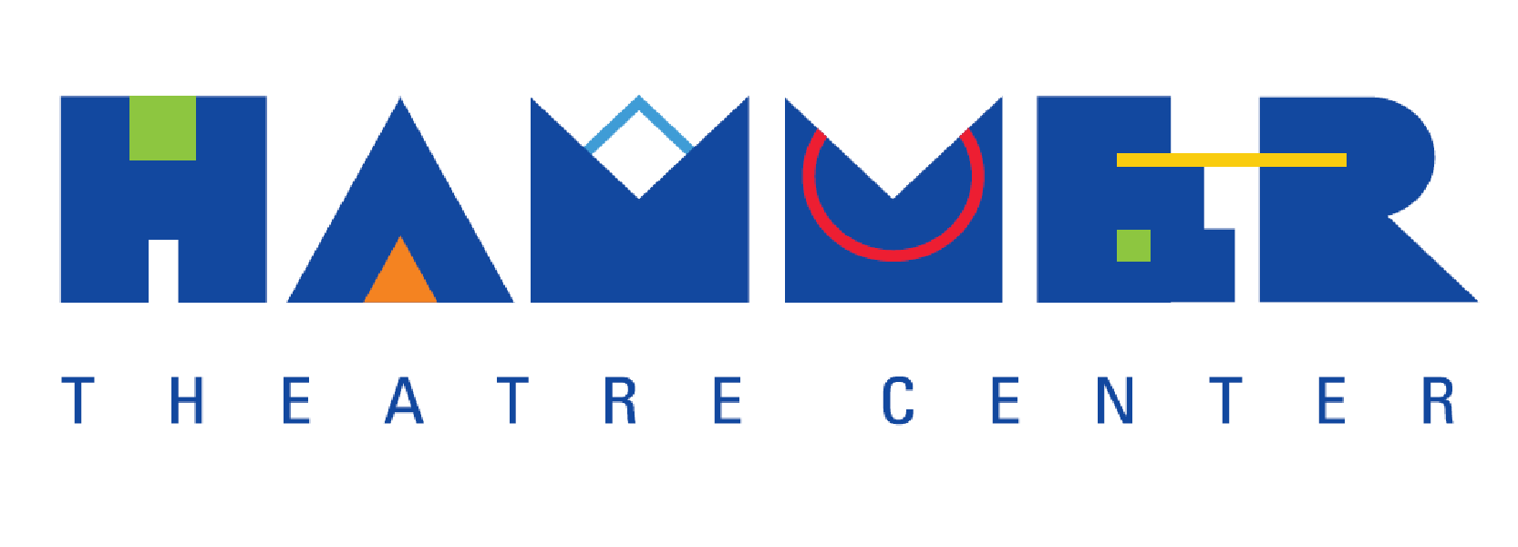

HAMMER THEATRE CENTER PRESENTS
FALL 2023 SHAKESPEARE FESTIVAL
FEATURING NATIONAL THEATRE LIVE SCREENINGS OF SHAKESPEARE’S
OTHELLO, HAMLET AND KING LEAR
2 shows per day, showing in repertory: 2:00pm & 6:00pm;
Friday, September 15, through Sunday, September 17, 2023.

SAN JOSE, CA (15 July 2023) – Hammer Theatre Center invites audiences to partake in an exclusive festival-style event in Downtown San Jose with National Theatre Live (NT Live) screenings of three popular Shakespeare titles shown in repertory: Shakespeare’s Othello, Hamlet and King Lear.

Shakespeare’s Othello, directed by Clint Dyer (Deputy Artistic Director of the National Theatre.) Filmed in front of a live audience at the Lyttelton stage of the National Theatre, Shakespeare’s compelling tragedy of boundary-defying love features Giles Terera (Hamilton, Blues for an Alabama Sky, NT Live: Hamlet) and Rosy McEwen (The Alienist, Motion Sickness, Close to Me, Blue Jean, Vesper) in a gripping new production brought startlingly up to date by a stellar cast. Met with critical acclaim, Othello has been hailed as “Extraordinary…revelatory and relevant” (WhatsOnStage) and “transfixing, full of vision” (The Independent). The NT Live screenings of Othello will be presented at 2:00pm, Friday, September 15 and 6:30pm, Sunday, September 17, 2023.

Shakespeare’s Hamlet, directed by Lyndset Turner. Filmed live from the Barbican, Benedict Cumberbatch (Doctor Strange, Sherlock, The Power of the Dog) plays the title role of Shakespeare's great tragedy. Now seen by over 900,000 people worldwide, the original 2015 broadcast returns to international cinemas to mark National Theatre Live’s 10th birthday.
As a country arms itself for war, a family tears itself apart. Forced to avenge his father's death but paralyzed by the task ahead, Hamlet rages against the impossibility of his predicament, threatening both his sanity and the security of the state. “One of the most visually and atmospherically stunning productions I’ve ever seen, of anything, ever.” (Time Out). The NT Live screenings of Hamlet will be presented at 6:30pm, Friday, September 15, and 2:00pm, Saturday, September 16, 2023.

Shakespeare’s King Lear, directed by Jonathan Munby. Filmed live from London’s West End, Ian McKellen’s ‘extraordinarily moving portrayal’ (Independent) of King Lear. Chichester Festival Theatre’s production received five-star reviews for its sell-out run, and transferred to the West End for a limited season. Considered by many to be the greatest tragedy ever written, King Lear sees two aging fathers – one a King, one his courtier – reject the children who truly love them. Their blindness unleashes a tornado of pitiless ambition and treachery, as family and state are plunged into a violent power struggle with bitter ends. Acclaimed as ‘nuanced and powerful’ (The Times) this is a contemporary retelling of Shakespeare’s tender, violent, moving and shocking play. The NT Live screenings of King Lear will be presented at 6:30pm, Saturday, September 16, and 2:00pm, Sunday, September 17, 2023.

All shows are at the Hammer Theatre Center, 101 Paseo De San Antonio, San Jose. Tickets on sale now (Single show $20; estival pass, student and senior discounts available.) For more information, the public may visit hammertheatre.com or call (408) 924-8501.

Launched by the British National Theatre, NT Live is the theatre’s groundbreaking initiative to broadcast world-class theatre to movie screens. Each broadcast was filmed in front of a live audience in London, with cameras carefully positioned throughout the auditorium to ensure that viewers get the “best seat in the house” view of each production.

Owned by the City of San Jose and operated by San Jose State University, the Hammer Theatre Center is a state-of-the-art performance venue located in the heart of downtown San Jose at 101 Paseo De San Antonio, between 2nd and 3rd Streets. The theatre has presented an array of offerings including outstanding professional productions, community-based works, SJSU shows, and concerts, as well as dance, music, talks, film screenings—even live aerial performances with dancers suspended outside, scaling the sides of the iconic blue building. From jazz performances to mariachi extravaganzas to National Theatre Live film screenings, Cinequest film festival presentations, ballet and modern dance shows, kid-friendly performances, live art, and more, the Hammer’s mission is to serve the community through artistic and educational programming that express the unique characteristics and diverse cultures of Silicon Valley.

For Calendar Editors
WHAT: Hammer Theatre Center invites audiences to partake in an exclusive festival-style event in Downtown San Jose with National Theatre Live (NT Live) screenings of three popular Shakespeare titles shown in repertory. Titles include Shakespeare’s Othello, directed by Clint Dyer (Deputy Artistic Director of the National Theatre) and featuring Giles Terera (Hamilton, Blues for an Alabama Sky, NT Live: Hamlet) and Rosy McEwen (The Alienist, Motion Sickness, Close to Me, Blue Jean, Vesper) ; Hamlet, directed by Lyndset Turner and featuring Benedict Cumberbach (Doctor Strange, Sherlock, The Power of the Dog); and King Lear, directed by Jonathan Munby and featuring Sir Ian McKellen.

WHERE: Hammer Theatre Center
101 Paseo De San Antonio, San José
(Between 2nd and 3rd Streets)

WHEN: 2:00PM and 6:30PM
Friday, September 15, 2023 - Sunday, September 17, 2023

INFO: For specific showtimes and tickets ($20), the public may visit hammertheatre.com or call (408) 924-8501. Discounts for multiple shows, Seniors (62+) and SJSU Community (staff, faculty, students, alumni) are also available.
-30-

PRESS: Contact Katie Hahn, Hammer Theatre Center
katherine.santos@sjsu.edu

PHOTOS: Downloadable high-res photos are available here:
https://bit.ly/HammerGraphics

