FOR IMMEDIATE RELEASE
AUTHORS JOIN THE INTERNATIONAL FIREBIRD BOOK AWARD CIRCLE OF WINNERS
July 20, 2023
Speak Up Talk Radio announced the recent FIREBIRD BOOK AWARDS contest winners.
One of the winning entries was from Georgia; author Terri Kozlowski, whose book titled Raven Transcending Fear, won in the Memoir category.
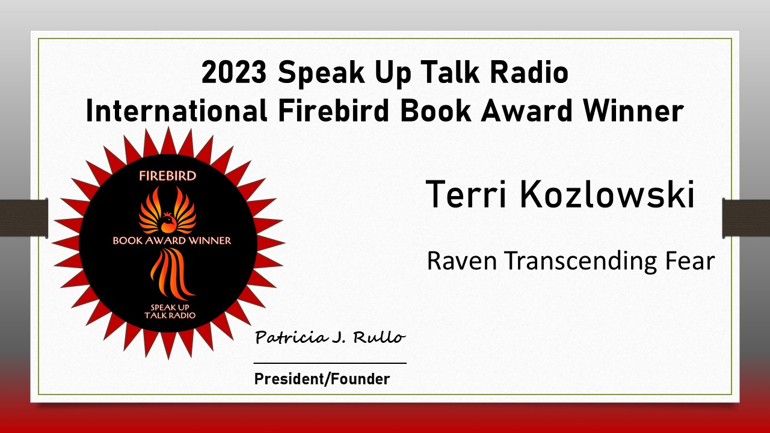
Authors and publishers worldwide submitted their work to the International Firebird Book Awards. Two judges from a select panel of 27 read each book and independently scored each entry. All judges commit to a set of standardized criteria that evaluates the quality of the writing as well as production aspects. Only entries with the highest scores are awarded the coveted Firebird.
Patricia J. Rullo, the founder of the Firebird Book Awards, says, “The Firebird Book Awards adds a charitable twist that allows the author’s entry fee to be tax-deductible. In return, we make handmade fun and colorful pillowcases and send them with children’s books to women and children who are experiencing homelessness, including the shelter Enchanted Makeovers, a 501(c)3 tax-exempt organization. In this way, authors get notoriety for their work while helping to transform homeless shelters into bright and happy homes. While it feels good to win a book award, it feels even better to do good and serve others.”
The Firebird Book Award judging panel includes a diverse group who represent a cross-section of ages, cultural heritage, races, religions, gender, and experience. At Speak Up Talk Radio, we offer creative people a welcome place to promote themselves via book awards, podcast awards, radio interviews, audiobook production, and podcasting services, including free opportunities to be featured in the BOOMBANGOHMYGOSHWOW podcast, where authors share short but helpful tips with fellow authors as well as share guest posts on our Blogatini.
The Firebird Book Awards run quarterly contests so authors can receive recognition on a timely basis. Authors from all genres, mainstream, independent, and self-published, are welcome. For additional winning authors, titles, and entry information:
https://www.speakuptalkradio.com

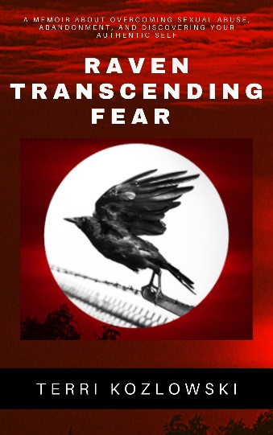
Book Title: Raven Transcending Fear: A memoir about overcoming sexual abuse, abandonment, and discover your authentic self.
Author: Terri Kozlowski
Publisher: Higher Ground Books & Media
ISBN-10: 1949798801
ISBN-13: 978-1949798807
Contact Information: www.TerriKozlowski.com
108 Copper Ridge Drive, Woodstock, GA 30188
Terri@TerriKozlowski.com or 770-530-5376
https://www.facebook.com/groups/8548967271811747
https://www.facebook.com/KozmicSoulSolutions/
https://twitter.com/tmkozlowski
https://www.instagram.com/terrikozlowski/
https://www.linkedin.com/in/terrikozlowski/
https://www.youtube.com/channel/UCbT3ygWLAxEcPqOOgCflL_A
https://www.pinterest.com/terrikozlowski/

Book Summary: Raven Transcending Fear [143 pp., 02/2021, $9.99] is a unique guide to self-empowerment. It’s the authors' raw and personal story of surviving childhood abuse, being abandoned on the streets of Albuquerque with her sister, and diving deep into her terror before ultimately getting comfortable with fear and transcending it. Through this teaching memoir, readers will go on the journey with her as Terri moves from a life ruled by fear, learned the skills of empowerment, to transcend the fear and regain a connection with the Divine.

Everyone is born fearless, knowing who they are and what their purpose is. However, life experience or abuse may instill fear and break the connection with the authentic self. In this book, Terri shares her story and the lessons she has learned from her spiritual journey. She wants to inspire and support others who struggle with fear and empower them to transcend it.

Editorial Review: “What a beautifully written book. The author, Terri Kozlowski's spiritual journey, is transformational. I so enjoyed each page, each chapter, and each lesson provided in this thought-provoking book. Life is about growth. Healing, helping, and guiding your spirit are key to health and happiness. Success is an inside job, and this book will aid your spirit on your own personal journey. A great read. I highly recommend it.”
~ Dr. Eric Kaplan, three-time #1 best-selling author, made appearances on the Dr. Oz show, Good Morning America, Primetime Live, Montel Williams, CNBC, ABC, NBC, and Fox.

About The Author: Native American Terri Kozlowski is a certified life coach, blogger, and founder of Soul Solutions. She specializes in empowering women by teaching them to set personal boundaries, reframe the stories they tell themselves, overcome their fears, and push past their limiting beliefs. On her successful podcast and YouTube channel, Soul Solutions, she delves into the soul and offers bite-sized takeaways for controlling our egos and emotions. Terri holds a BS in Social Science from the University of Pittsburgh, writes for NewsBreak, TealFeed, Medium, is a featured coach in Natural Awakenings Atlanta, appeared on over 100 podcasts, and has spoken to groups from 5 to 600. Terri lives in Woodstock, GA, with her husband and pampered chihuahua, Lelu.
###

