Author Bio: Jeffrey P. Mix

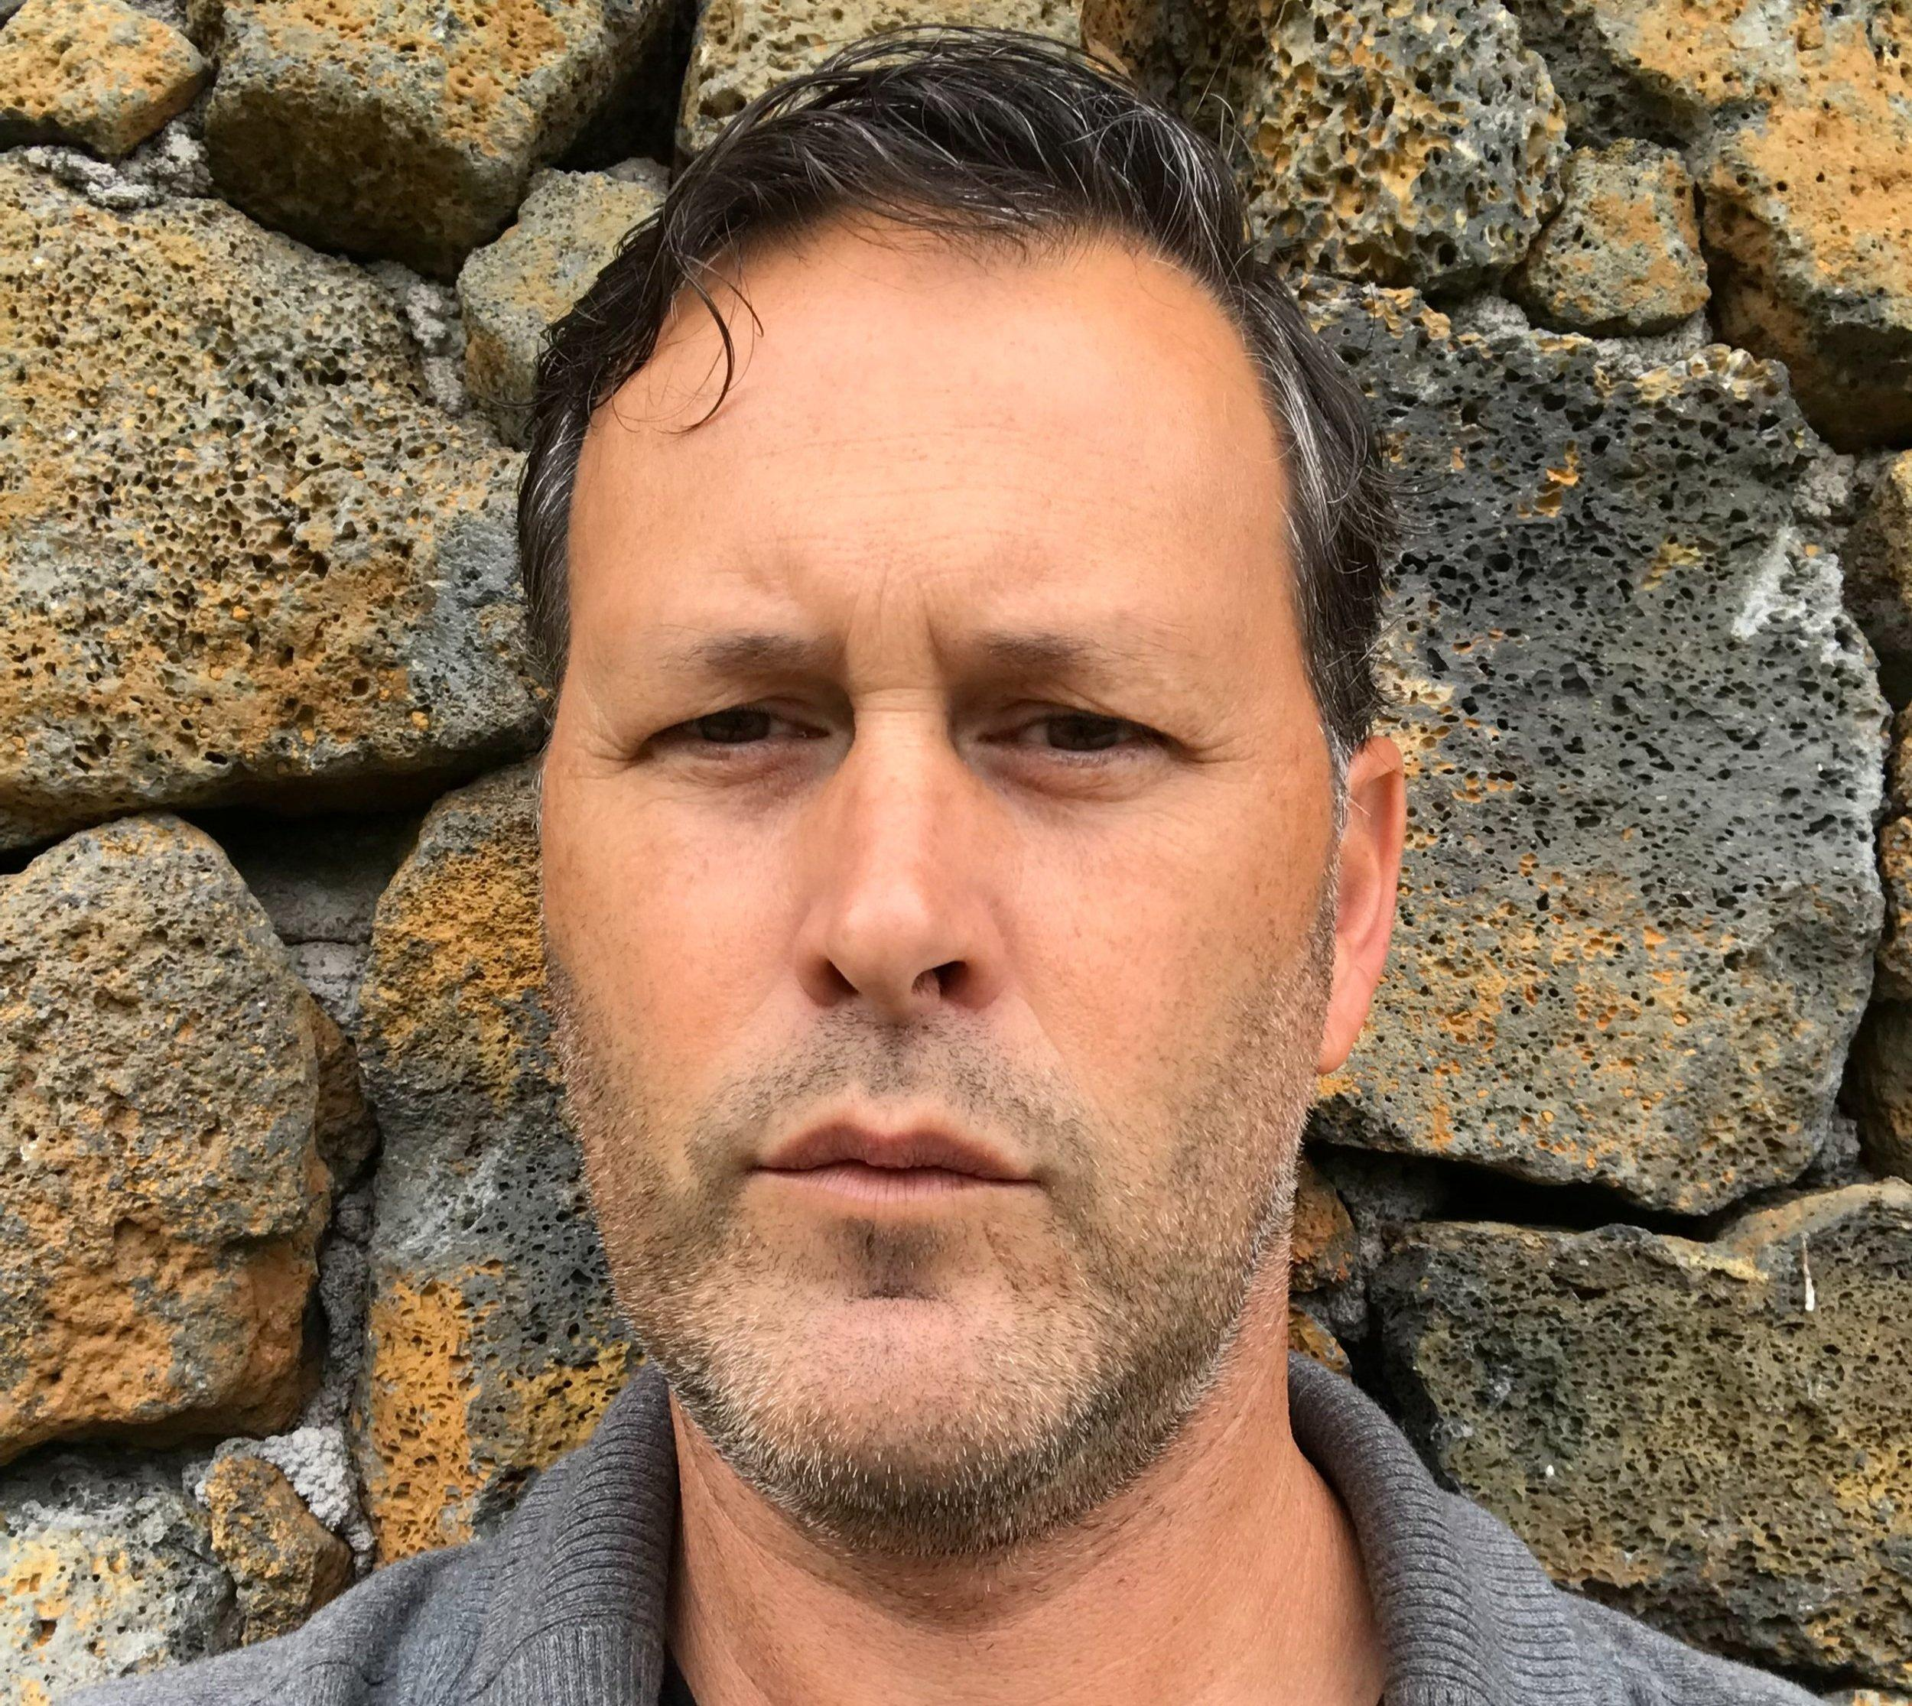

Jeffrey has an MFA in Creative Writing from Pacific Lutheran University. He’s been a staff writer for Spokane Coeur d’Alene Living magazine and editorial staff for the Northwest-based literary magazine A River and Sound Review. An excerpt from his first novel, THE SPIRITS OF PHA PHANG, was published in Straylight Literary Magazine. One of the essays featured in HAVE YOU SEEN MY SOULMATE?, “The Emptying Hourglass” was first published in T.H.R.O.B. (The Hawaii Review of Books). Jeffrey Teaches English and Creative Writing at Hawaii Preparatory Academy, and during the summer months he teaches Creative Writing in Siena, Italy for Oxford/Siena Academia.
Jeffrey grew up in the 300-person farm town of Spangle, WA—but from an early age suffered from a chronic and debilitating case of wanderlust. Places he’s since called home include Seattle, WA, Boulder, CO, Florence, Italy, Rio Dulce, Guatemala, Luang Prabang, Laos, Honolulu, HI, and he currently lives on the Big Island of Hawaii with his wife and two daughters. If he’s not writing or teaching, he can be found hiking volcanoes, or in the ocean doing his best merman impression for his two little mermaids, or spending entire weekends slow-cooking Italian food while pretending he’s back in Tuscany.

Jeffrey P. Mix Contact Information:

Email: mixjeffrey@gmail.com
Phone: (808) 430-2538
Mailing Address: P.O. Box 2541, Kamuela, HI 96743

Author Website: www.jeffreypmix.com
Amazon Author Page: www.amazon.com/author/jeffreypmix
LinkedIn: www.linkedin.com/in/jeffrey-p-mix-4207495/

