For immediate release

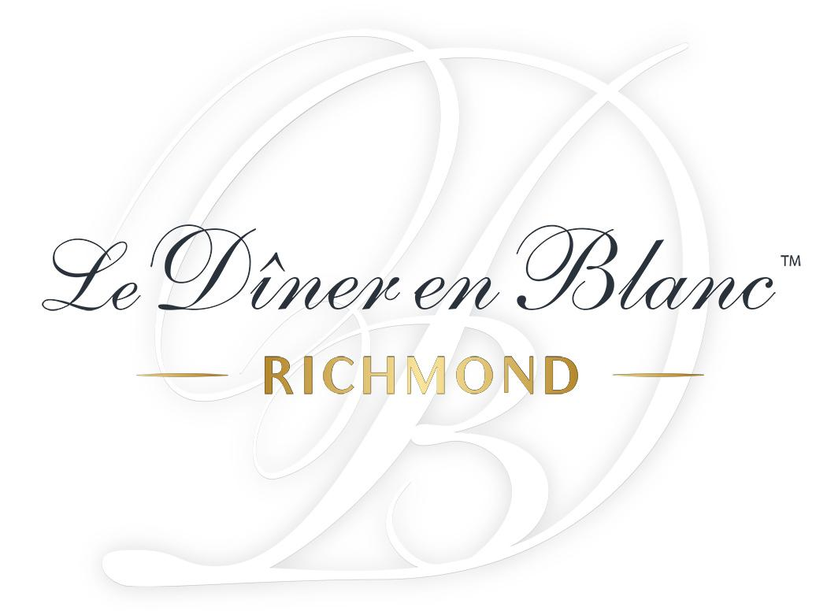
The City’s Largest Urban Picnic Returns on September 9, 2023

Richmond, 7/28/23 – Le Diner en Blanc returns to Richmond for its 2023 Edition! This elegant and secret affair has become THE foodie event of the year! On September 9th at a new secret location, guests are awaited to dine and dance under the stars.

To get the opportunity to be part of the experience, people can sign up now by visiting richmond.dinerenblanc.com and clicking on the Register tab.

Le Diner en Blanc is an event that transports us into another world. The sea of ​​people all adorned in white creates images that are instantly ‘Instagram-able’. Meeting new people or reuniting with longtime friends. Getting all dressed up to attend a dinner à la française where conversation and champagne are essential.

Christine Wansleben, co-host of Le Diner en Blanc in Richmond is glad that Le Diner en Blanc is returning to the city: "This chic and elegant affair seems perfect to encourage people to shop locally and bring to the event their local flavor. To not miss this amazing night celebrating our city and community, we invite the participants to register early, not to wait until the last moment. "

To maintain the uniqueness of Le Diner en Blanc, every guest has its part to play and observes certain requirements such as:
- Dress code: head-to-toe in white only. Elegance and Originality are key!
- Table setting: all white!
- French-influenced event only wine and/or Champagne are served.
  - As per state alcohol regulations guests cannot bring their own alcohol. Guests wishing to enjoy some wine or Champagne, must reserve online through Le Diner en Blanc’s e-store. However, guests are welcome to bring their own non-alcoholic beverages.
- To ensure that the location secret is kept undisclosed until the last minute, guests meet at the assigned departure location and are escorted by a Diner en Blanc volunteer.
- So, the event location is left as clean as when guests arrived, they are required to leave with all their belongings, leftovers, and litter.

Guests are to bring:
- A table, two white chairs, white tablecloth.
- A picnic basket comprising fine food and proper stemware and white dinnerware.
  - A catered picnic basket option, which can be picked up on site, will be available for those who do not wish to pack their own. Guests wishing to do so must reserve online through Le Diner en Blanc’s e-store.

Le Diner en Blanc – Richmond gratefully acknowledges Chloe Wine Collection as an official local partner of the 2023 edition of Le Diner en Blanc.

About the Hosts of Le Diner en Blanc – Richmond
Le Dîner en Blanc – Richmond host team is composed of Ayana Obika, Christine Wansleben, Jessica Braum Corbett. Together, they possess over 20 years’ event production experience. Ayana has honed her skills by producing large scale events such as expos and film festivals nationally. Christine is the chef/owner of Mise en Place offering amazing culinary experiences through private and group classes. Jessica, the owner of Echelon Event Management, finds joy in the production of annual events with attendance of over 20,000 people. Event logistics is her calling. All three bond over their shared love for their city and enthusiasm for a great glass of wine.

About Le Diner en Blanc
Le Diner en Blanc is so much more than an event. It’s a unique cultural movement that empowers friends of friends to gather and celebrate their shared passions for life, food, fashion, and community, year after year, with a pinch of mystery and large serving of spontaneity. Elegantly dressed all in white, guests arrive at a secret location for a chic picnic en masse. They bring their own tables, chairs, picnic baskets—all the trimmings—to sit down with friends and make new connections in one of their city’s most beautiful public spaces. The location remains secret up until the very moment of arrival. Over the course of the evening, guests from all backgrounds eat, dance, and reconnect with the finer things in life, as they appreciate the night’s magical experience.

To this day, over 120 cities in 40 countries have joined the ever-growing and international network to celebrate gourmet cuisine, offer extraordinary entertainment, and bring together vibrant individuals and bon vivants around the world. While Diner en Blanc International is headquartered in Montreal, Canada, every event in every city is hosted by passionate local organizers who fell in love with the original Parisian concept and wanted to bring it home and dress it up with local flair. For more info, photos, and videos of Le Diner en Blanc events from around the world, visit dinerenblanc.com.

###

To keep up to date on event announcements, visit richmond.dinerenblanc.com or
DinerEnBlanc.Richmond dinerenblancrva dinerenblancrichmondva
#dinerenblanc #debrichmond2023

For media requests, interviews or images, contact:
Lisa Elaine Hall, CateyezInk – c.804-269-6873 – e. media@richmond.dinerenblanc.com

