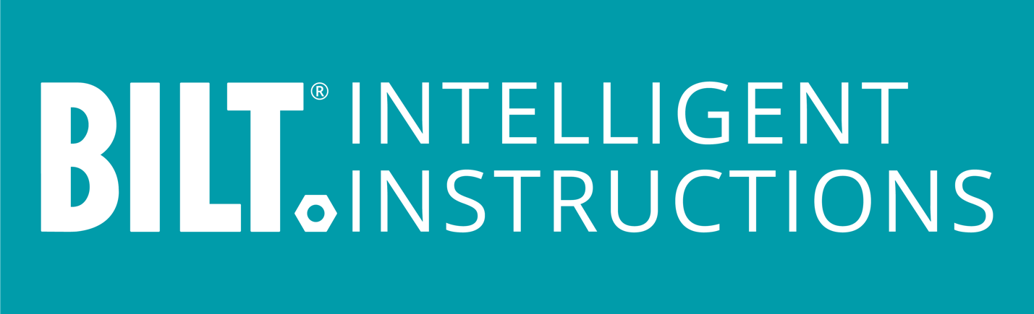

PRESS RELEASE

BILT Named to Inc. 5000 for 4th Year Running
3D Instruction App Company Accelerates Growth

GRAPEVINE, TX, August 15, 2023 – Inc. magazine announced today that BILT ranks 1247 on the list of the 5000 fastest-growing private companies in America. The list provides a data-driven look at the companies and entrepreneurs that have generated rapid growth while navigating inflationary pressure, the rising cost of capital, and hiring challenges. This year’s list added almost 1.2 million jobs to the US economy.

“I’m proud of our team. The credit goes to each individual whose consistent effort enriches the lives they touch, from our brand partners to our end-users,“ says BILT Chairman & CEO Nate Henderson.

BILT has won a spot on the Inc. 5000 list every year for the past four years. The 2023 list reflects revenue growth between the second quarter of 2019 and the last quarter of 2022, the years of the global COVID-19 pandemic.

“Surviving and then thriving in this climate comes from focusing on creating promoters of the brands we serve,” says Henderson. “The courage to innovate despite uncertain economic times is a testament to our brand partners’ commitment to their customers and employees.”

Besides enhancing the out-of-the-box customer experience, BILT supports training and enablement of the professional trades. Brands like Siemens, Connecticut Electric, Assa Abloy, and Amico provide 3D Intelligent Instructions® to increase safety and efficiency while reducing tech support costs and upskilling time. BILT enables real-time feedback and insight from users to empower product and operations improvements.

“Making the Inc. 5000 means the top companies in the country in terms of growth…most are in the top half percent of all privately owned companies, better than 99.5%,” says Inc. Editor-in-Chief Scott Omelianuk. “There are clear trends this year: healthcare companies, software firms, and staffing platforms all indexed in the highest echelon. Startup culture here in the States is strong.”

###

About BILT:
Millions of people worldwide rely on the award-winning BILT app for official instructions from hundreds of brands. The 3D animated guides for assembly, installation, maintenance, and repair are interactive and ad-free. BILT is accessible, customizable, and sustainable. It provides DIYers and pros an efficient, easy-to-follow alternative to paper manuals and instruction videos. Download the mobile app on iOS and Android or go to BILTapp.com for details.

Contact:
Juliette Qureshi
VP, PR & Media Communications
Juliett@BILTcorp.com
703-554-3020

