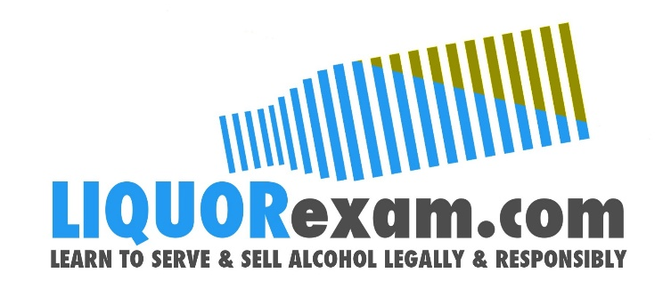
August 28, 2023
Contact
Edward McLean, Program Director 888-344-5554 admin@LIQUORexam.com

FOR IMMEDIATE RELEASE

LIQUORexam.com Revolutionizes Hospitality Job Applications with Free AI Resume and Cover Letter Builder

September 6, 2023 — LIQUORexam.com, a leader in hospitality certifications, has launched the Free AI Resume and Cover Letter Builder, a groundbreaking solution for hospitality professionals seeking career advancement in a competitive job market.
Designed exclusively for the unique demands of the hospitality industry, LIQUORexam's AI-powered tools within the Free Resume and Cover Letter Builder highlight candidates' industry-specific skills and experiences. This addresses the need for tailored applications that resonate with potential employers seeking specialized expertise.
The tool's user-friendly interface allows professionals to begin crafting their applications immediately from the homepage, eliminating signup barriers. With step-by-step guidance, regardless of technical expertise, the process remains intuitive.
Reflecting a commitment to accessible career development, LIQUORexam.com offers the Free AI Resume and Cover Letter Builder at no cost, promoting inclusivity and allowing candidates to create exceptional applications without financial constraints.
By harnessing AI technology, the builder accelerates the creation of impactful resumes and personalized cover letters. This time-saving innovation analyzes inputs to create documents that emphasize candidates' strengths, providing a competitive edge.
The tool uniquely highlights LIQUORexam certifications within resumes and cover letters, underlining candidates' commitment to excellence in the field.
Edward McLean, Owner and Program Director of LIQUORexam.com, shared: "The Free AI Resume and Cover Letter Builder underscores our dedication to empowering hospitality professionals. This tool reflects our commitment to innovative solutions benefiting our community."
The LIQUORexam.com Free AI Resume and Cover Letter Builder promises to reshape hospitality career paths. This tool equips professionals, from novices to seasoned experts, to stand out in a competitive market.
###

