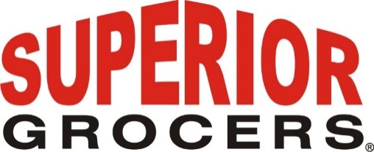

**Superior Foundation 20th Annual Charity Golf Tournament**

**Santa Fe Springs, CA (September 25, 2023)** - Superior Grocers held its Annual Foundation Golf Tournament on September 23rd at the JW Marriott in Palm Desert marking a remarkable milestone for the foundation, which was founded 25 years ago. This event celebrated not only the legacy of giving but also the achievement of over $3.5 million in total donations since its inception in 1998.

**The Superior Foundation: Empowering the Future, One Child at a Time**

The Superior Foundation has been a beacon of hope and transformation for a quarter of a century. Guided by the belief that every child deserves an equal opportunity to succeed, the foundation has worked tirelessly to uplift communities, nurture young minds, and create brighter futures.

**Record-Breaking Contributions to Education, Music & Arts, Health, and Scholarships**

In an extraordinary display of generosity, The Superior Foundation, alongside its dedicated vendor partners, raised over $400,000 during this year's golf tournament. These funds will be allocated to support vital initiatives in the areas of education, music & arts, health and wellness, and scholarships for higher education.

The impact of these contributions will be felt across the community, as they continue to empower underserved children and families, ensuring access to quality education, fostering creativity through the arts, promoting overall well-being, and creating pathways to higher education.

**KTLA's Sam Rubin as Master of Ceremonies**

The tournament's reception was graced by the presence of KTLA's Sam Rubin, who served as the Master of Ceremonies. Sam's charismatic presence added an extra layer of excitement and energy to the event, highlighting the importance of the cause and encouraging attendees to join hands in making a difference.

Superior Grocers is one of the largest independently-owned chain of grocery stores in Southern California. Superior began its operations in 1981 with one store and now operates 71 stores throughout Southern California, and employs nearly 4,500 associates. Aside from its wide assortment of grocery, produce, meat, bakery, frozen, deli, international foods & general merchandise products, Superior stores also offer a variety of freshly prepared products in the Bakery, Meat & Seafood, Service Deli and Hot Foods departments. Superior offers shoppers the highest quality products at the best value along with exceptional customer service.

Superior Foundation, its non-profit arm, was founded 25 years ago. The foundation’s efforts make a direct connection with local communities providing ongoing support to schools, youth programs and scholarship foundations.

The Superior Foundation has donated over $3.5 million to schools and non-profits in support of youth and education in Southern California.

**@SUPERIORGROCERS**

Image result for facebook png Image result for instagram png

**Visit Our Website**

**Superiorgrocers.com**