News Release

For Immediate Release:

October 5, 2023
_____________________________________________________________________________________________
Contact: Mike Hall | General Manager – Sapphire Bay Marina
678-207-9065 | mikehall@sapphirebaymarina.com
Denise Perrin | Public Information Manager
City of Rowlett | 4000 Main Street | Rowlett, TX 75088
972-412-6192 | dperrin@rowlett.com

Marina Association of Texas Names Sapphire Bay Marina
2023 Clean Marina of the Year

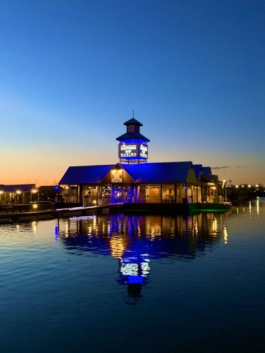
ROWLETT, TEXAS— The City of Rowlett announced today that Sapphire Bay Marina (SBM), on Lake Ray Hubbard, has been named the 2023 Clean Marina of The Year by the Marina Association of Texas (MAT) during their annual convention in Boerne, TX. The award is one of the most prestigious designations in the marina industry. By receiving this award, SBM, its facilities, employees, ownership, and management were recognized for their exemplary leadership in pollution prevention and environmental protection on Lake Ray Hubbard. SBM was honored last year with the prestigious Marina of The Year award by the same organization.

“Rowlett is a vibrant lakeside community, and our residents enjoy all the outdoor entertainment opportunities and amenities offered by living on the shores of Lake Ray Hubbard,” says Mayor Blake Margolis. “It’s wonderful to have our own Sapphire Bay Marina recognized for their exemplary efforts to safeguard this ‘blue space’ enjoyed by so many from all over North Texas, to protect our environment, and for taking a leadership role in pollution prevention.”

The Clean Texas Marina Program was created through a partnership between the Marina Association of Texas, Texas Sea Grant College Program, Texas Commission on Environmental Quality (TCEQ) and Texas Parks & Wildlife Department (TPWD). This program recognizes marinas for their efforts in environmental responsibility, and lets boaters identify marinas that promote clean activities and follow best management practices. Participation is voluntary and shows a marina's commitment to keeping Texas boating areas safe and clean. Marina facilities certified in the Clean Texas Marina program meet rigorous standards for pollution prevention. Marina operators adopted measures to control pollution associated with marina operations and stand as notable examples of the conservation ethic: individual responsibility for healthy land and water.

Sapphire Bay Marina, one of the largest inland marinas in the country, was recognized for their work promoting safety and Environmental Management Practices among their 1,000+ tenants, developing a prioritized Environmental Management System to take a comprehensive look at potential environmental hazards.

Mike Hall, General Manager of SBM, accepted the award on behalf of Sapphire Bay saying, “We are extremely proud of our marina team and boating community. It takes creativity, resources, persistence, and cooperation to continually work towards improving our environmental practices. We are lucky to have such great partners in our environmental endeavors and would like to thank them for their continuing support.”

Presenting the award on behalf of the Marina Association of Texas Clean Marina Program was Kim Shrum Executive Director of MAT and, Director for the MAT Clean Marina Program. “Our inland lake and marine resources are under tremendous pressure these days from rapid development and upland sources of pollution,” said Shrum. “Every activity helps in our fight to improve and make our waterways more fun, safe, and productive for generations to come. No one knows this more and can do this better than the boating community, many of whom have built their lives around spending time in, on and around the water.”

About Sapphire Bay Marina
Sapphire Bay Marina is a 1,000+ slip modern, deep-water marina with luxury amenities. It is part of the $1.5 billion Sapphire Bay development. Visit ww.sapphirebaymarina.com for more information.

About the Clean Marina Award
Clean Marina Award is an incentive-based certification program in which marinas assess their operations and implement improvements to better protect the environment. The Clean Marina Award was created in 1996. The Clean Texas Marina Program was created through a partnership between the Marina Association of Texas, Texas Sea Grant College Program, Texas Commission on Environmental Quality (TCEQ) and Texas Parks & Wildlife Department (TPWD). This program enables marinas to be recognized for their efforts in environmental responsibility. It also lets boaters identify those marinas that promote clean activities and follow best management practices. Participation is voluntary and shows a marina's commitment to keeping Texas boating areas safe and clean. www.marinaassociationoftexas.com

About Rowlett, Texas
The City of Rowlett is located on the shores of Lake Ray Hubbard, 20 minutes east of Dallas, and is easily accessible from IH 30, the President George Bush Turnpike and the DART light rail. Home to over 68,000 residents, Rowlett offers award-winning schools, unique shopping opportunities, diverse housing opportunities, top-quality health care, an outstanding regional hospital, beautiful lakeside parks, and a wide variety of community, entertainment, and special events. Visit Rowlett.com for more information.

###

