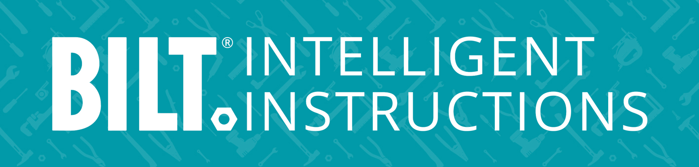

PRESS RELEASE

BILT & ELB Learning launch partnership to expand training & enablement options;
Immersive 3D tools will enhance customizable mobile learning

Grapevine, TX, October 19, 2023 – BILT and ELB Learning announced today they are teaming up to provide a one stop shop for e-learning, digital training, and operational enablement. The award-winning solutions are modernizing knowledge transfer for corporate and technical professionals. ELB Learning’s modes include technology solutions, gaming, simulation, animation, video, and virtual courses. BILT’s software as a service platform complements the learning suite with 3D interactive Intelligent Instructions® delivered via mobile app.

“Partnering with ELB Learning is a win for customers,” says BILT President & COO Ahmed Qureshi. “They architect best-in-class training for most of the world’s top companies.”

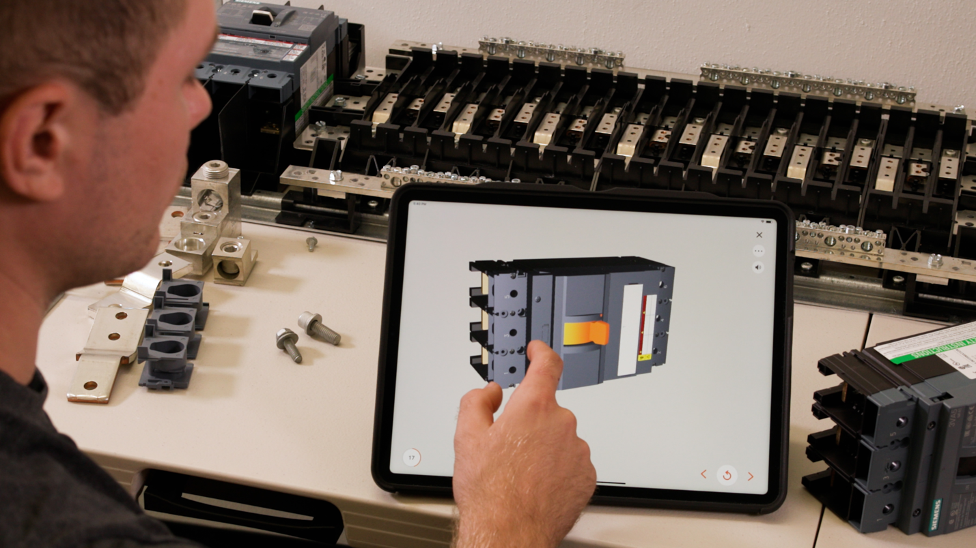

Video: https://youtu.be/YZiwiBW6P_s
Central to both brands is a mission to create better learner and user experiences. As a global leader in learning technology, ELB Learning helps companies increase employee productivity by bringing together innovative software and tailored professional services. BILT was born out of a need to guide consumers through at-home assembly and installation, but today the platform enables technicians through complex professional projects while fueling continuous improvement to both instruction and product design.

“Both organizations believe in creating interactive, accessible training to help increase performance and productivity,” says ELB Learning Co-founder & CEO Andrew Scivally. “This partnership brings more options for our clients to enhance their training solutions.”

###

About BILT:
BILT is the leader in immersive 3D instructions, transforming manuals and videos into fully manipulable animated guides. Hundreds of brands and manufacturers deliver next-gen operational enablement and training on BILT for thousands of jobs from assembly and installation to maintenance and repair. BILT is proven to reduce errors, rework, and calls to support and increase performance and productivity. The award-winning BILT app is available worldwide on iOS or Android. Learn more at BILTapp.com.

About ELB Learning:
ELB Learning offers the most comprehensive suite of products and services worldwide to ensure businesses distribute more immersive and impactful learning. As a market leader, ELB Learning creates and delivers turnkey and custom learning solutions including eLearning, gamification, virtual reality, video practice and coaching, staff augmentation, and courseware. Today, 80% of Fortune 100 companies trust ELB Learning to elevate their corporate learning experiences.

Contact:
Juliette Qureshi
VP, PR & Media Comms
Juliette@BILTcorp.com
703-554-3020

