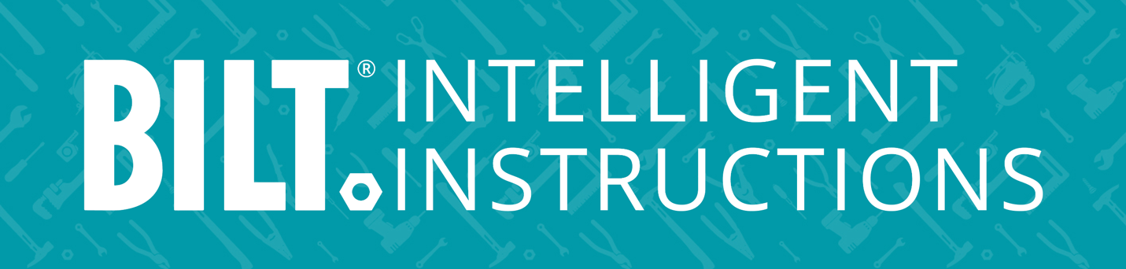

PRESS RELEASE

BILT empowers pros & techs with project sharing capability
New feature facilitates teamwork & efficiency

Grapevine, TX, Nov 29, 2023 – BILT, the operational enablement tool, announced today a new feature tailored to professional technicians and tradespeople tasked with upskilling a new generation of workers. The latest app update introduces project sharing, a collaboration feature designed to enhance on-the-job enablement. Some educators expect trainees may be able to successfully install products in the field without ever having touched the equipment in the classroom if they have familiarized themselves with the 3D instructions.

“BILT is a game-changer in a training environment,” says Lab Instructor Christie Peterson of the San Francisco Joint Apprenticeship & Training Committee for Local 6. She says “BILT is absolutely the next step in the evolution of training and ideal for apprentices.”

With the new project sharing function, technicians and tradespeople can:
- Streamline teamwork: Now, users can easily invite colleagues to work together on complex projects, ensuring tasks are completed with precision and speed.
- Collaborate in real-time: Teams can synchronize efforts on the job, eliminating communication gaps to promote a smooth workflow.
- Follow 3D interactive guidance: Images and animations on the 3D app can be manipulated to suit an individual user’s perspective to enable a comprehensive understanding of each task’s intricacy.
- Contribute feedback: BILT garners ratings, reviews, and user feedback and provides managers with analytics and insights to identify pain points and potential delays.

“Project sharing fosters a dynamic, collaborative environment that boosts productivity,” says BILT Chairman & CEO Nate Henderson. He says the tool is uniquely attuned to helping professional technicians facilitate teamwork, reduce errors, and improve training.

For a demo, click: https://youtu.be/I_t5Jdrzl50

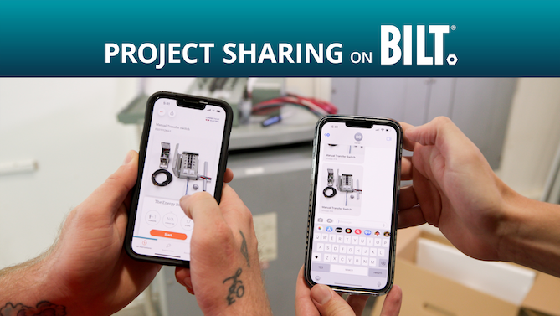

###

About BILT:
BILT is the leader in 3D interactive instructions, transforming paper manuals and videos into fully manipulable animated guides. Hundreds of brands and manufacturers deliver next-gen training on BILT for thousands of jobs from assembly and installation to maintenance and repair. BILT is proven to reduce errors, rework, and calls to support and increase performance and productivity. The award-winning BILT app is available worldwide on iOS and Android. Learn more at BILTapp.com.

Contact:
Juliette Qureshi
VP, PR & Media Comms
Juliette@BILTcorp.com
703-554-3020

