Pamela Breece FOR IMMEDIATE RELEASE
602.717.8814
hello@penelopeandmacaroni.com
www.penelopeandmacaroni.com

FALL IN LOVE WITH PENELOPE AND MACARONI
A children’s book about a girl living in a house with her horse…based on a semi-true story
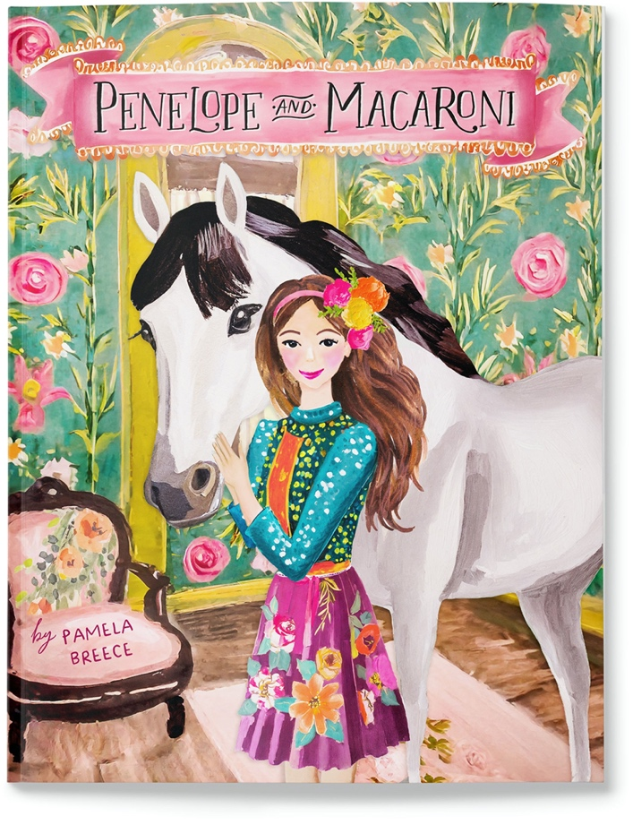
PHOENIX, ARIZONA, November 29, 2023
When Penelope Bellaflora grew up, she decided to move her horse, Macaroni, into her house.
Spend a day in the magnificent world of best friends Penelope and Macaroni in this beautifully illustrated new children’s book by author/illustrator Pamela Breece. Combining the spirit of Pippi Longstocking with the heart of Charlotte's Web, Penelope and Macaroni is perfect for children ages 3-9.
The sweet 36 page story was inspired by Breece’s Mustang horse, Charlie, who regularly comes into Pamela's house to visit. Breece and her “house horse” went viral last year on social media and in the press, and Penelope and Macaroni is a magical depiction of a day in the life of the unlikely duo.

"Penelope and Macaroni was a true passion project" says author Pamela Breece. "I hope that it makes readers smile, seeing the beautiful bond between Penelope and her horse. Penelope and Macaroni live the life that people *THINK* that Charlie and I live; all stardust and no stall cleaning!”
About the Author
Pamela Breece is an illustrator and owner of the equestrian brand Pony Macaroni. She lives on a small farm in Arizona with her horses, pigs, mini ponies, chickens, dogs and cats.
Pamela and her horse, Charlie, have recently been featured in media outlets such as People Magazine, The New York Post, The Dodo and Good Morning America.
Follow the adventures of Pamela, Charlie and all of her farm animals on Instagram @ponymacaronilove
Book Info
Penelope and Macaroni is available for sale in paperback, hardback and Kindle online at Amazon, and at www.barnesandnoble.com
For additional information or media inquiries, contact Pamela Breece at hello@penelopeandmacaroni or visit www.penelopeandmacaroni.com/press
Printed in USA - 8.5 x 11” cover - 36 pages - 36 illustrations - Published November 2023
Hardcover ISBN 979-8-9895849-1-8 Softcover ISBN 979-8-9895849-0-1
###

