ROAD RANGER AS PRIMARY PARTNER OF TY MAJESKI’S NO. 66 TOYOTA TUNDRA TRD PRO IN NASCAR Camping World Truck Series races

SANDUSKY, Ohio (May 14, 2022) – Road Ranger has partnered with ThorSport Racing to serve as the primary partner on the No. 66 Toyota Tundra TRD Pro for multiple NASCAR Camping World Truck Series races starting at Texas Motor Speedway.
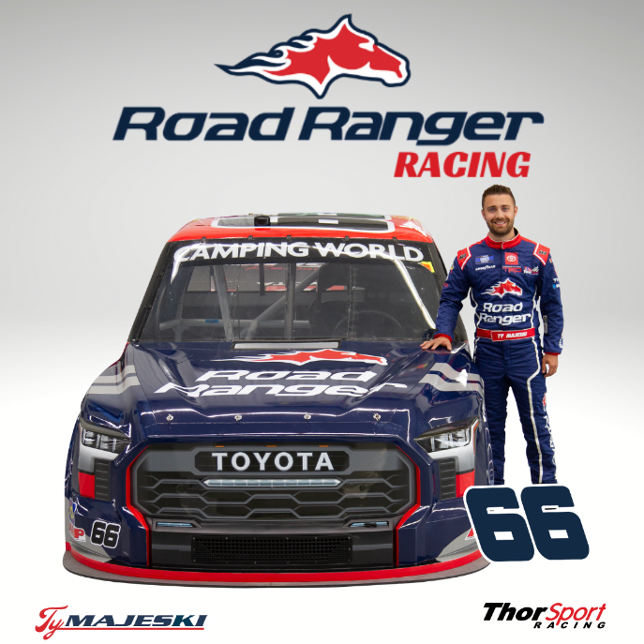
"The Partnership with ThorSport Racing is an exciting new journey that we are thrilled to embark on. Ty is someone we are especially excited to partner with, as his career in NASCAR Truck series racing is kicking into high gear - just like ours! By the end of 2022, we plan to expand from 43 to 54 locations. The future growth plans do not stop there. Just like Ty’s career, we believe the sky's the limit,” said Marko Zaro, CEO at Road Ranger.

With 43 travel stops across seven states, Road Ranger today stands as the fourth-largest travel center chain in the United States. Road Ranger proudly serves professional drivers, motorists, and travelers throughout the mid-continental United States. Locations can be conveniently found on major highways in Illinois, Wisconsin, Iowa, Missouri, Indiana, Arkansas, and Texas. As the plan for growth continues, they will soon expand to neighboring states.

“With the launch of our new Ranger Rewards Loyalty App, we figured there was no better time to reach out to the most brand-loyal fans in the world - NASCAR fans of course! I think I speak for my entire team when I say that we are beyond ready and excited to partner with ThorSport Racing and Ty Majeski. As Road Ranger continues to expand our fuel network, our focus on customer-centric marketing that is designed solely around the customer's needs and interests is a top priority. We look forward to paying it forward to our loyal customers through in-app sweepstakes, Race Weekend Giveaway packages, free promotional gear, and bonus points,” said Ryan Arnold, VP of Marketing.

With seven races complete in the 2022 season, Majeski has two top-five, four top-10 finishes, and 22 laps led in addition to his pole award at Daytona International Speedway.

“Being from Wisconsin, I could not be more thrilled to partner with Road Ranger, a Midwest-based company. Building a partnership with not only the Road Ranger brand, but the individuals at Road Ranger has been a great experience so far. I am looking forward to representing them on and off the racetrack,” said Majeski.

"Like Road Ranger, Ty has a remarkably interesting story. He is a hardworking individual who cares about small things. When we visited the ThorSport Headquarters, Ty was there working on his truck - engineering, designing, and perfecting. At Road Ranger, we have the same mindset. Every little detail matters. From convenience to customer service, we believe success is built on perfecting the small things. NASCAR is the perfect place to showcase our brand and our commitment to our customers." - Ryan Arnold, VP of Marketing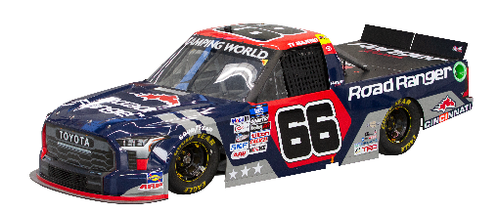
Catch all the racing action from Kansas Speedway Saturday, May 14. Race coverage begins at 7:00 p.m. ET on FOX Sports 1. Additional coverage can be found via the Motor Racing Network (MRN).

About Road Ranger:
Founded in 1984 by Dan Arnold, Road Ranger began its journey as a small, privately-owned chain of C-Stores, headquartered in Rockford, Illinois. In 2018 Road Ranger was acquired by Enex, a subsidiary of Chile-based Quiñenco S.A, sequentially moving its headquarters to Schaumburg, Illinois in 2021. With a plan for rapid expansion and growth, Road Ranger has set a new standard for travel center innovation, customer convenience, comfort, and safety. With 43 travel stops across seven states, Road Ranger today stands as the fourth-largest travel center chain in the United States. Road Ranger proudly serves professional drivers, motorists, and travelers throughout the mid-continental United States. Locations can be conveniently found on major highways in Illinois, Wisconsin, Iowa, Missouri, Indiana, Arkansas, and Texas. We offer clean facilities, CAT Scales, well-lit and spacious lots, top-tier gasoline, complimentary customer loyalty programs, and a wide variety of high-quality hot food to go. In addition to these offerings, we also provide a variety of quick-service restaurants including Ranger Kitchen, Dan’s Pizza, Tejas Tacos, Wendy’s, Subway, Church's Chicken, Chester's, Cinnabon, Dickie's Barbecue Pit, McDonald's, and Burger King.

Our values are consistent from the store to corporate levels - to provide families and professional drivers with highway hospitality, clean facilities, fresh quality food, and superior customer service. We believe that our company is made great by our unique culture and an environment in which everyone gives 100% of their talents and professional energies. An environment in which bold ideas are embraced, initiative runs rampant and where providing selfless customer service every day is commonplace. Our smiles, gracious attitudes, greetings, and thanks to each customer all work together to ensure a great experience every time you visit a Road Ranger Travel Center.

For more information visit: http://www.roadrangerusa.com.

About ThorSport Racing
ThorSport Racing, based in a state-of-the-art 100,000 square-foot facility in Sandusky, Ohio is the longest-tenured NASCAR Camping World Truck Series team, competing in the series since 1996. The Sandusky-based team has five championships. For more information visit www.thorsport.com.

About Toyota
Toyota (NYSE:TM) has been a part of the cultural fabric in North America for more than 60 years, and is committed to advancing sustainable, next-generation mobility through our Toyota and Lexus brands, plus our more than 1,800 dealerships.

Toyota directly employs more than 48,000 people in North America who have contributed to the design, engineering, and assembly of nearly 43 million cars and trucks at our 13 manufacturing plants. By 2025, Toyota’s 14th plant in North Carolina will begin to manufacture automotive batteries for electrified vehicles. With the more electrified vehicles on the road than any other automaker, more than a quarter of the company’s 2021 North American sales were electrified.

Through the Start Your Impossible campaign, Toyota highlights the way it partners with community, civic, academic, and governmental organizations to address our society’s most pressing mobility challenges. We believe that when people are free to move, anything is possible. For more information about Toyota, visit www.ToyotaNewsroom.com.

